GSB-520 Data Integration Project

Overview

Pentaho is enterprise-class data integration and analytics software for big data, cloud modernization, and mission-critical applications. We will be focusing on the ETL portion of the software suite. The aim of this exercise is to walk you through the basic concepts and processes involving in building a transformation with Pentaho Data Integration (PDI) in a typical business scenario. In this scenario, you are loading data from a MySQL database to an object-relational database PostgreSQL. During the loading process, some necessary transformation steps must be taken to standardize the data.

I will provide detailed step-by-step instructions on how to conduct this data integration process. However, I can only guarantee that my instruction works on a Windows machine. Since this is a group project, I suggest you use the system from your group members that has the most available computing recourses to do this. I do believe this will also work on a Mac. But you need to have the ability to customize some of the steps.

The following are the steps we will go through.

Contents

Step 1: Download PostgreSQL 3

Step 2 Download JDK 8 11

Step 3: Install Postgres and MySQL JDBC drivers 21

Step 4: Install Pentaho. 28

Step 5: Load JDBC files. 30

Step 6: Load a MySQL database. 31

Step 7. Create a table in PostgreSQL database. 34

Step 8: Pentaho Test Database Connection 43

Step 9: Create a Transformation 49

Step 10: Create Table in Pentaho 69

Step 11: Another Example Customer Address 73

Step 12: Another Example Apply Number Range 89

Step 13: Group Project Requirement 92

# Step 1: Download PostgreSQL

PostgreSQL is a widely used open-source object-relational database system. Object-relational database systems combine the features of both relational databases and object-oriented programming and allow database administrators to design complex database structures to model real-world problems, with the extensibility, inheritance, polymorphism, and encapsulation characteristics enabled by the object-oriented programming philosophy.

We are not going to talk about the details of this type of database, but you just need to understand that it is a special type of relational database, (which means that what you have learned so far, including ER, relations, SQL, can all be applied to this database).

Download PostgreSQL from

<https://www.postgresql.org/download/>

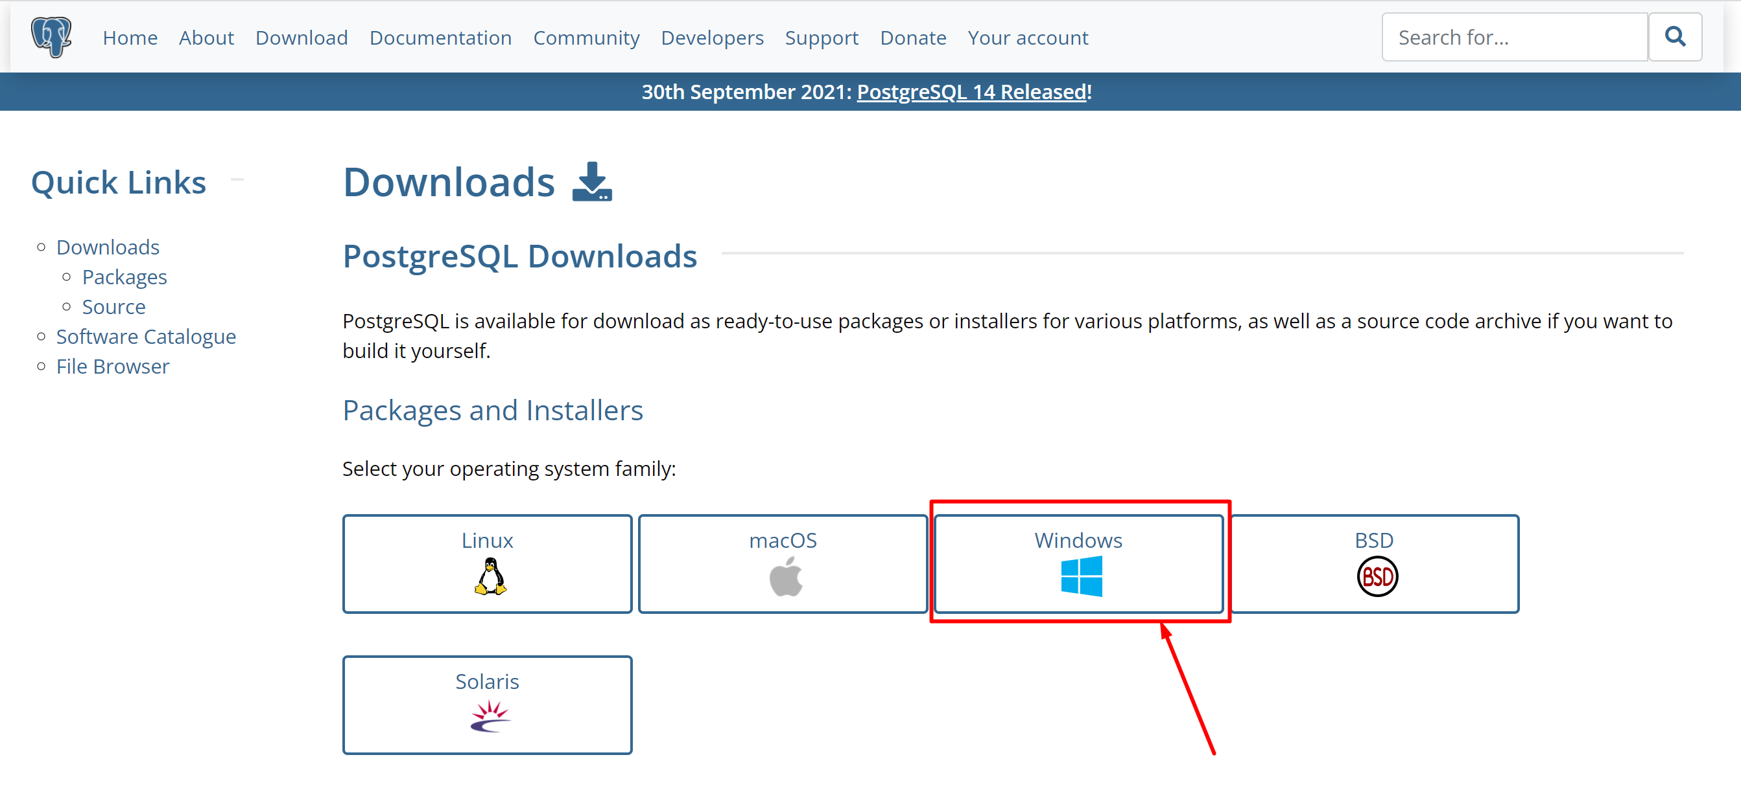

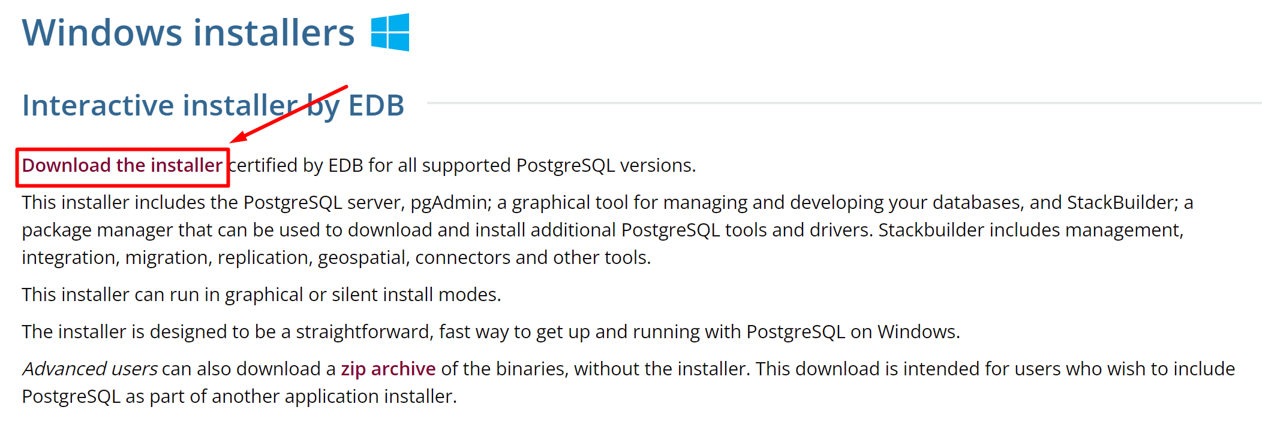

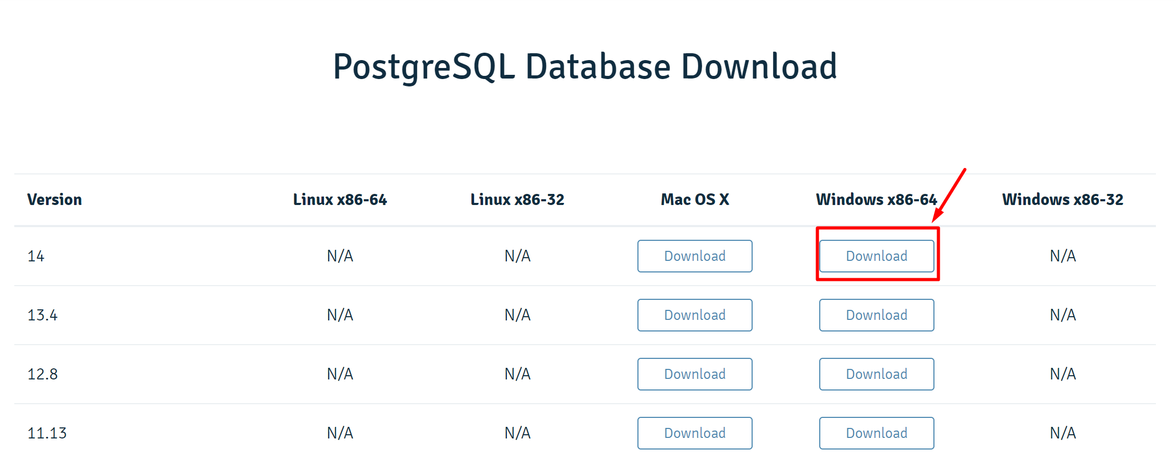

Install PostgreSQL.

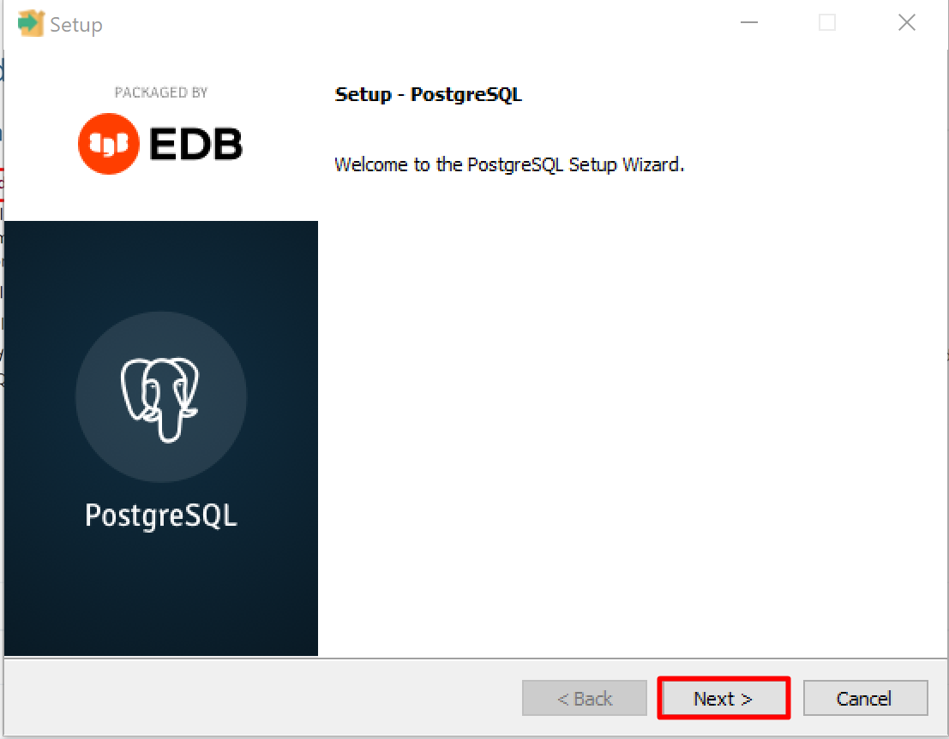

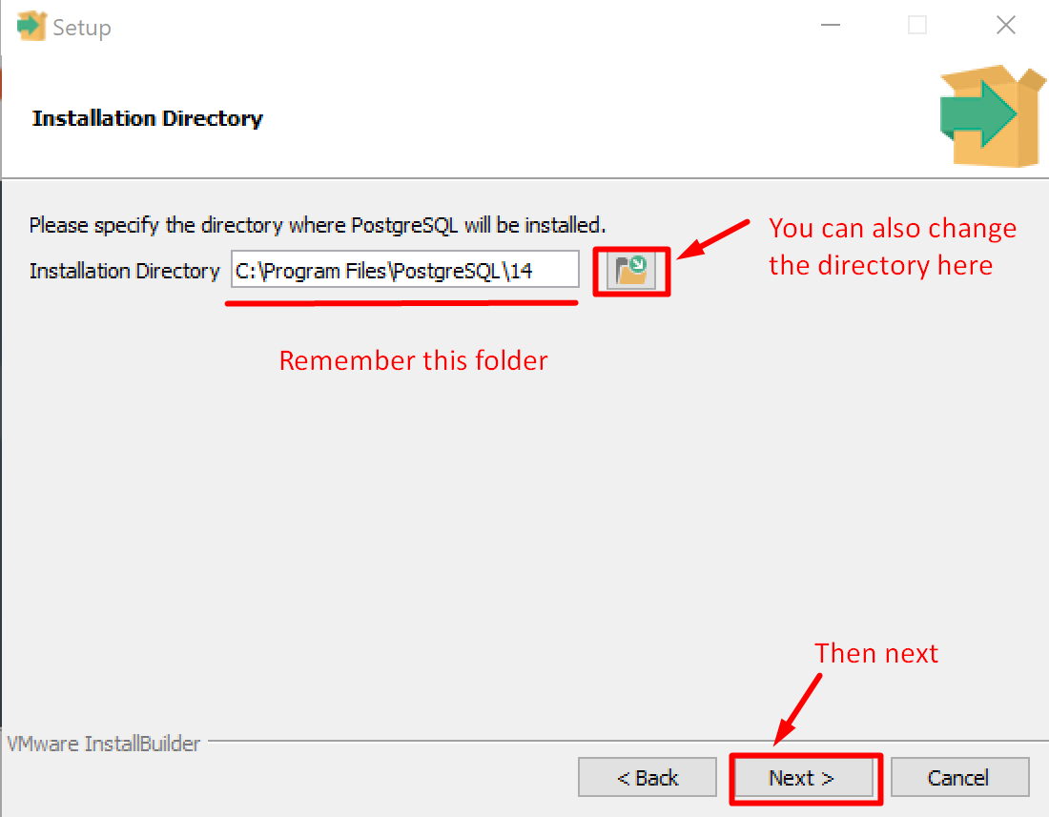

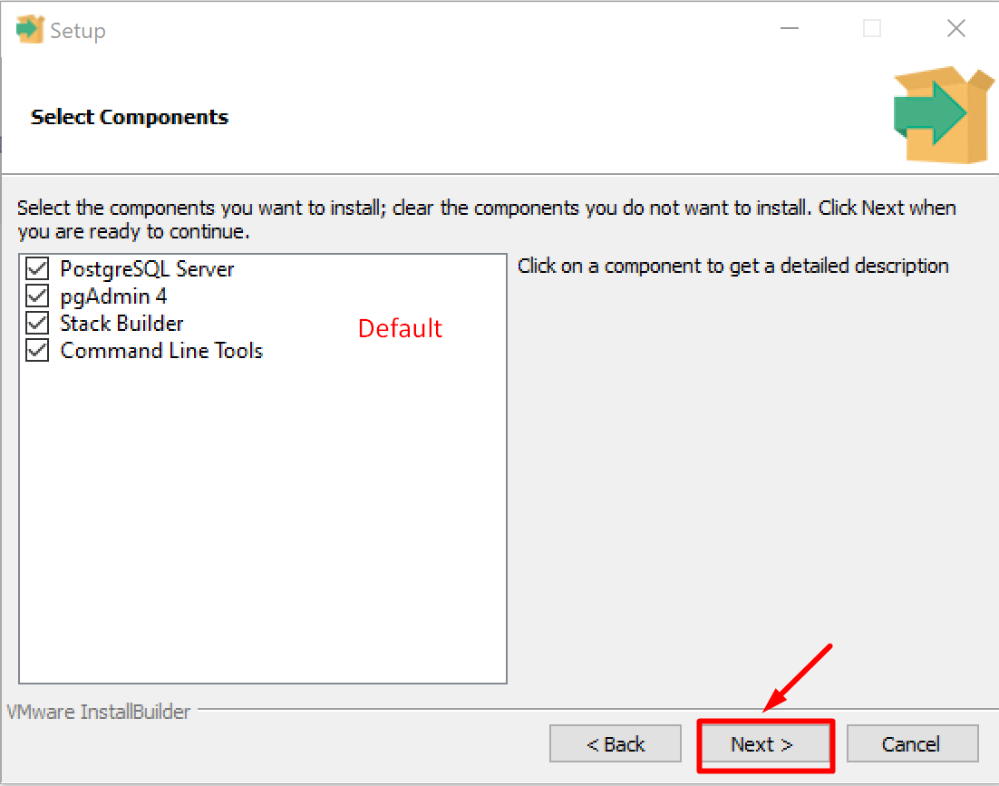

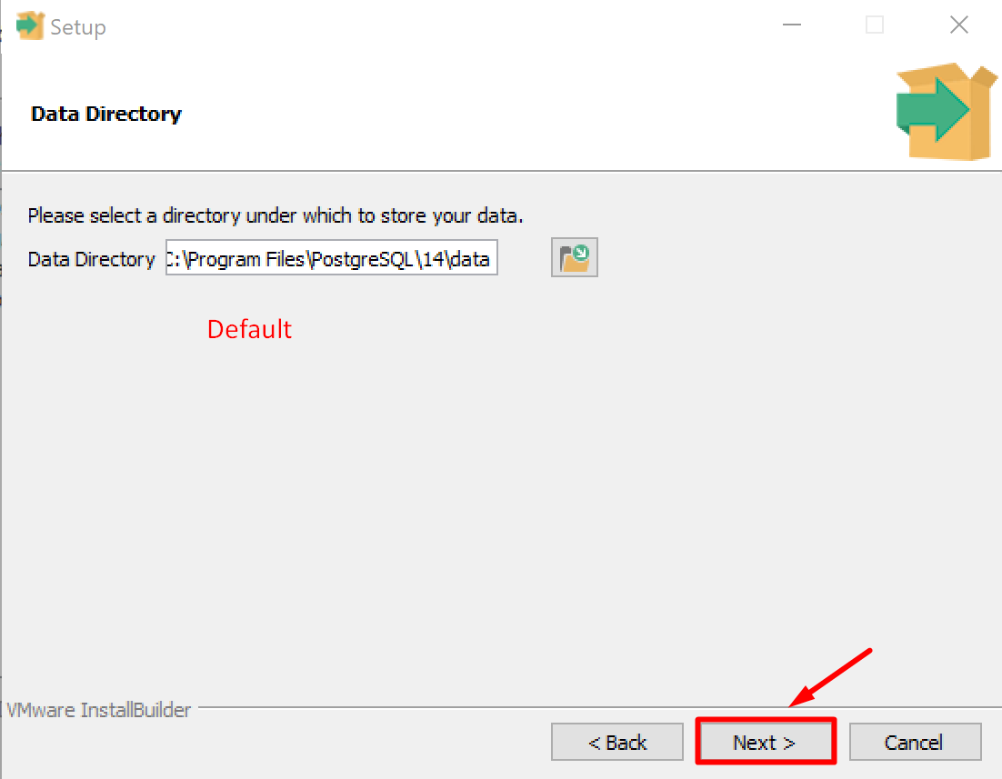

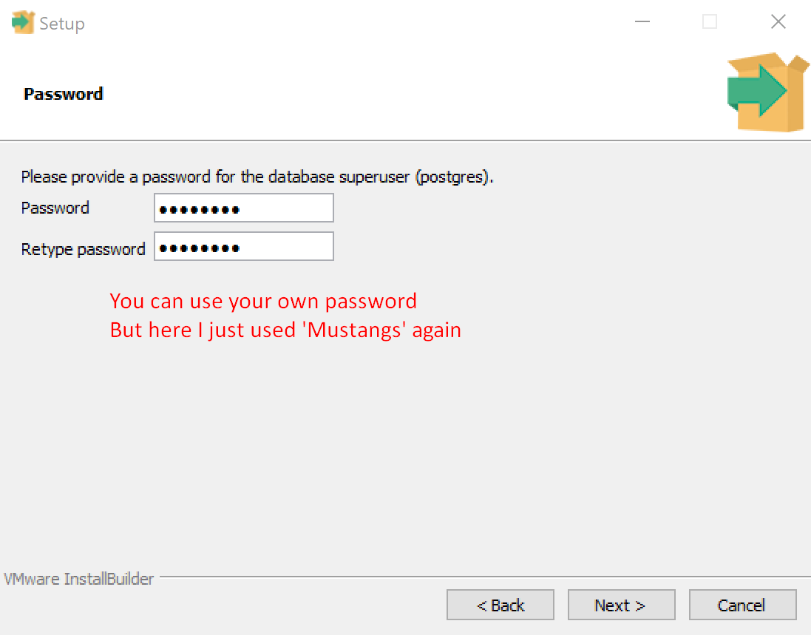

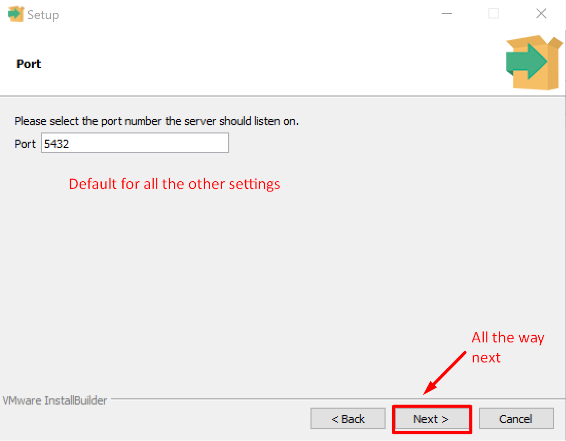

# Step 2 Download JDK 8

Java Development Kit (JDK) is a software development environment used for developing Java applications and applets. You need JDK to run Java applications. Since we are going to use Java DataBase Connectivity (JDBC) as the middleware to connect to databases, we need to install JDK beforehand. The latest version of Java is JDK 17 released on September 14th, 2021. But JDK 8 is good enough for our project.

Download JDK 8

<https://www.oracle.com/java/technologies/downloads/#java8>

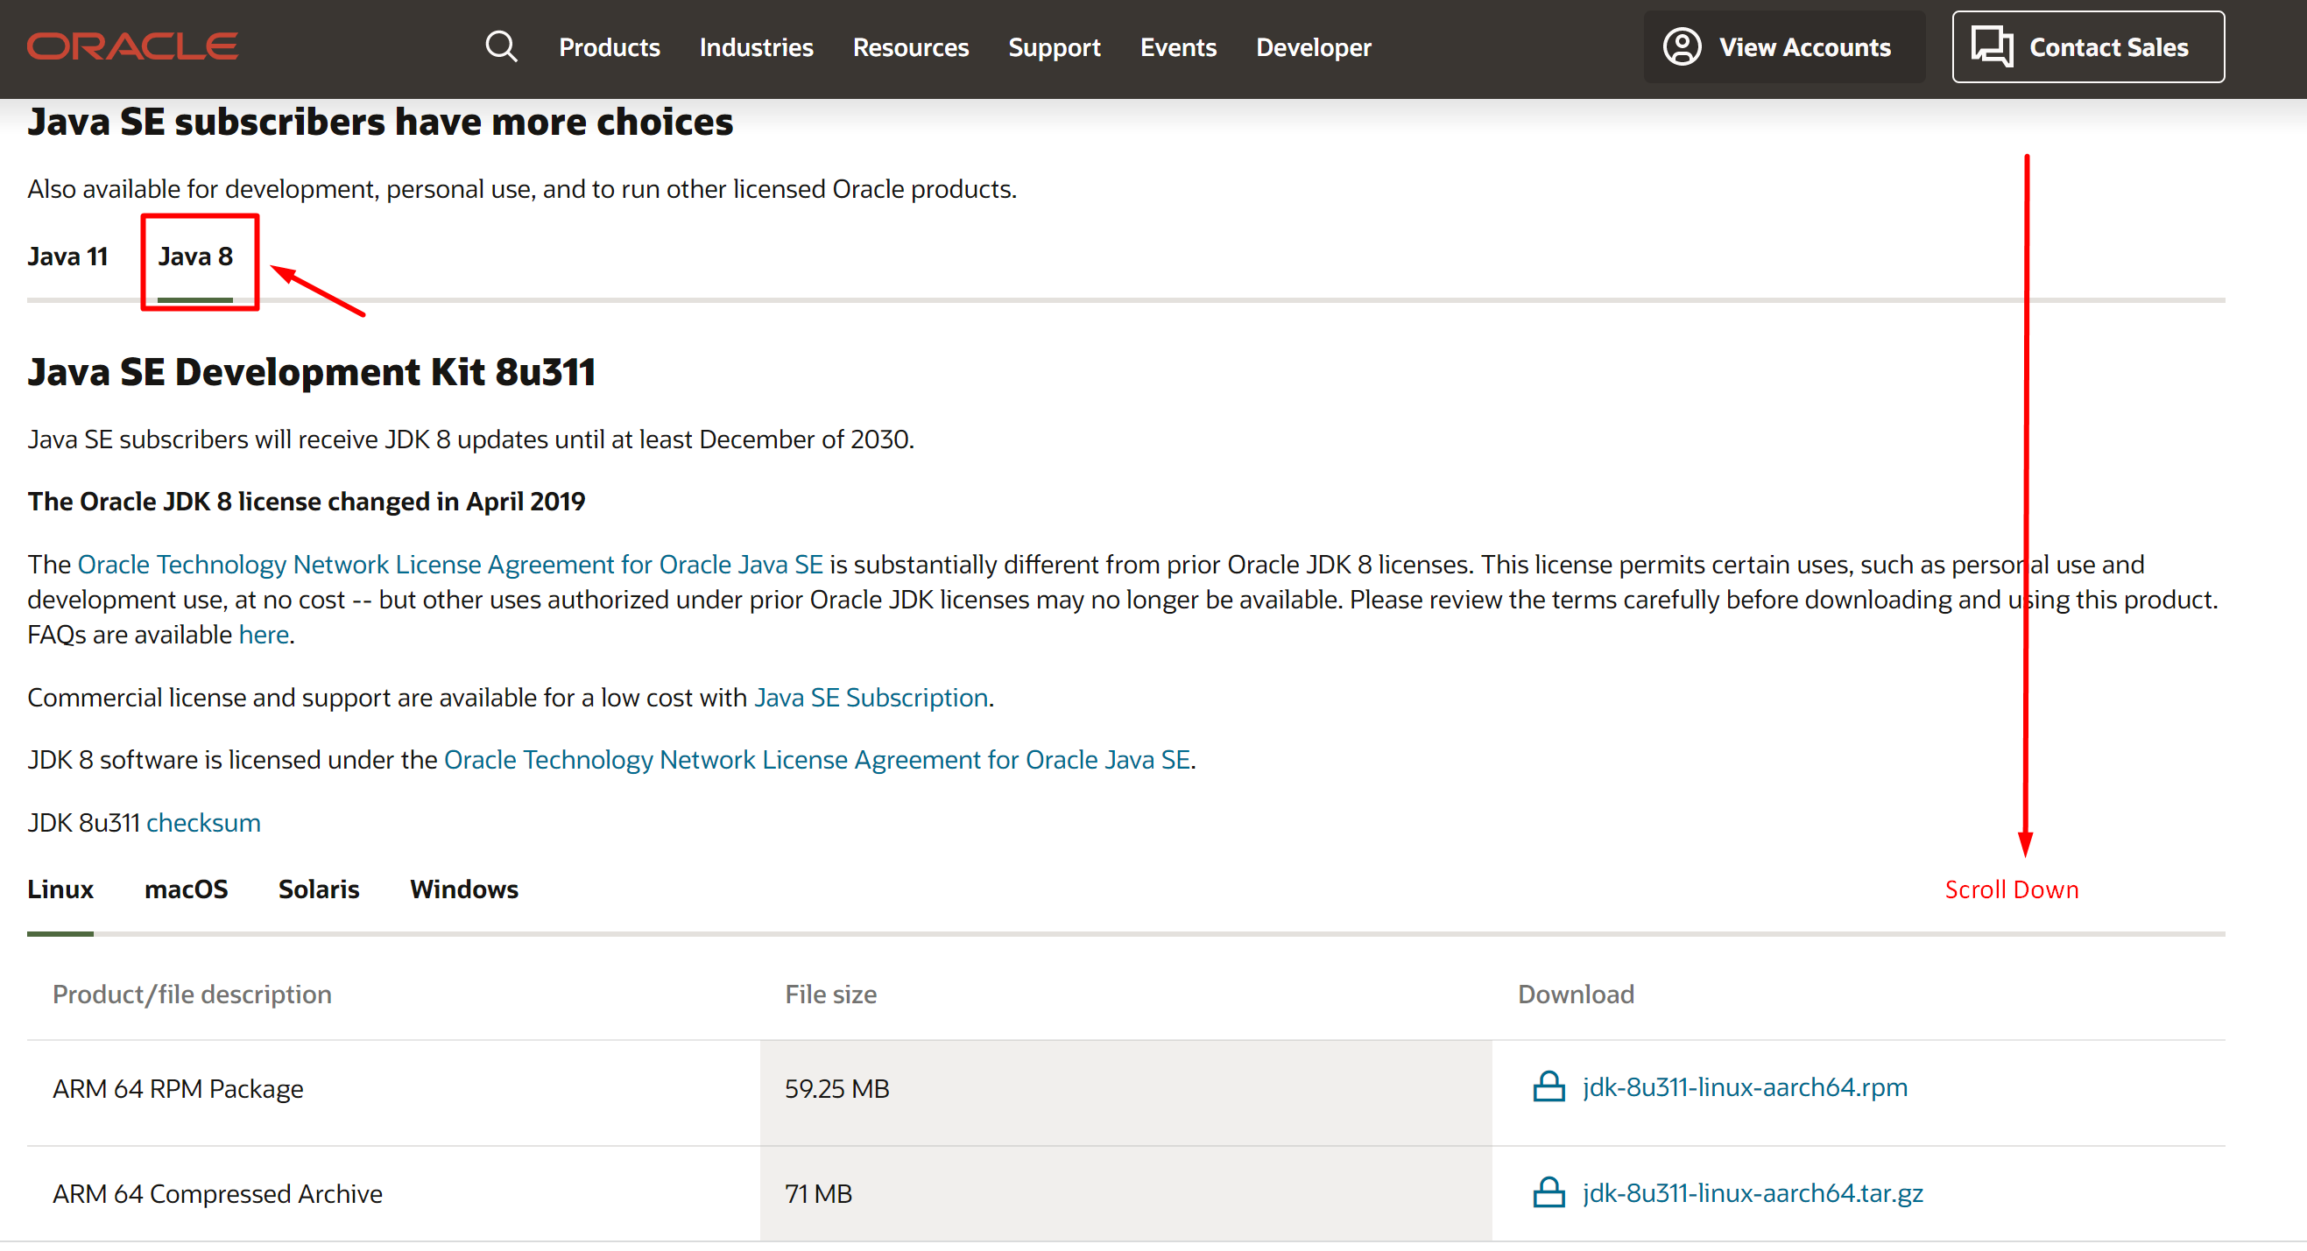

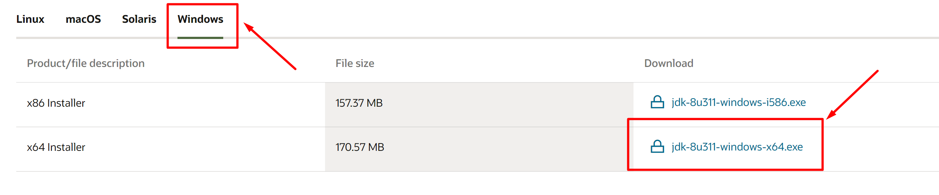

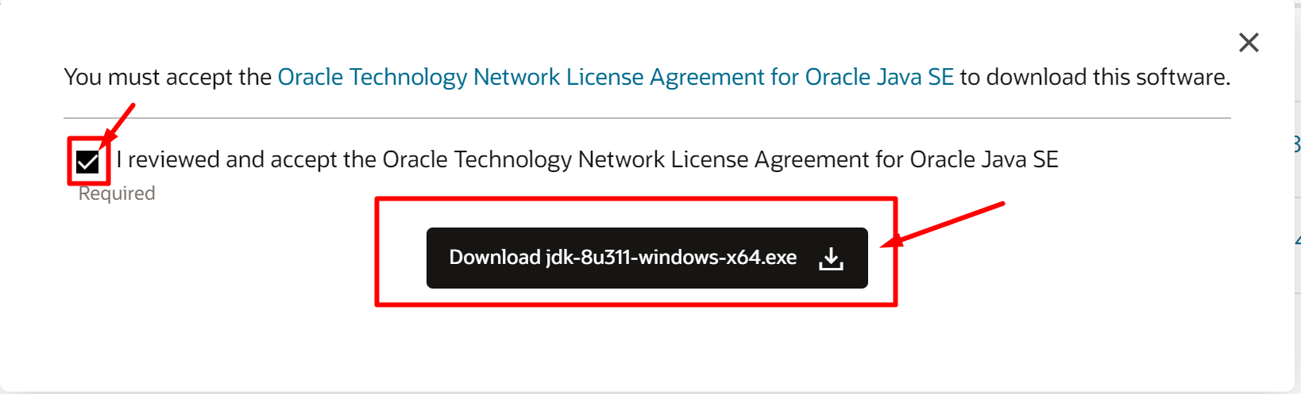

Create a free Oracle account and then start the download.

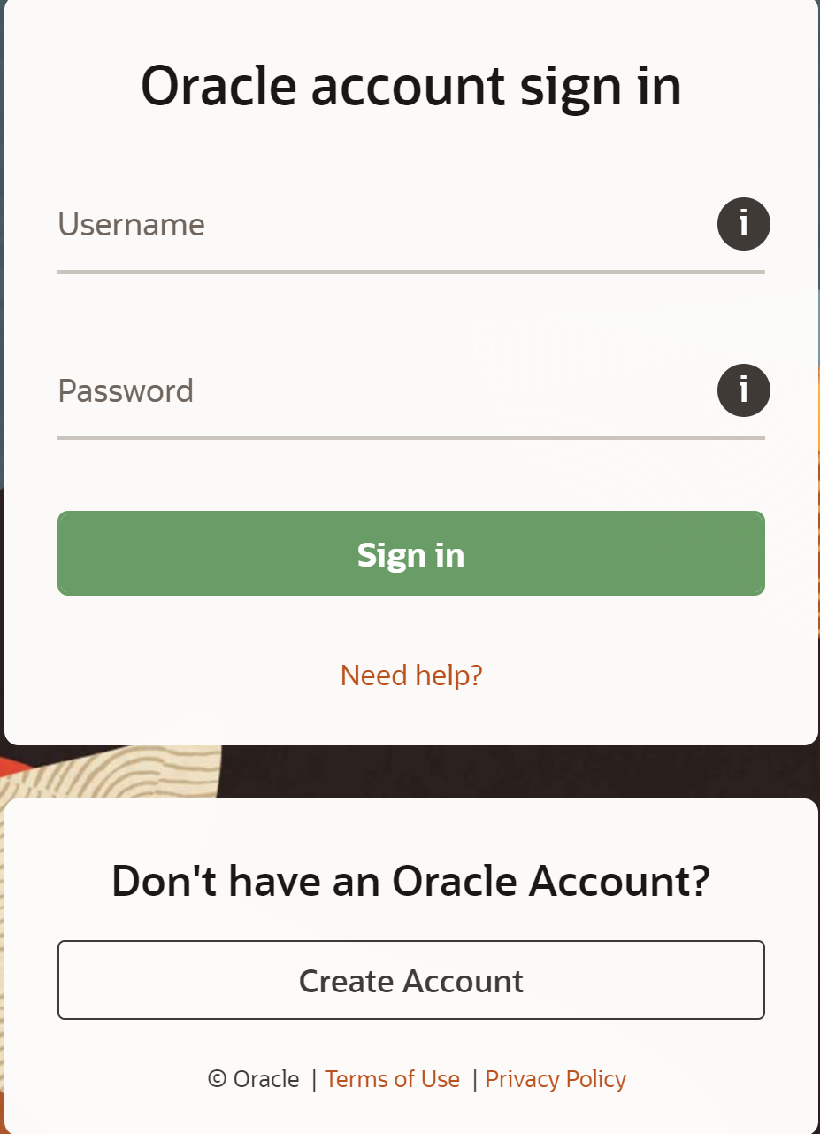

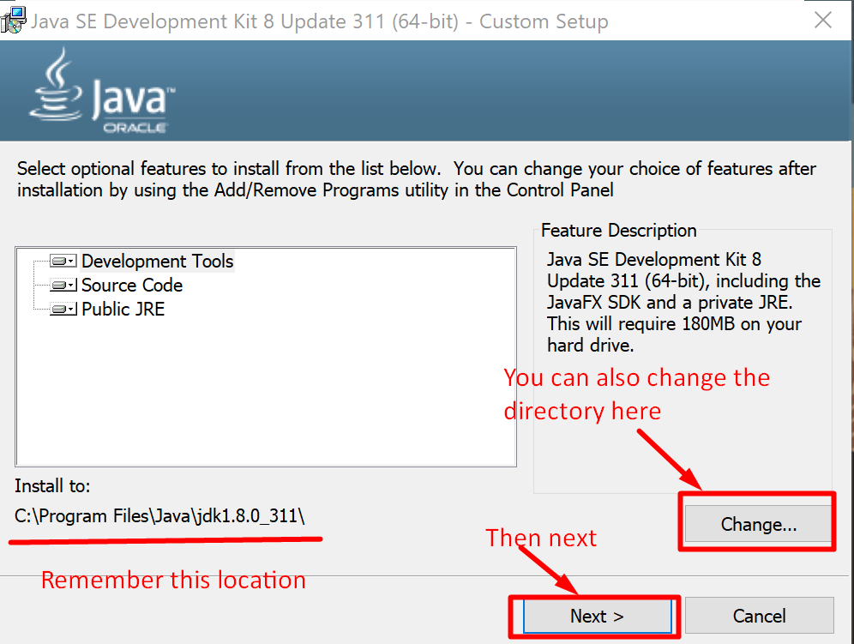

After installation, you need to add the Java directory path to the system environment variables.

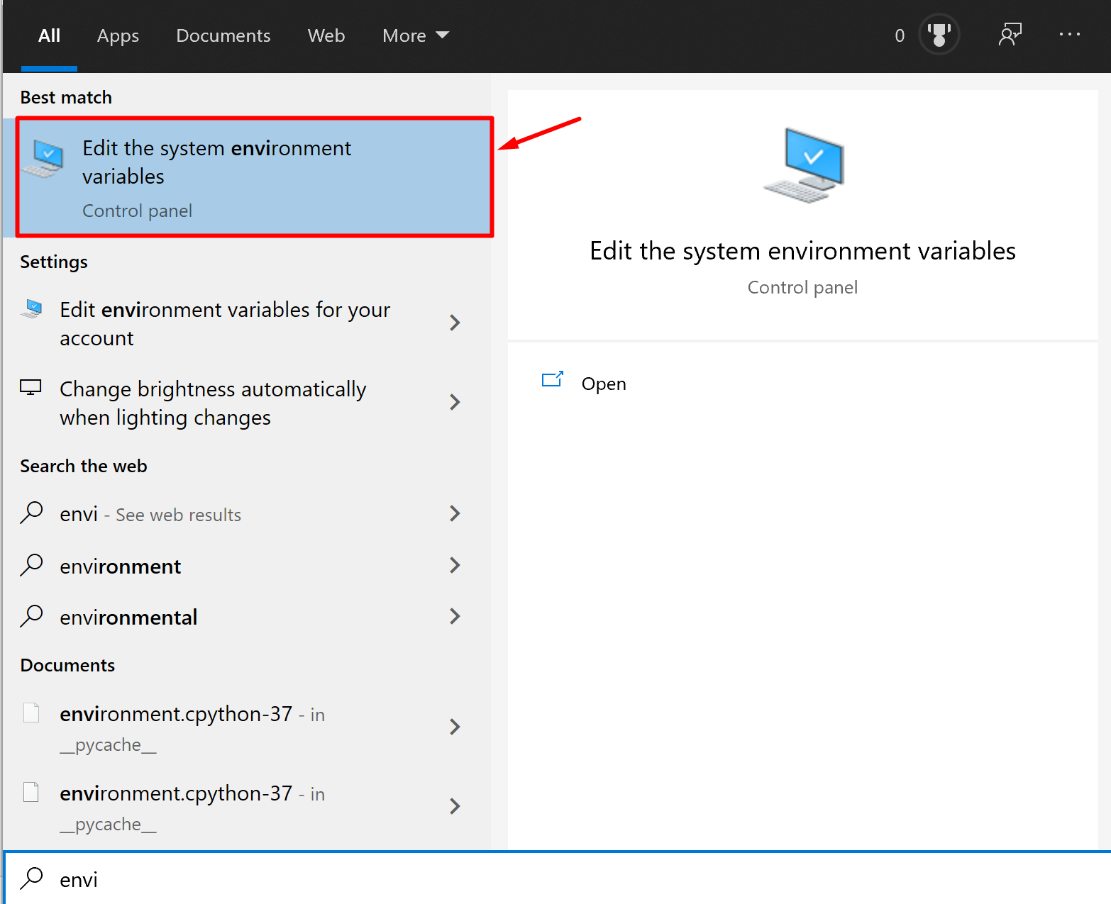

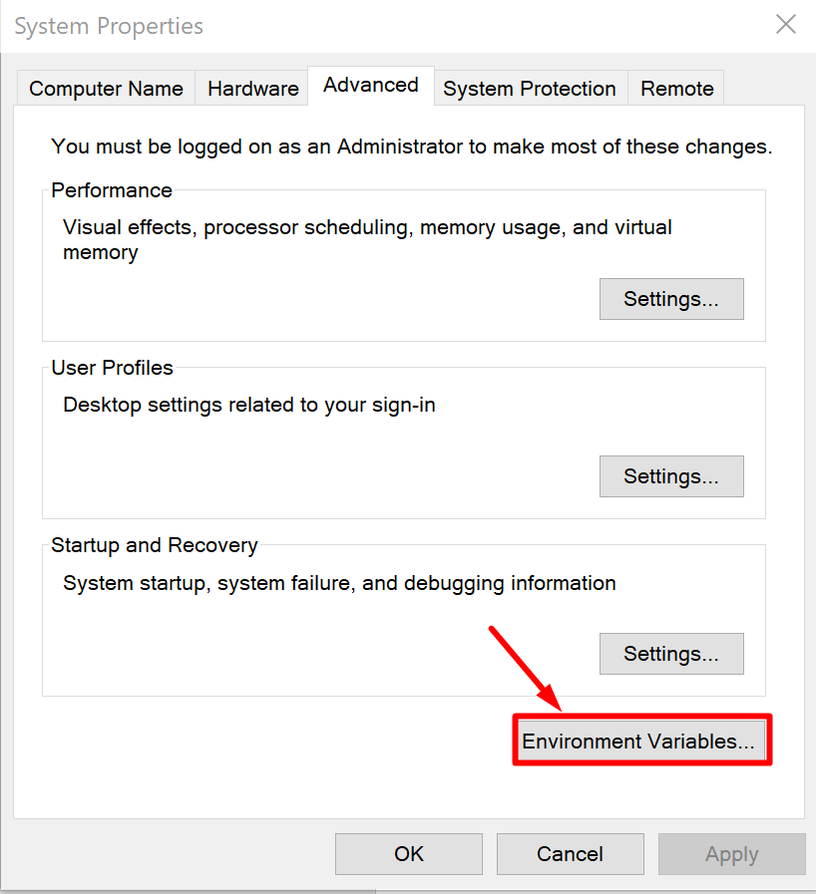

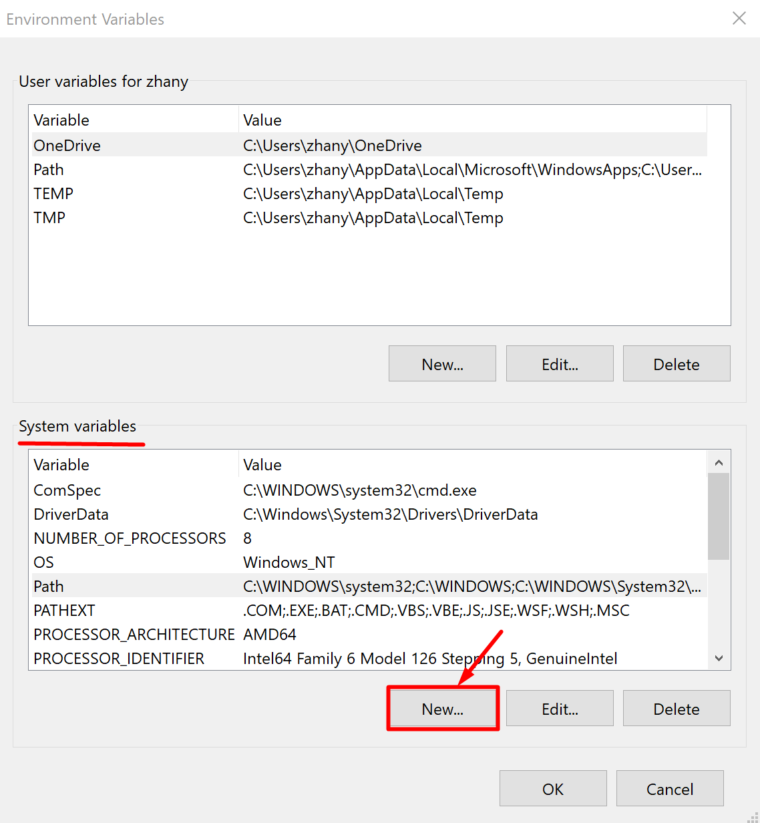

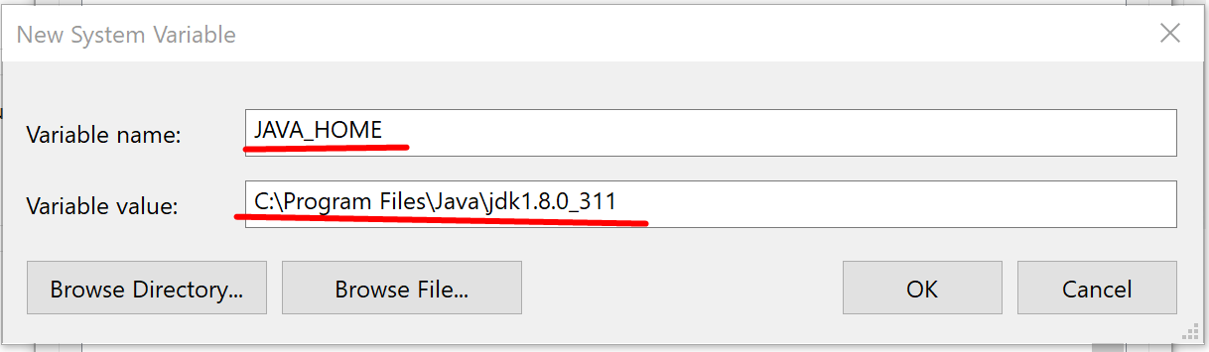

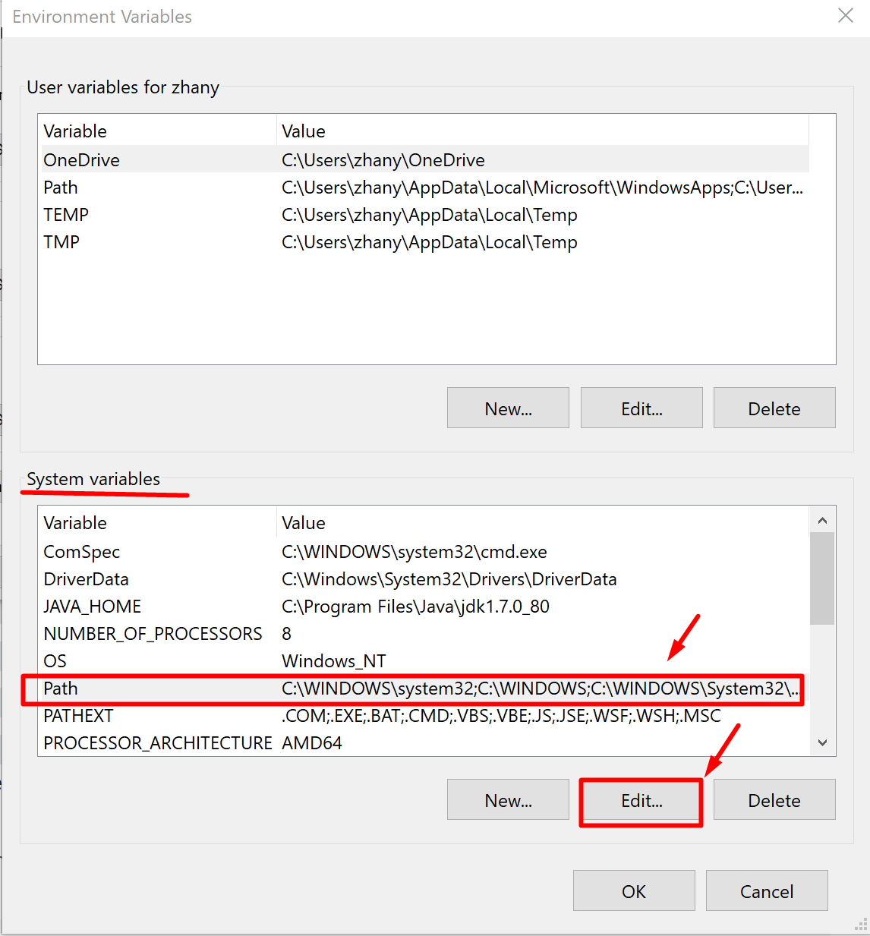

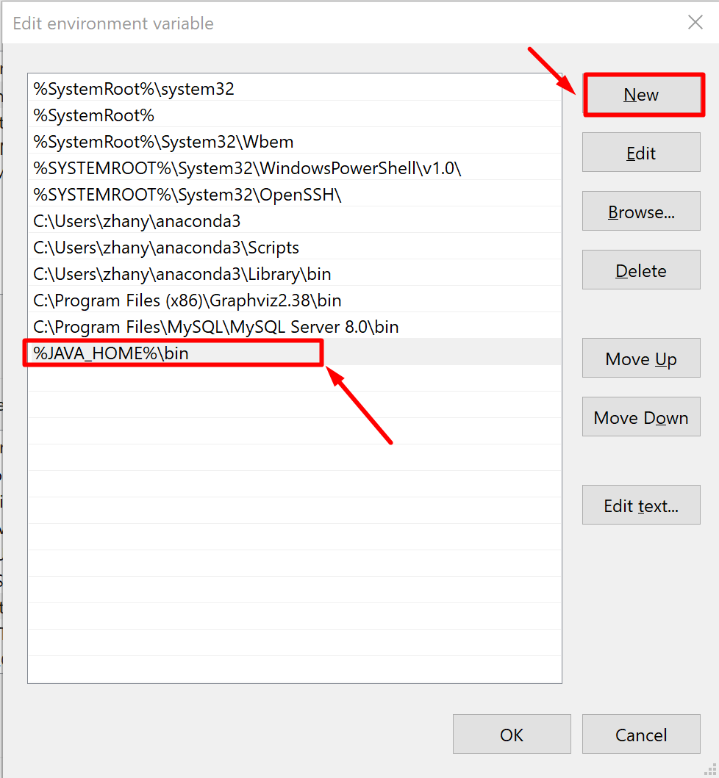

# Step 3: Install PostgreSQL and MySQL JDBC drivers

PostgreSQL

Download from

<https://jdbc.postgresql.org/download.html>

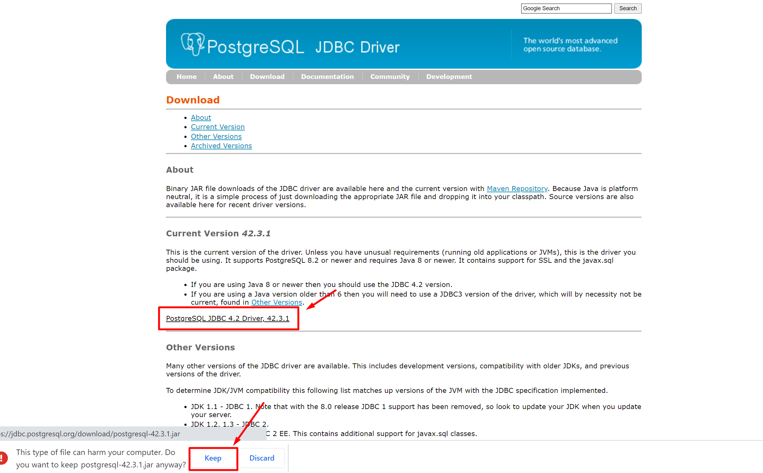

After download, you will find a JAR file. Right now just leave it there.

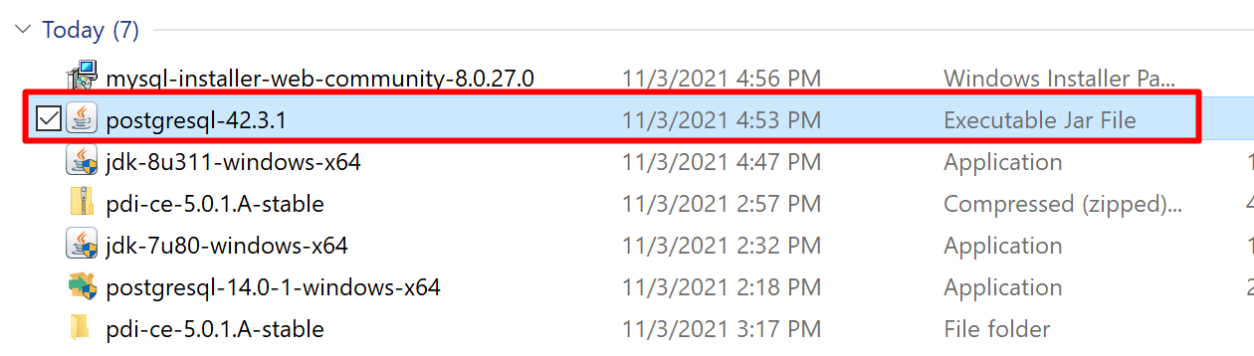

MySQL

Download JDBC from

<https://dev.mysql.com/downloads/connector/j/>

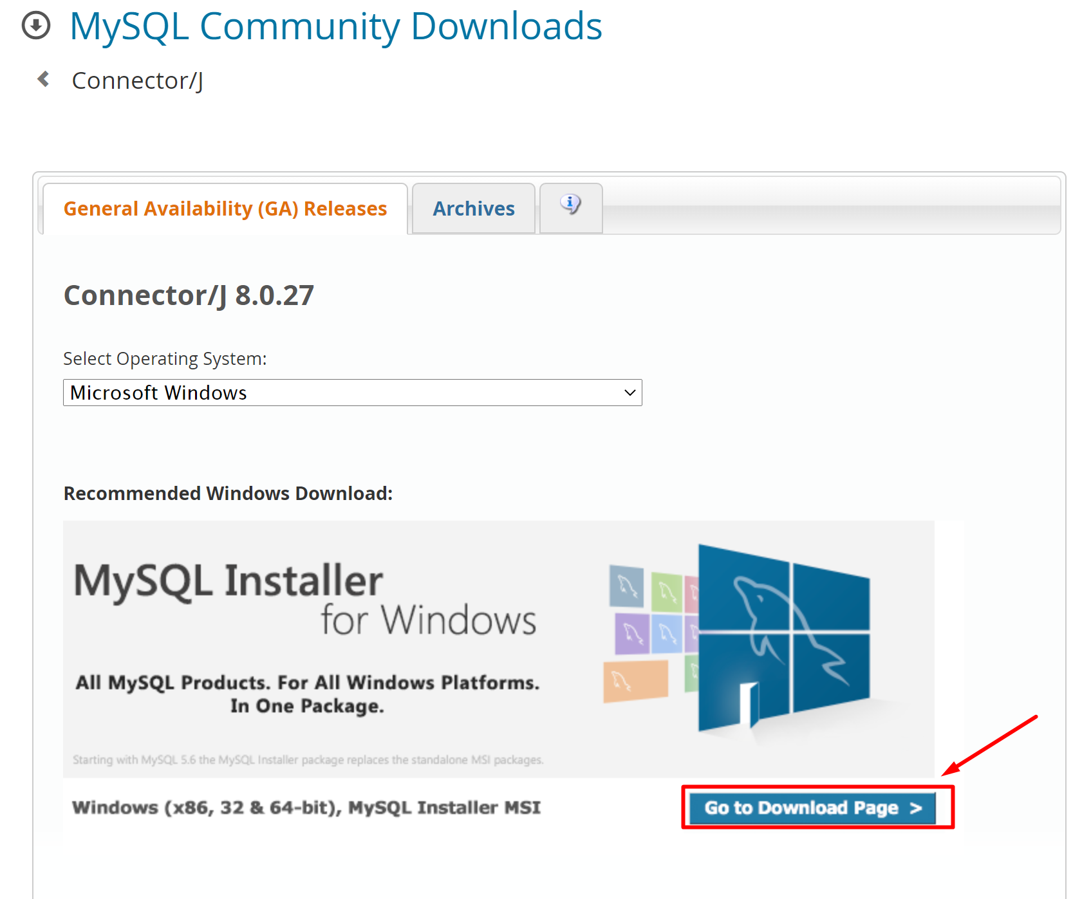

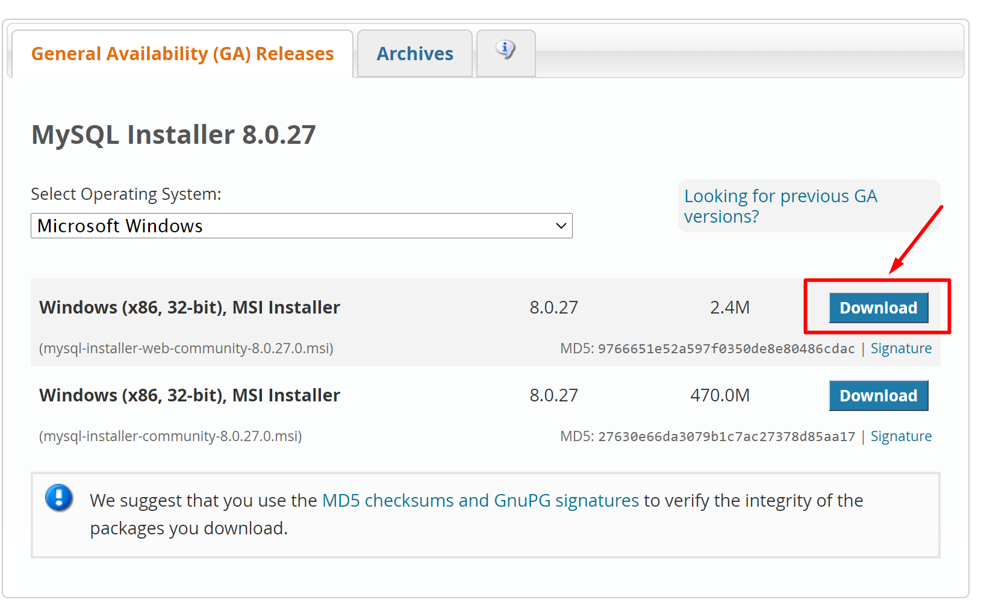

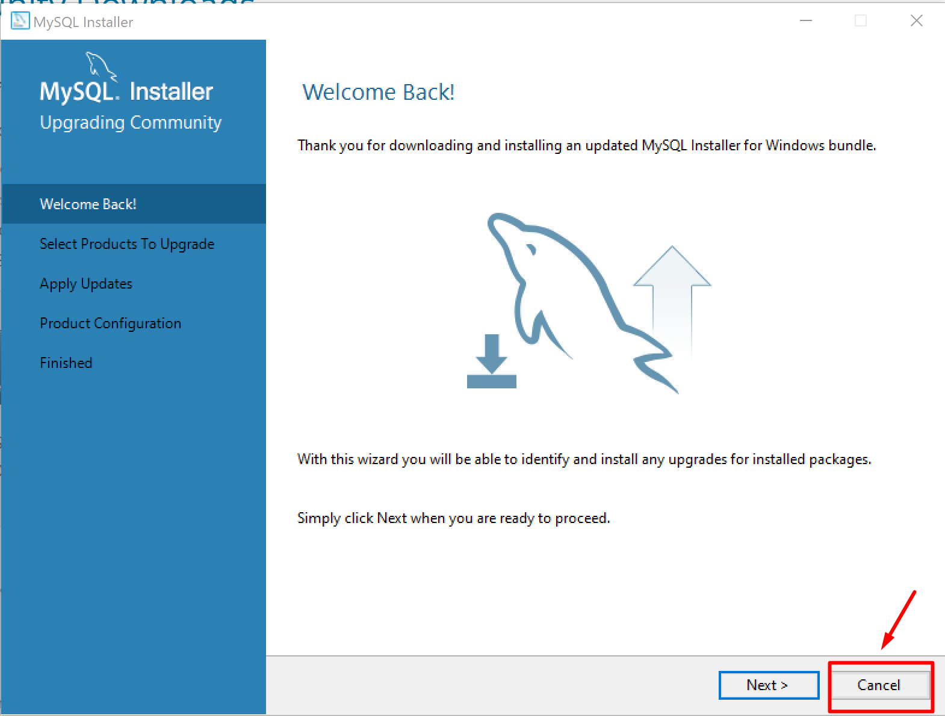

This is the same installer you used to install MySQL Server and MySQL Workbench. If you click “Next,” you will update the two MySQL products you already installed on your computer. So we just “Cancel.” Then you will see the following installer page.

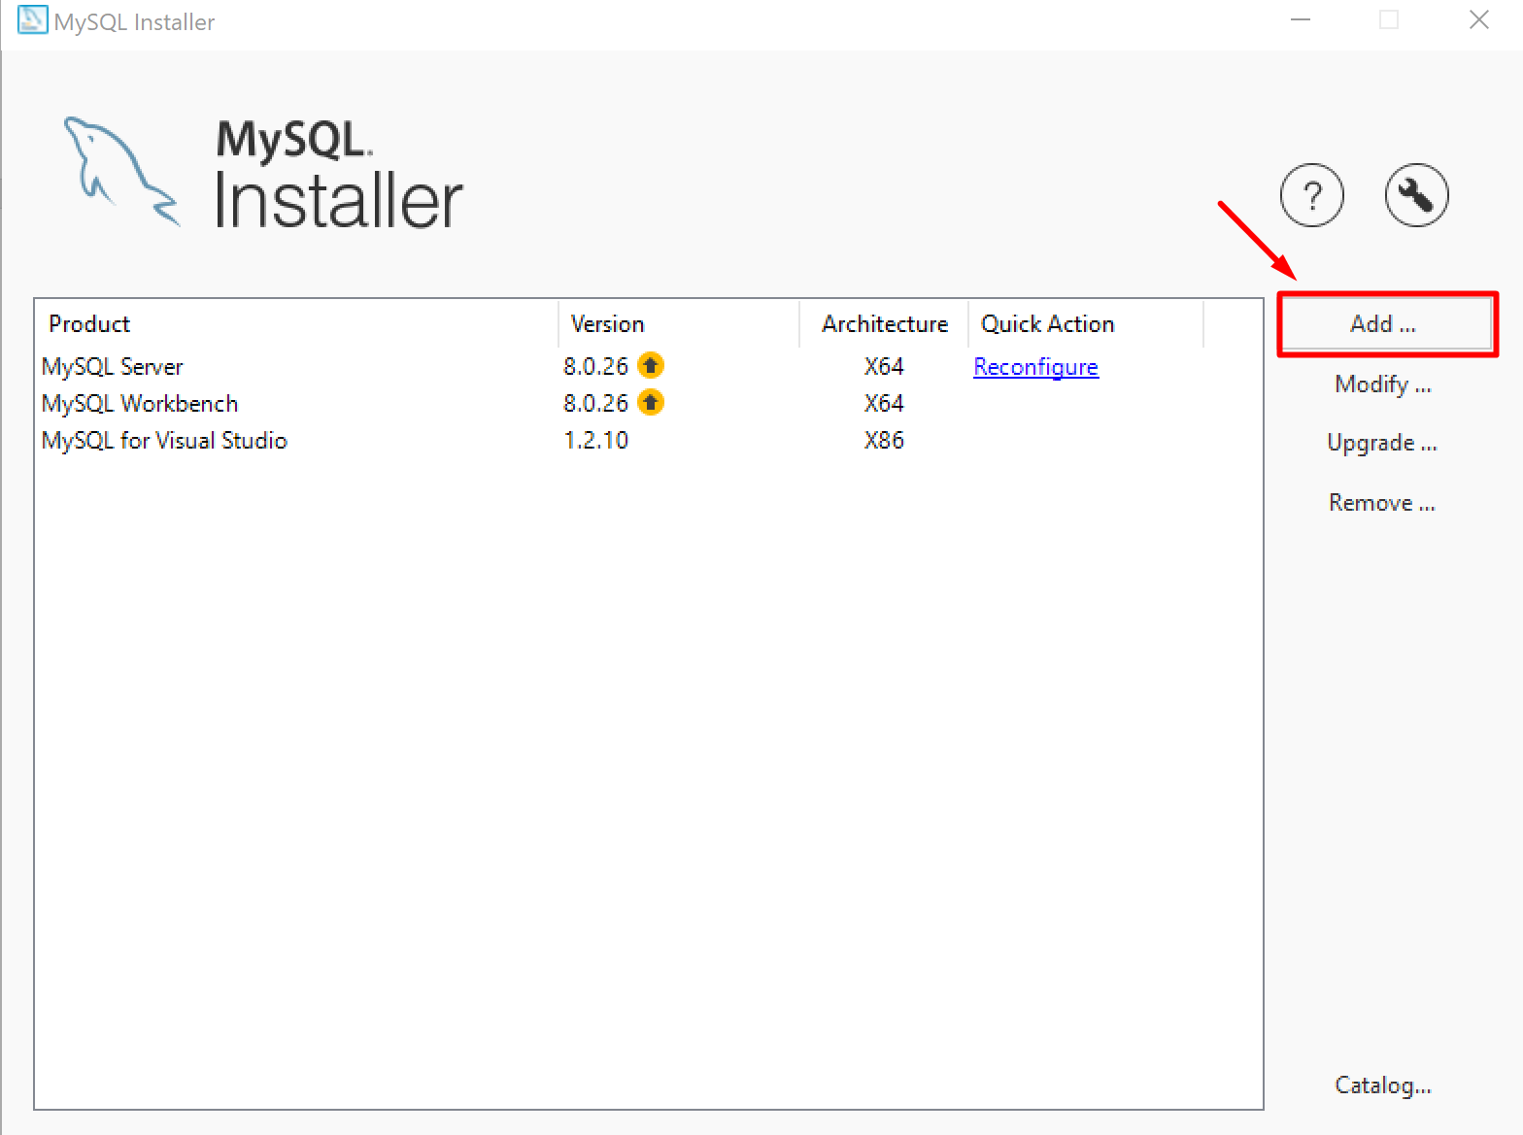

Now it is time to add the JDBC.

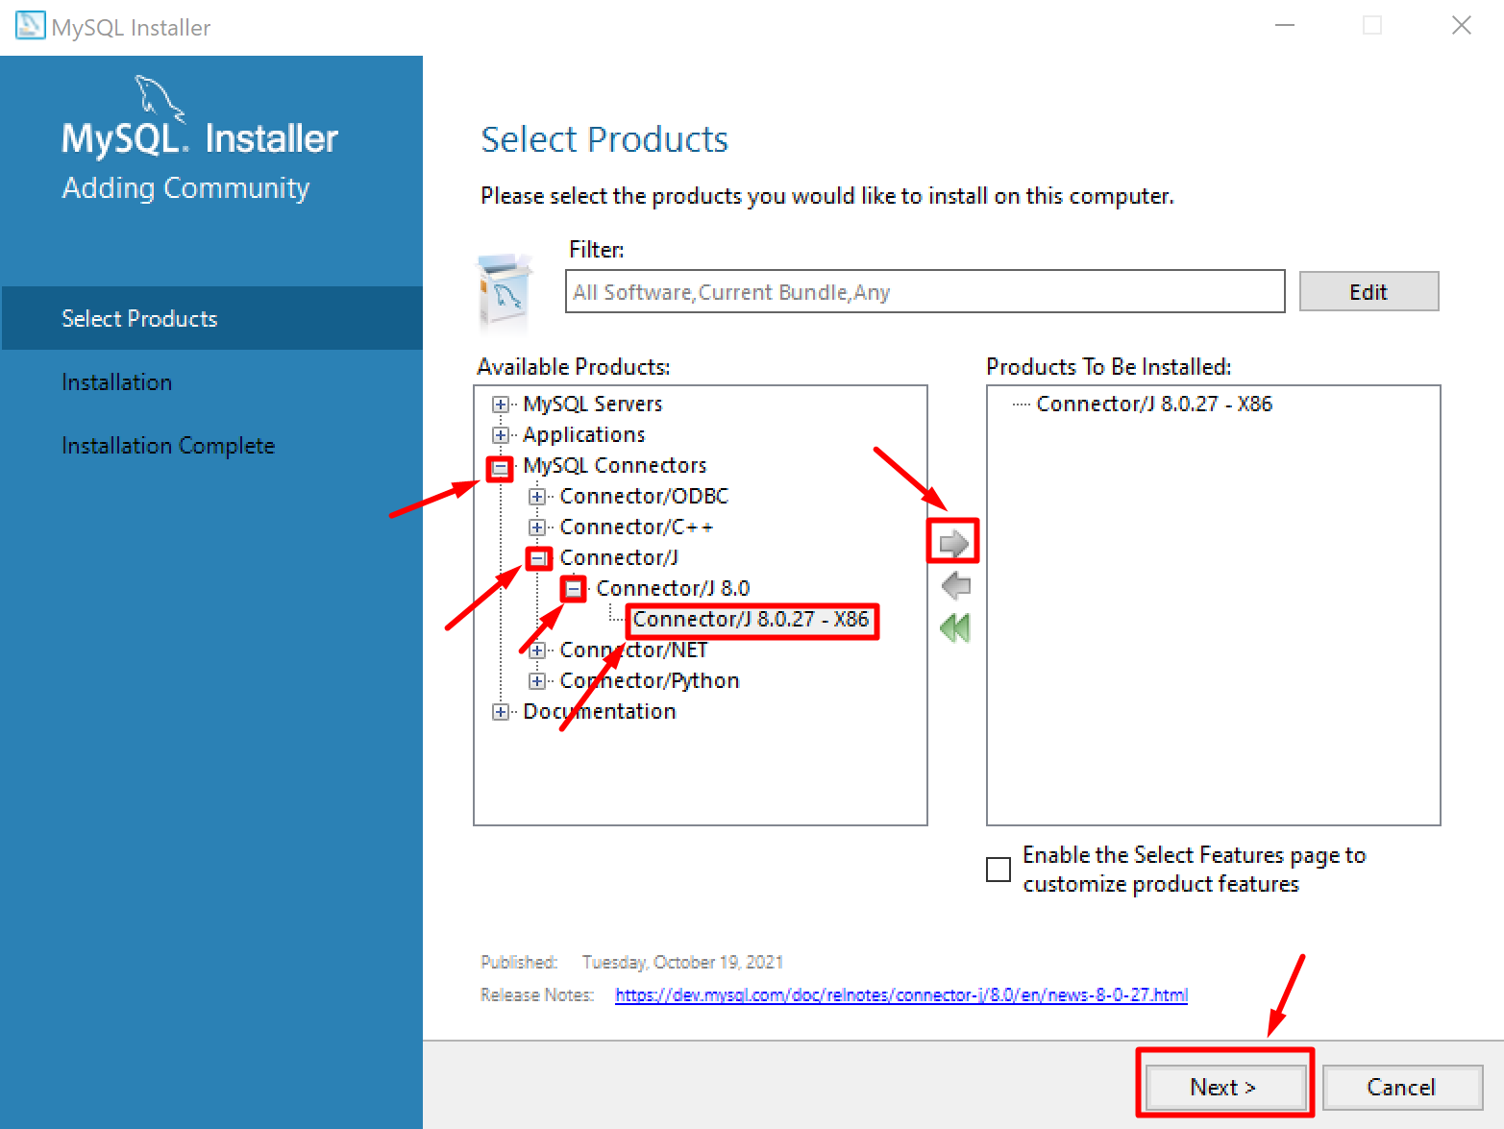

After installation, you can find the JDBC in the following MySQL folder.

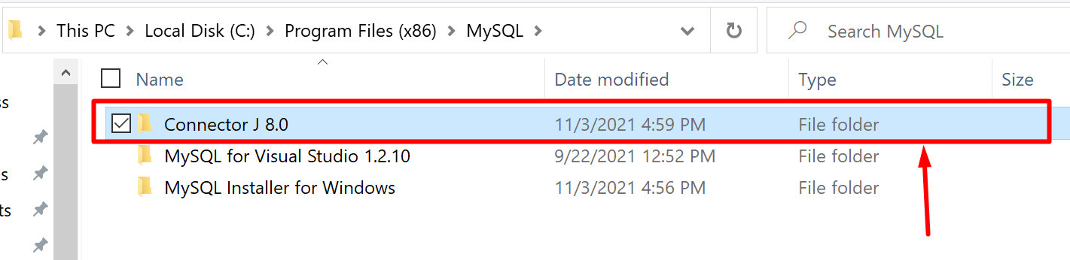

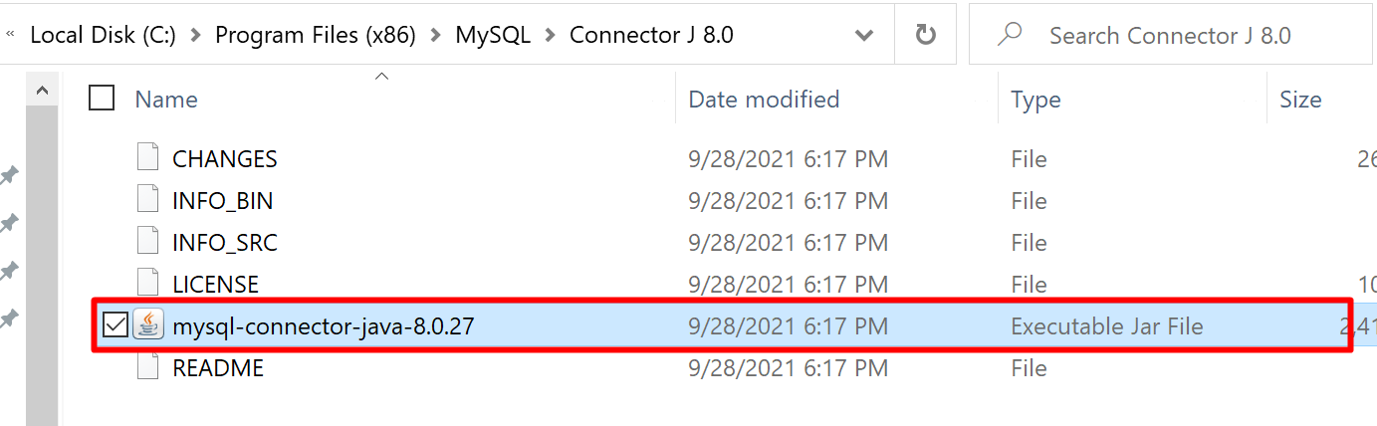

Again, right now just leave the file there. We are going to use them soon.

# Step 4: Install Pentaho.

Download Pentaho from

<https://sourceforge.net/projects/pentaho/>

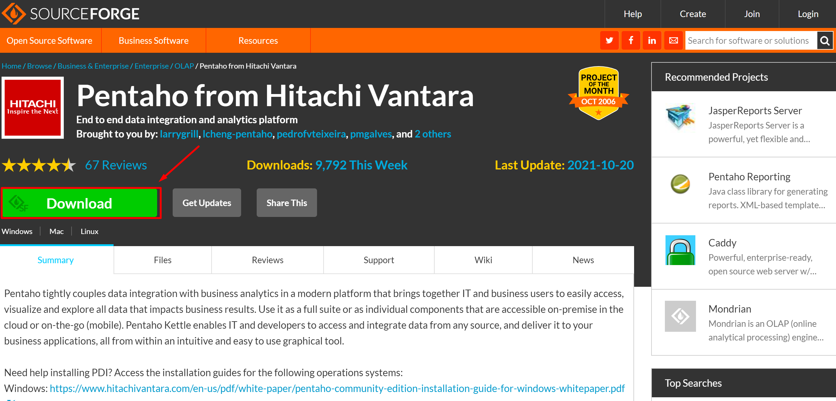

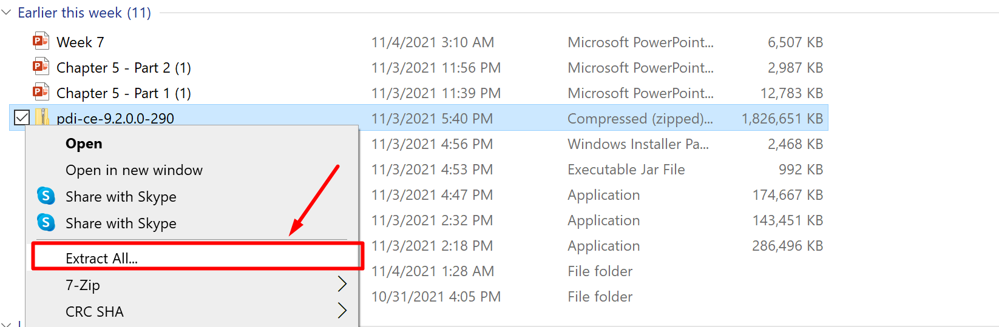

You downloaded a zipped file so remember to extract all files from it. Once it is done, you can launch the program by running this “Spoon” program. Spoon is a nickname of the Pentaho Data Integration as you use a spoon to mix your recipe, and spoon is the tool to make your ETL

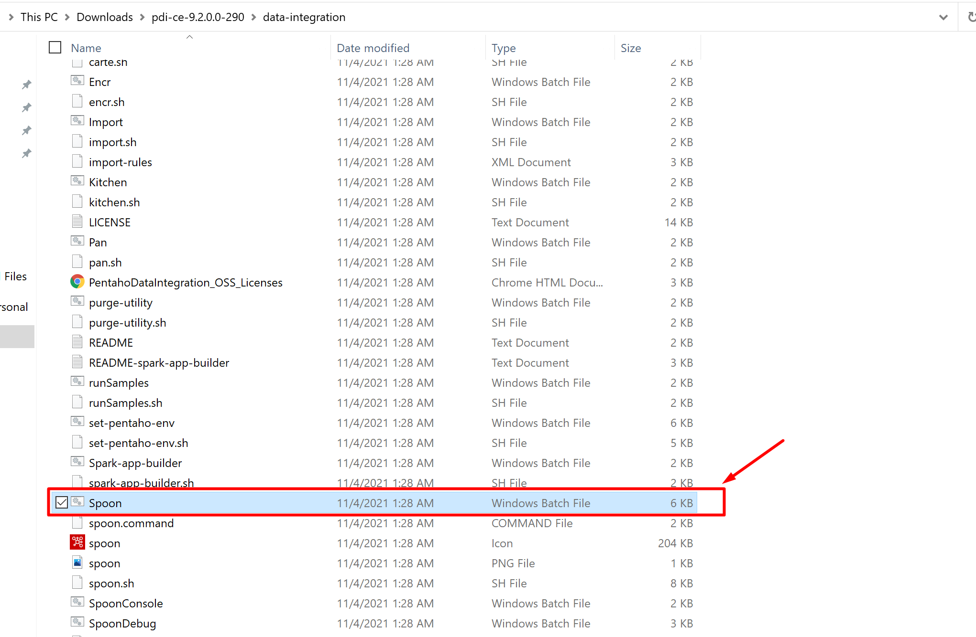

# Step 5: Load JDBC files.

Now it is time to load your JDBC files to Pentaho. Remember you have two JDBC drivers? One for MySQL and one for PostgreSQL. Copy and paste these two files to the following Pentaho folder.

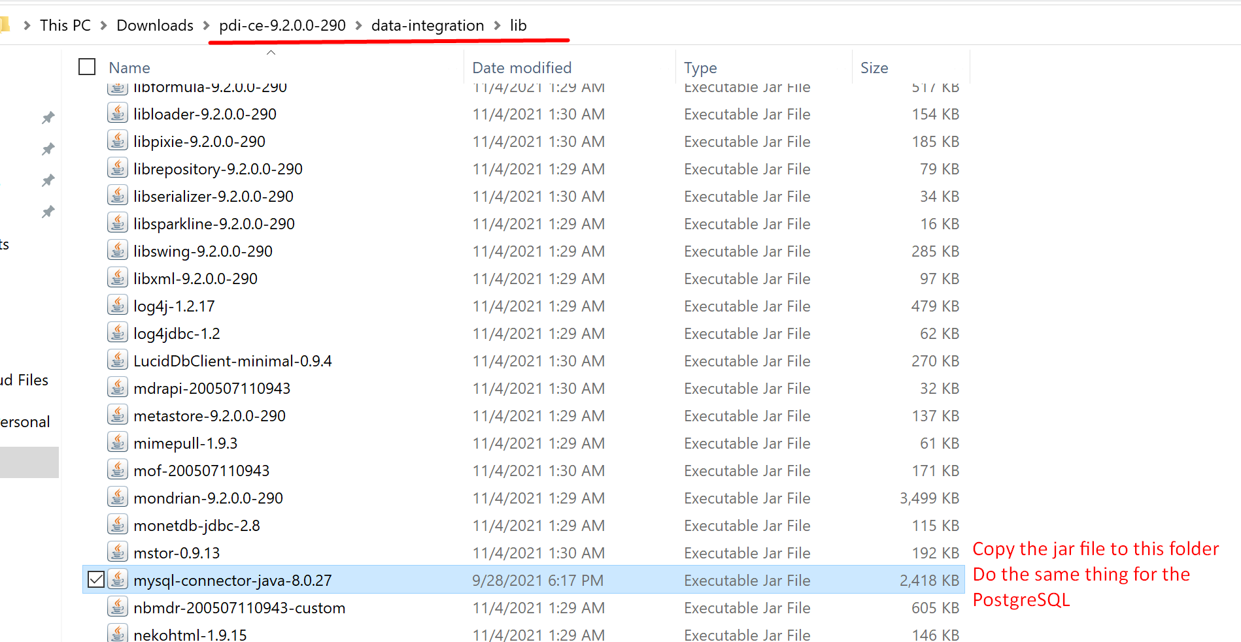

# Step 6: Load a MySQL database.

This time we use another database, Sakila. The Sakila database is a nicely normalized schema modelling a DVD rental store. Download this database from

<http://downloads.mysql.com/docs/sakila-db.tar.gz>

Remember to extract the files from the zipped file and you will see the following 3 files.

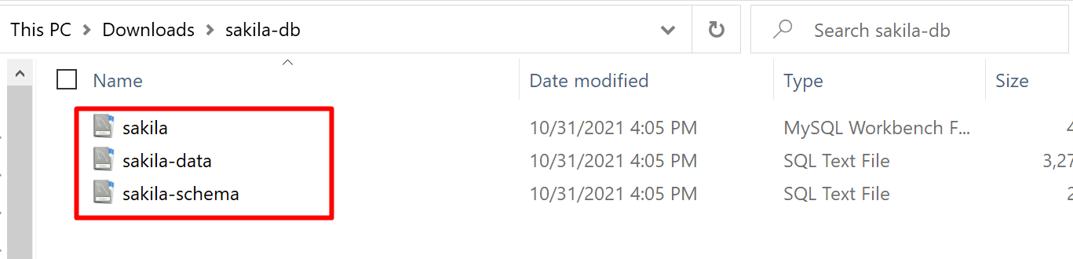

Run the two SQL files and you can get the tables and all the data records.

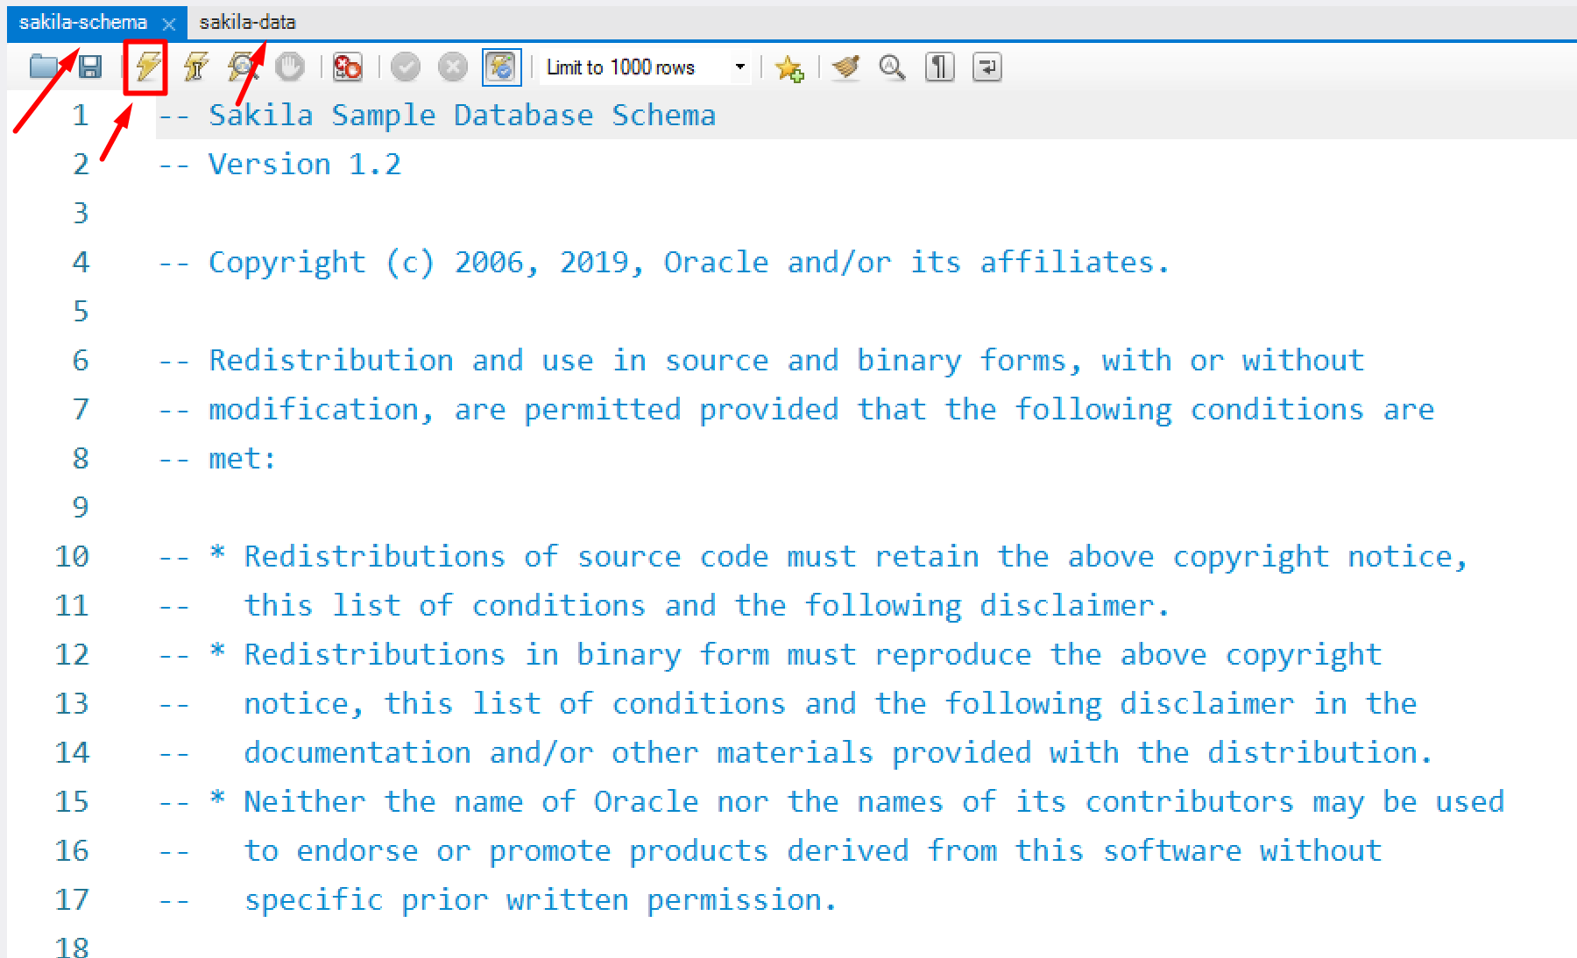

You can double-check by running the following SQL command and see whether you have successfully loaded the database.

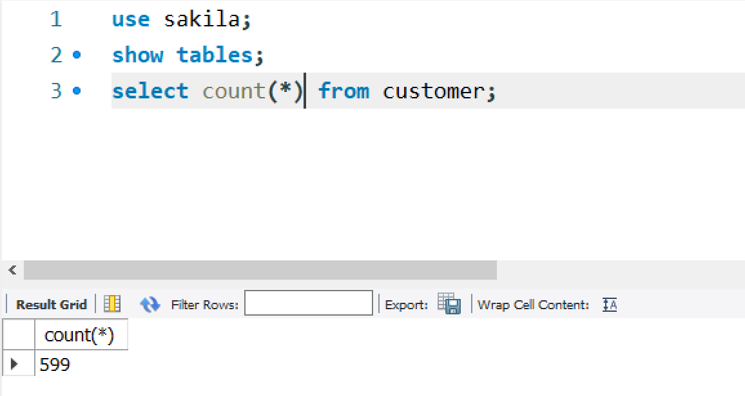

The following is the structure of this database. You can also obtain this diagram by “reverse engineering” this database in MySQL Workbench.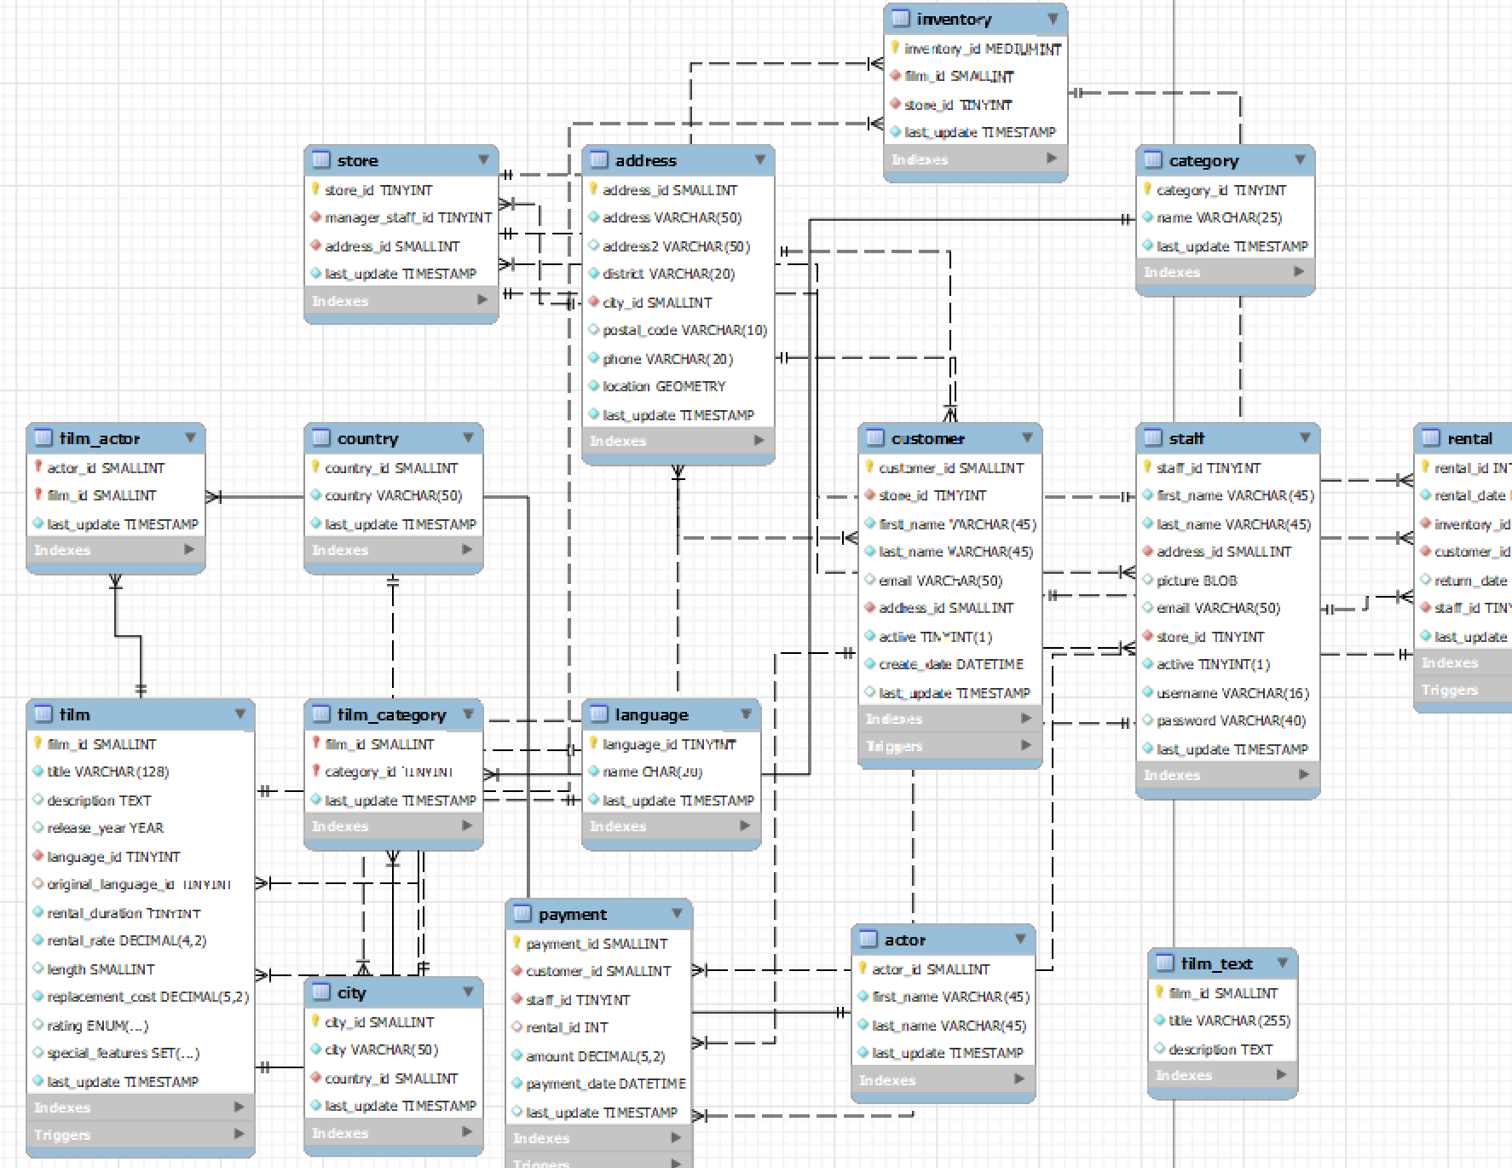

# Step 7. Create a table in PostgreSQL database.

Now our goal is to migrate data from MySQL Sakila schema to a new PostgreSQL schema. Let’s begin with the customer table. We will create an empty table first in PostgreSQL.

Go to the following folder and use the pgAdmin 4 tool to create a new table in PostgreSQL (you can consider pgAdmin 4 as the graphical user interface to use PostgreSQL, just like MySQL Workbench).

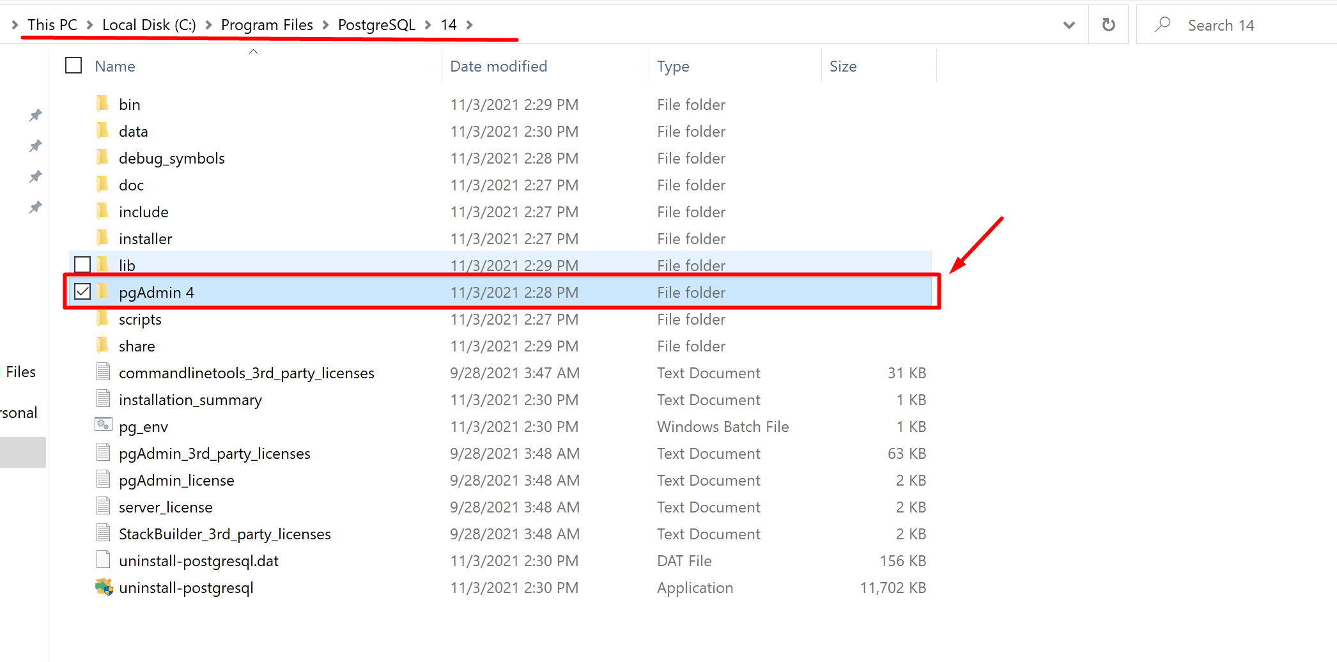

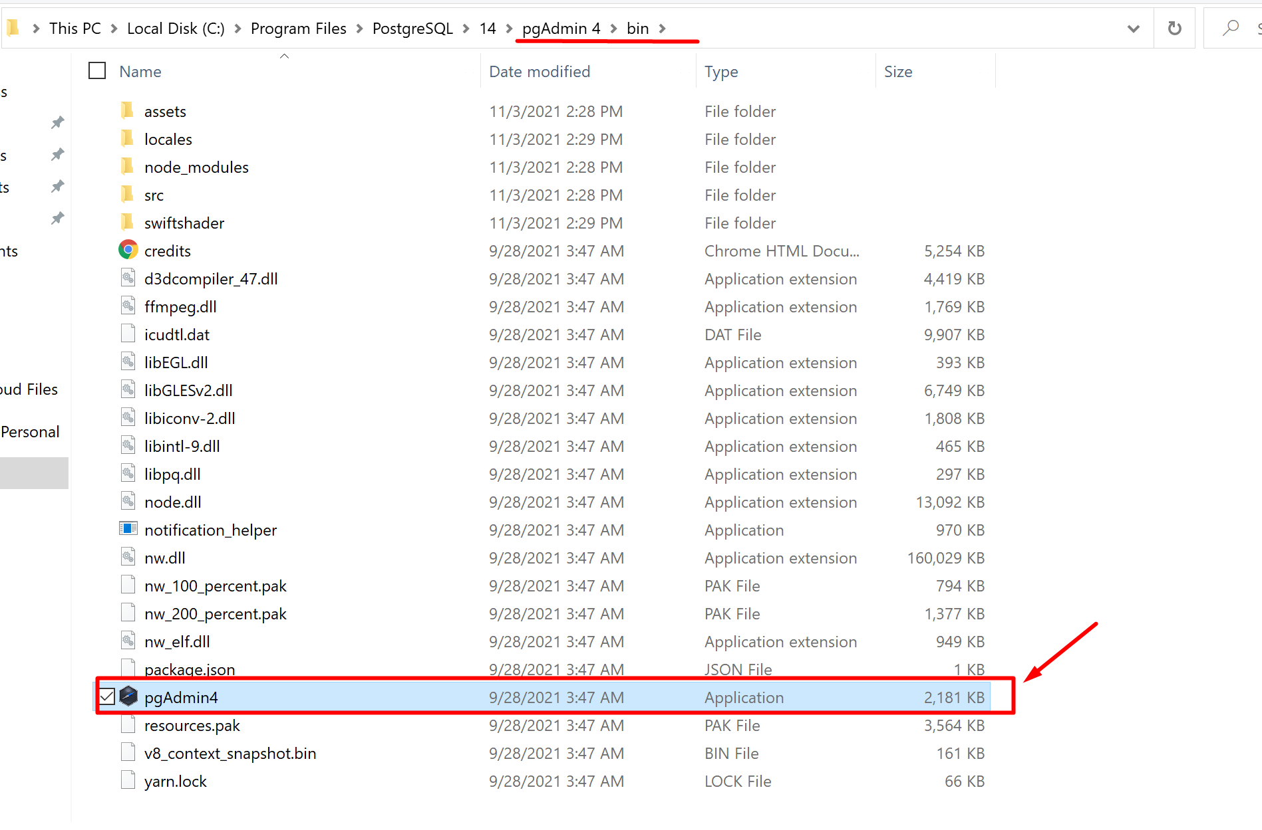

Create a new database and then create a new customer_tb table with 4 columns Customer_ID, Full_name, Active, and Email.

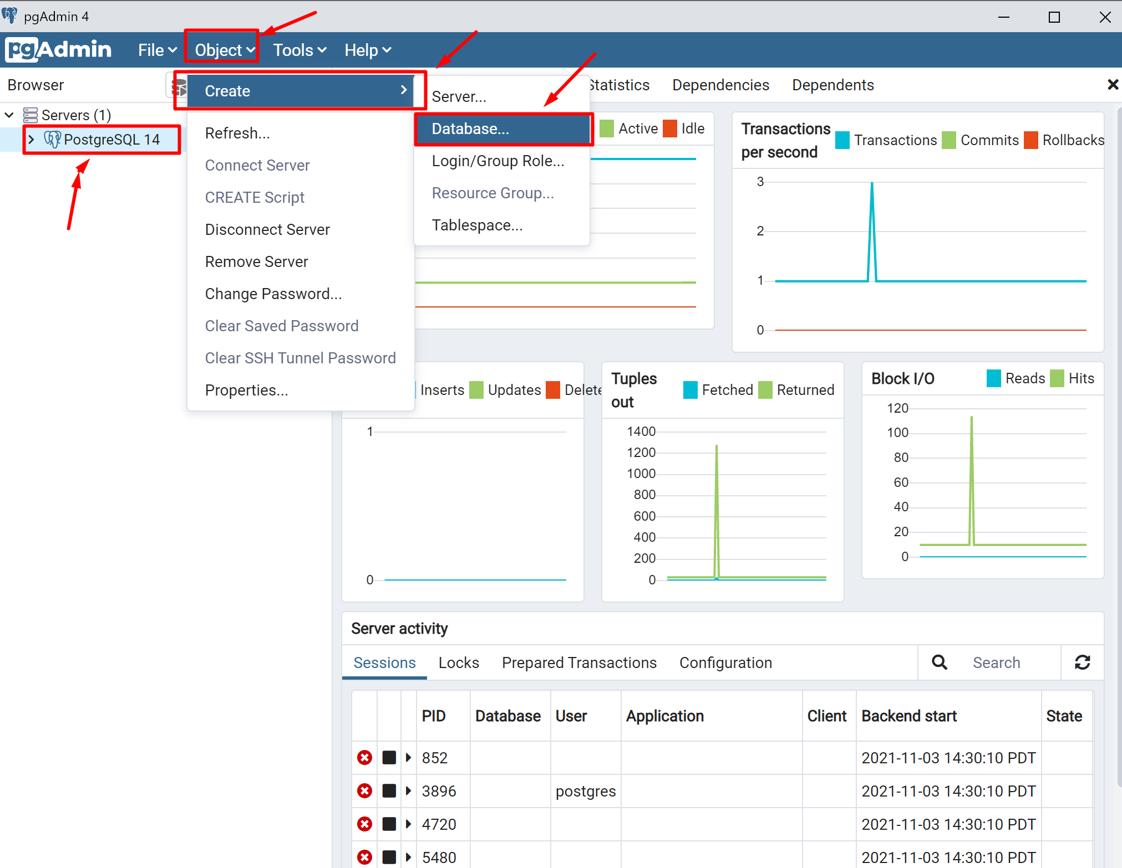

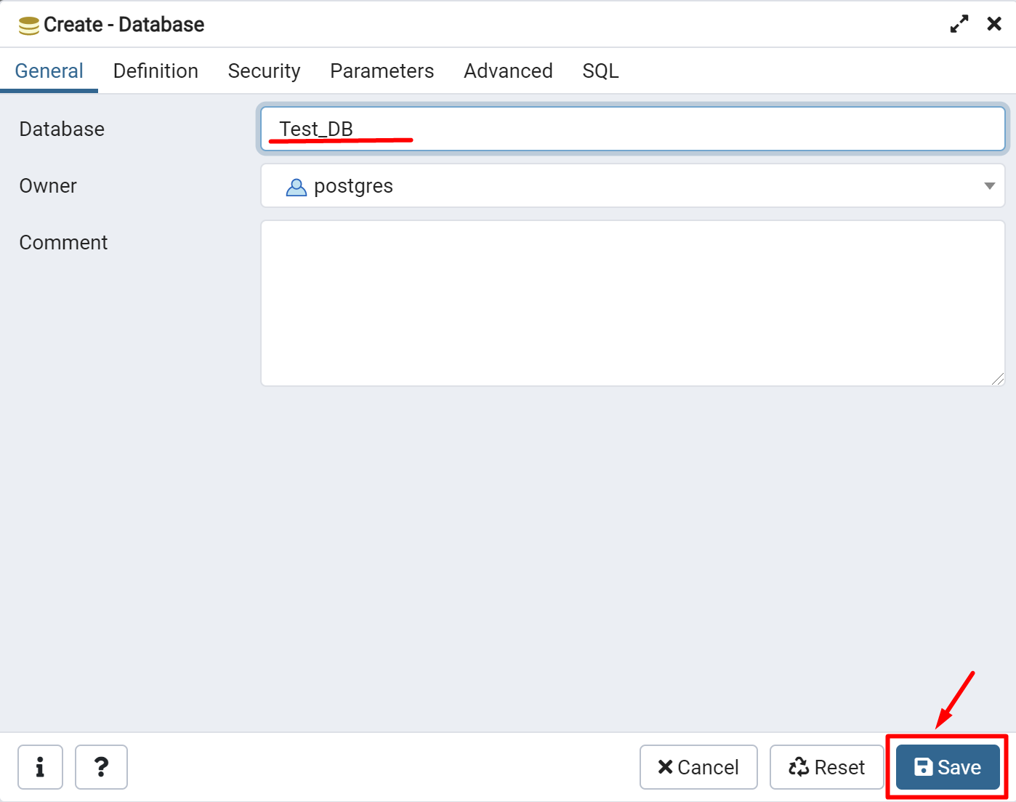

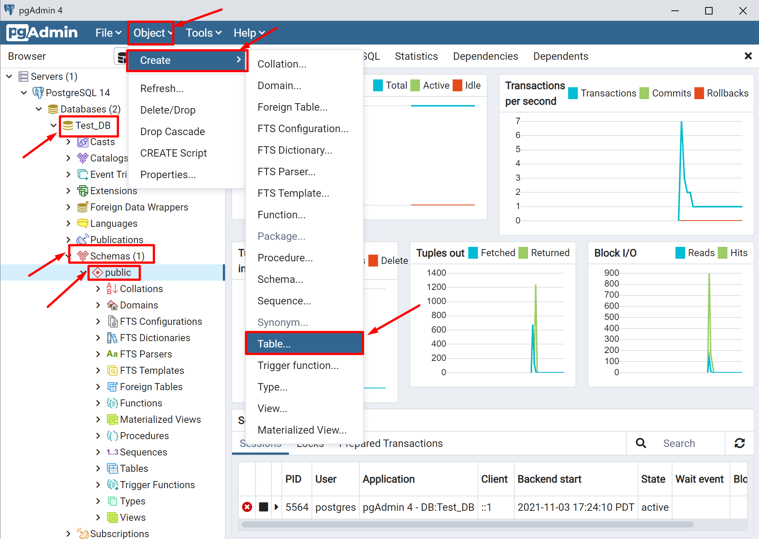

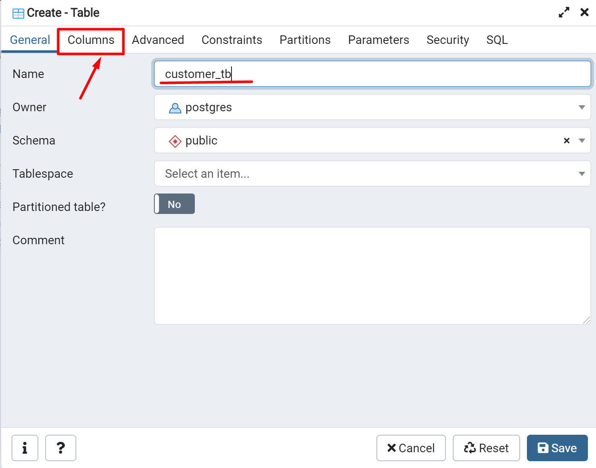

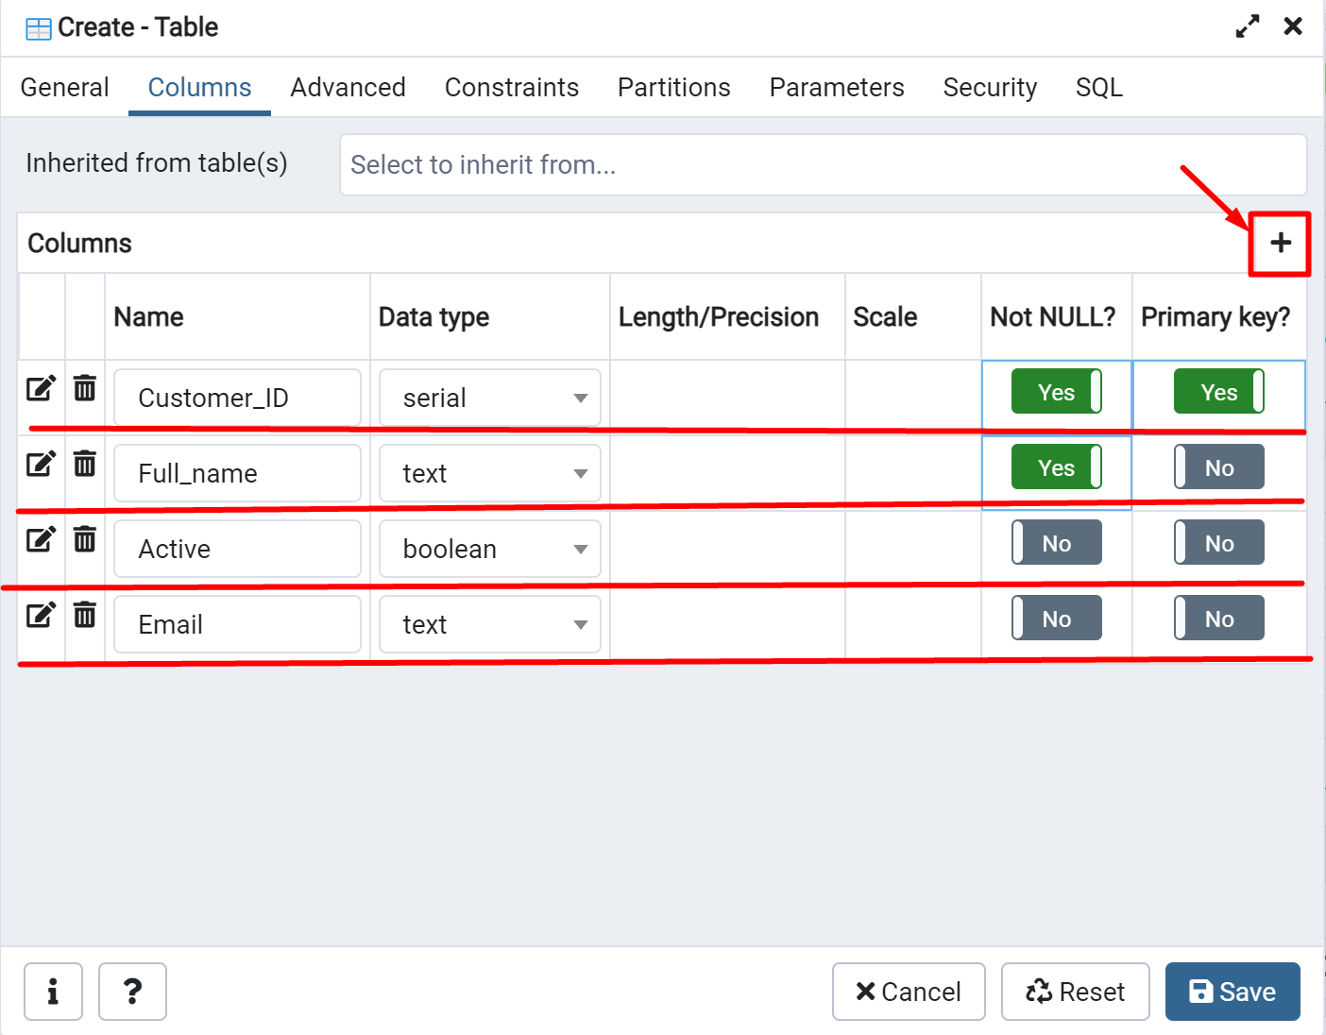

Remember to grant write privileges to the database and to the table in properties (otherwise you can’t write anything to this database/you can’t insert, update, or delete).

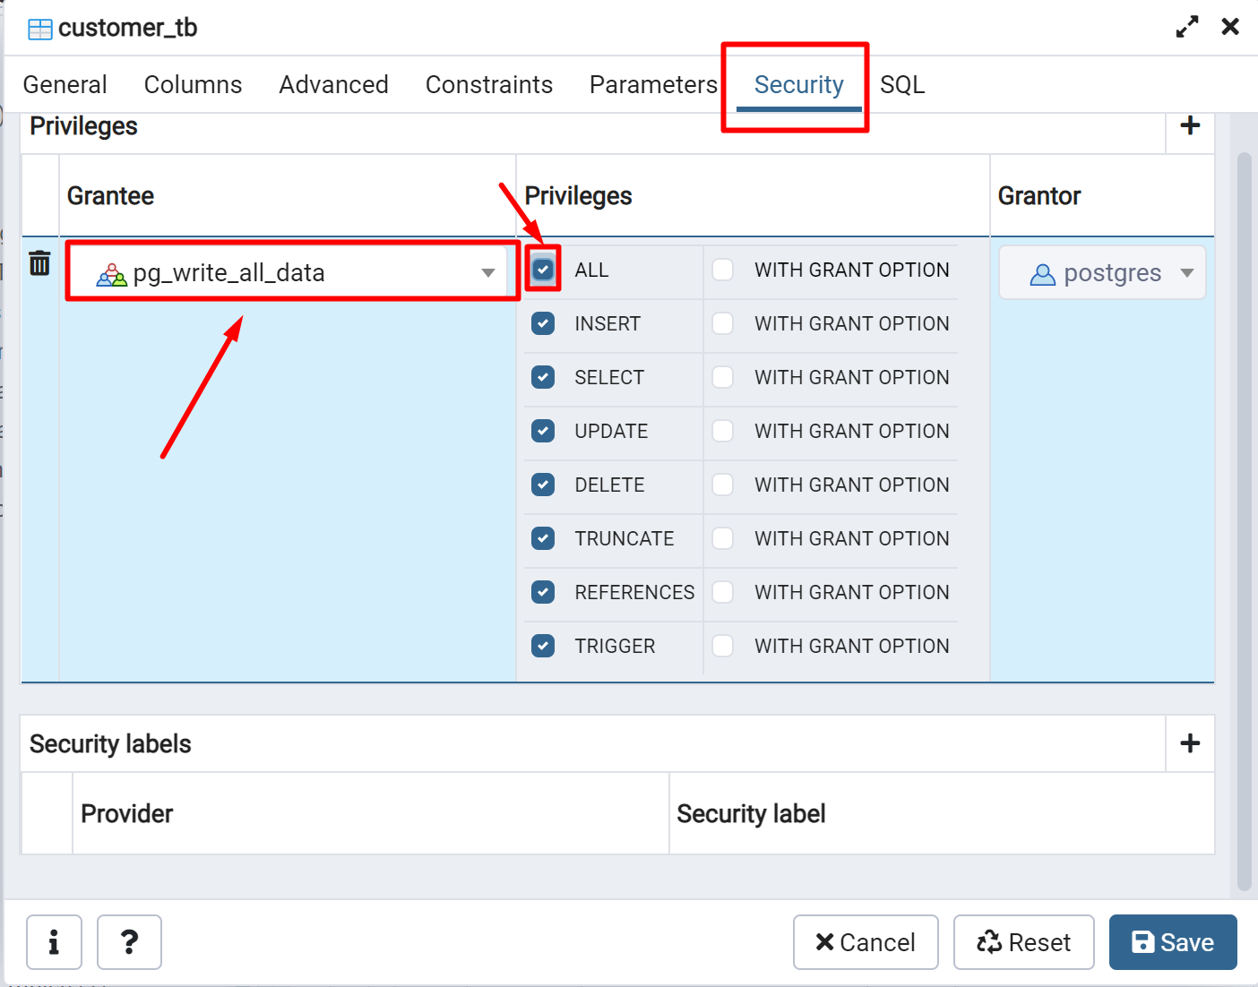

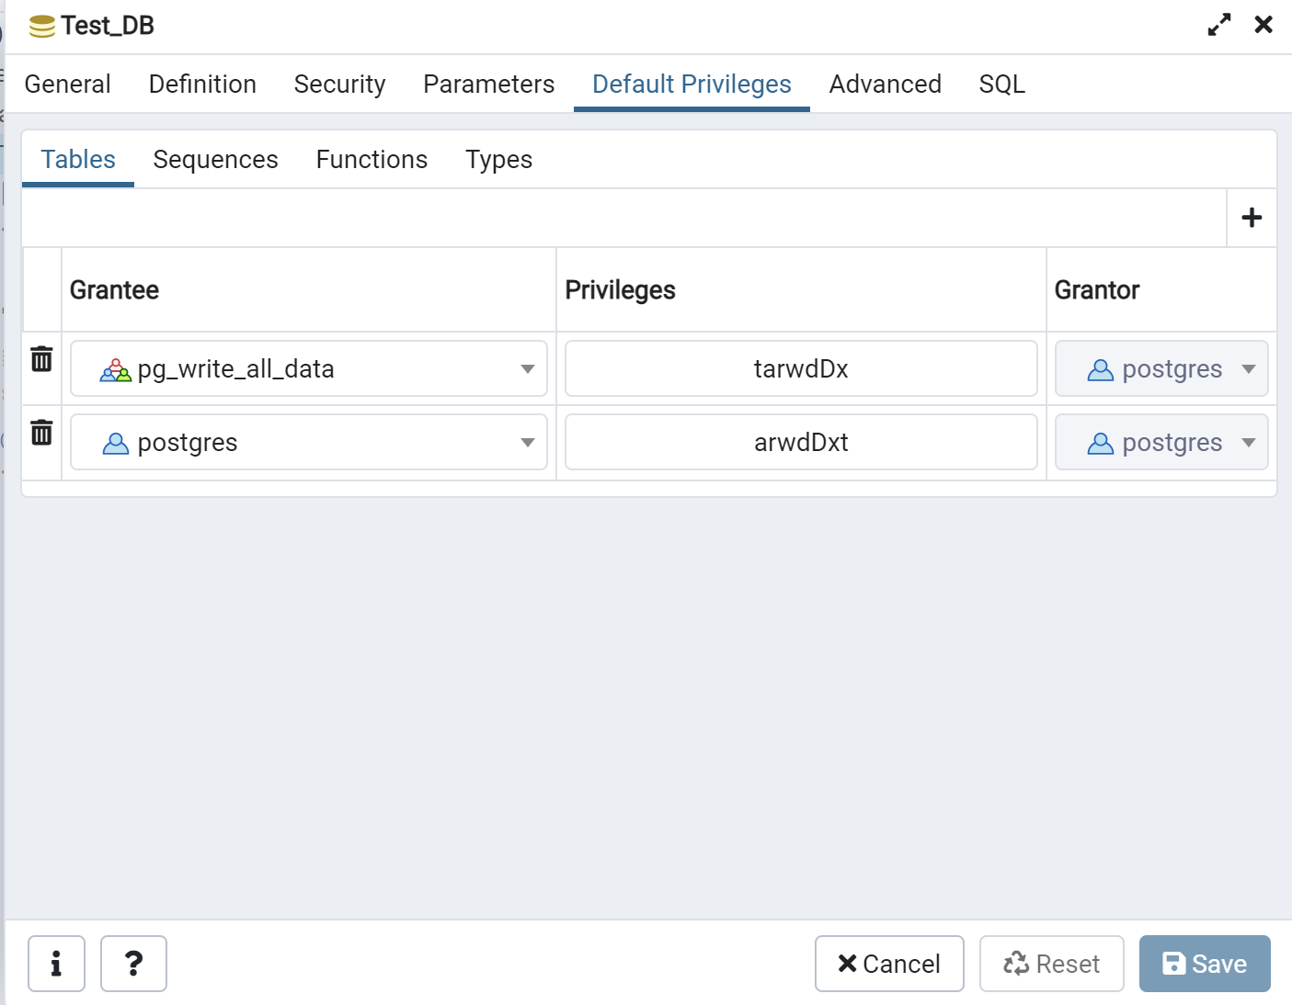

# Step 8: Pentaho Test Database Connection

Finally we will start the transformation process.

Run the Spoon program and start a new transformation process.



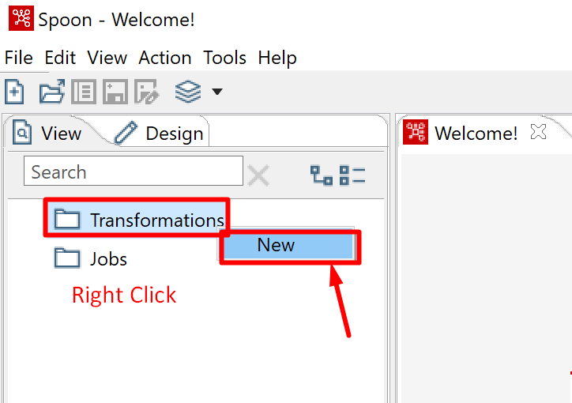

Before we do anything, we need to test the connection to the two databases, MySQL and PostgreSQL.

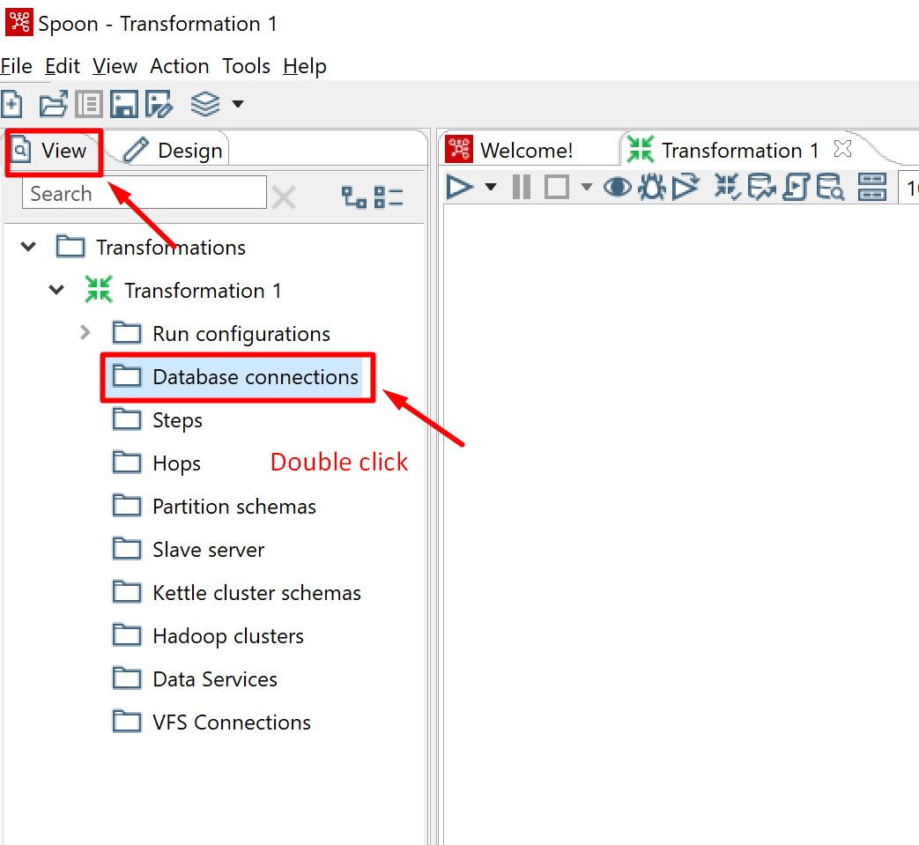

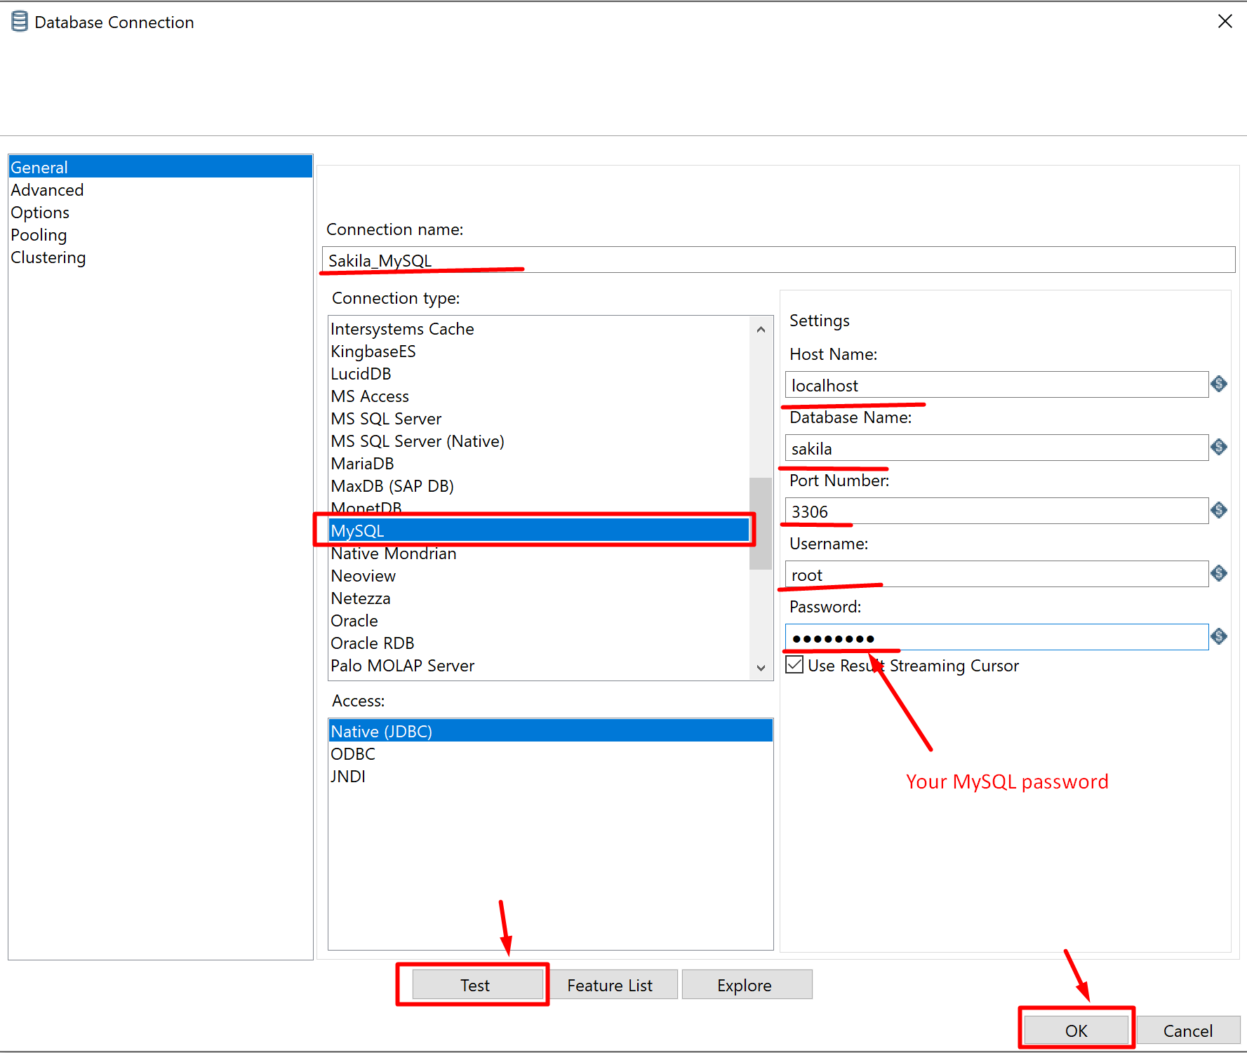

If you haven’t loaded the JDBC driver to the corresponding Pentaho library folder, you will get the following error. Go back to Step 5 to solve this problem.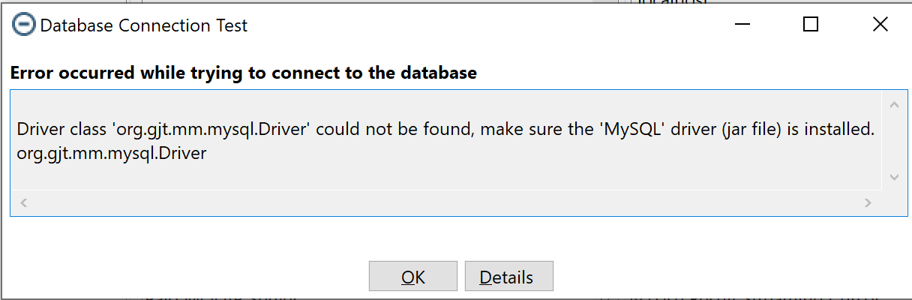

Once successfully connected, you will see the following dialog box.

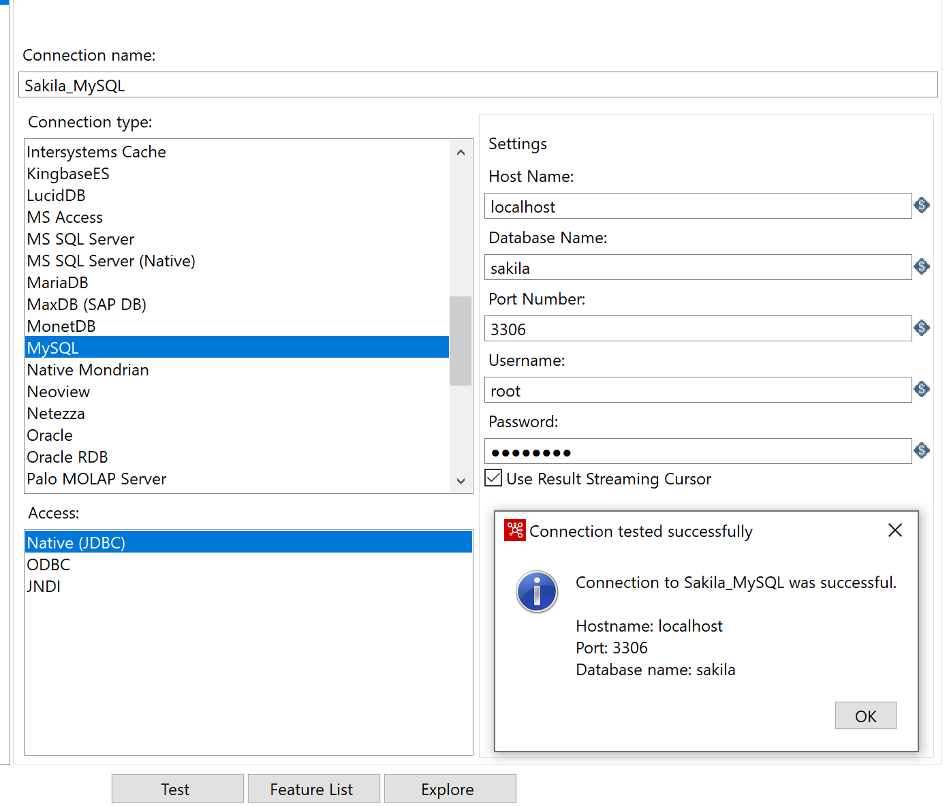

The same thing for the PostgreSQL connection.

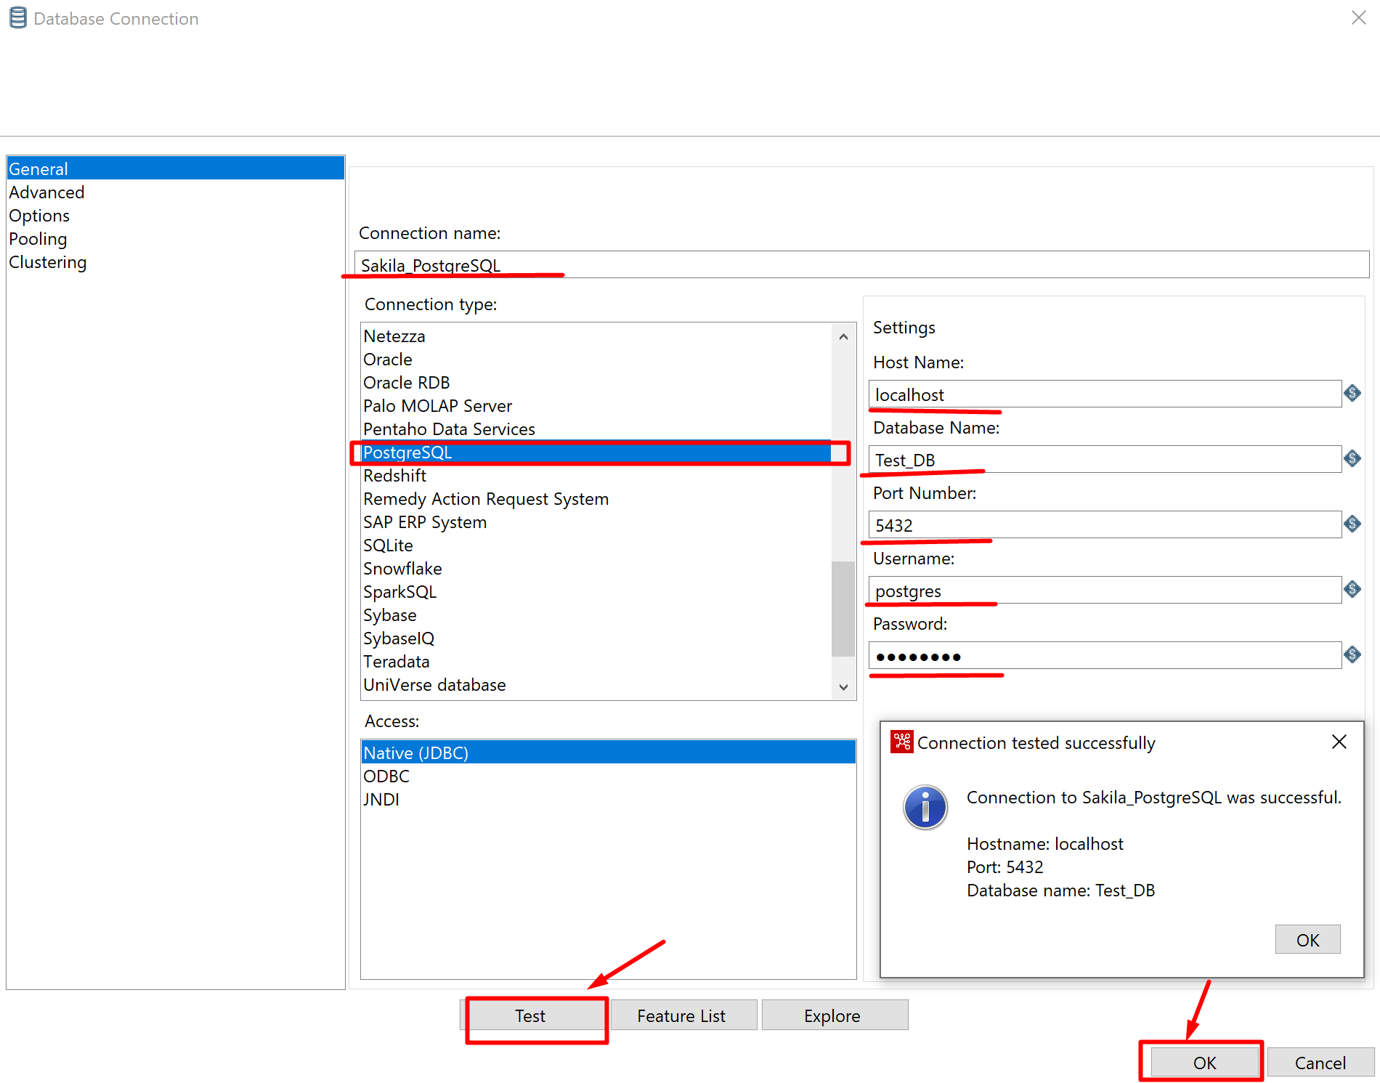

# Step 9: Create a Transformation

Now we start the data migration process. Get a Table Input step.

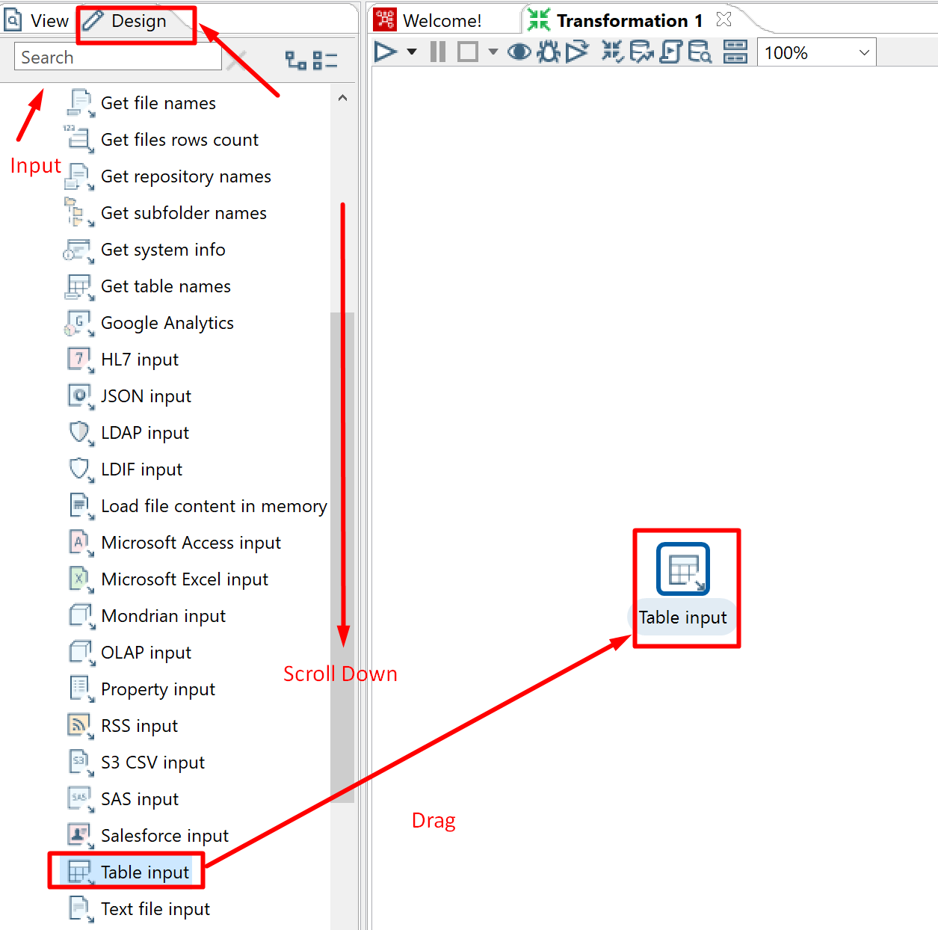

Load the data we want to obtain from the original MySQL Sakila database.

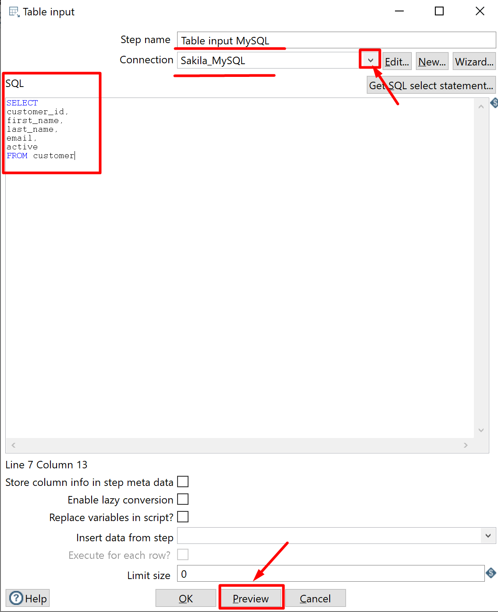

You can preview the SQL results.

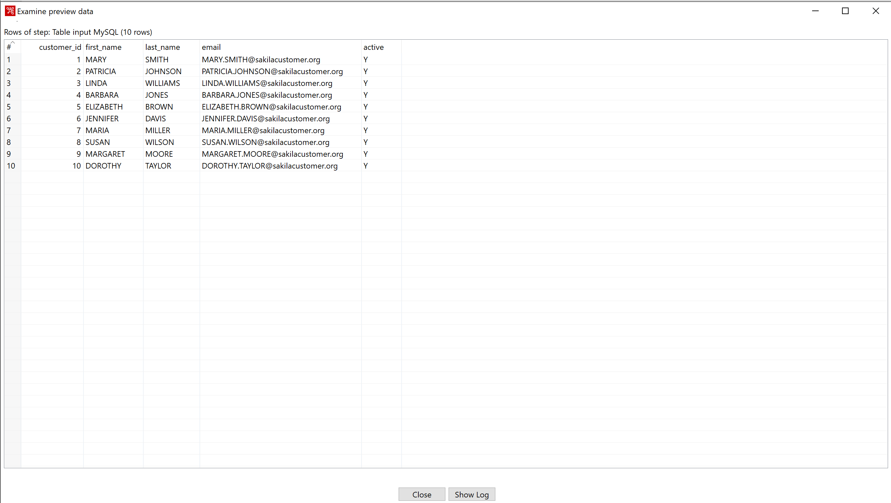

Now let’s go to the data validation step, where you will create your error alerts for non-standard data.

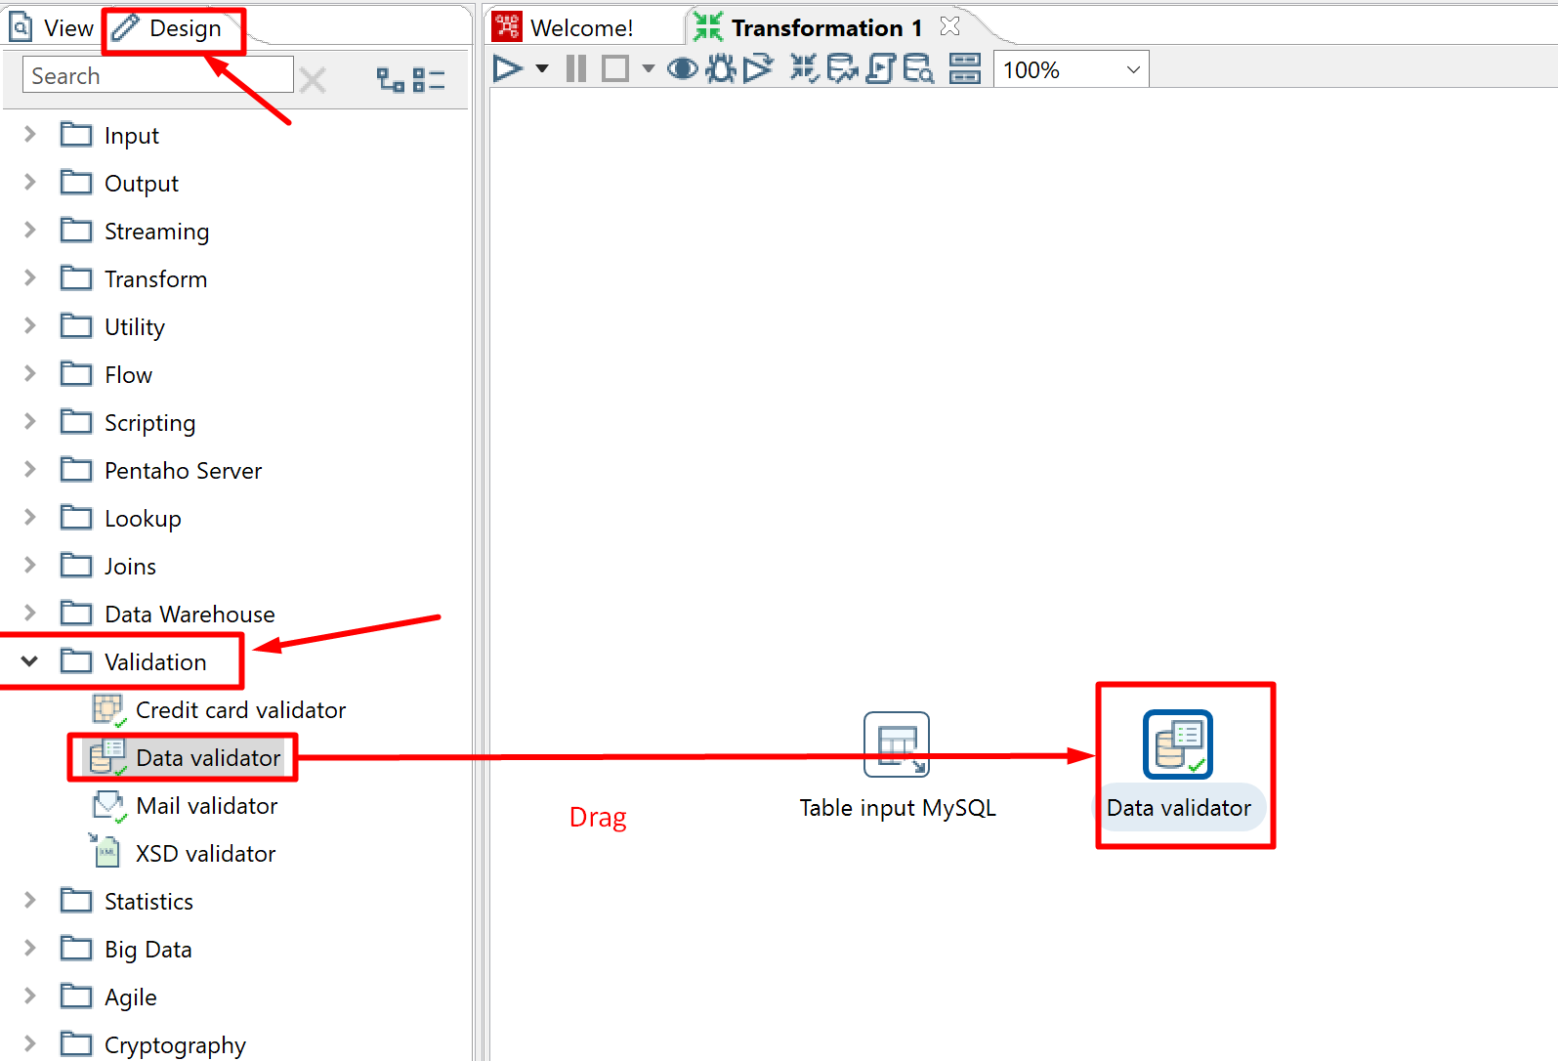

Hold down the control (Ctrl) key to select both of the steps to create a data flow link between them.

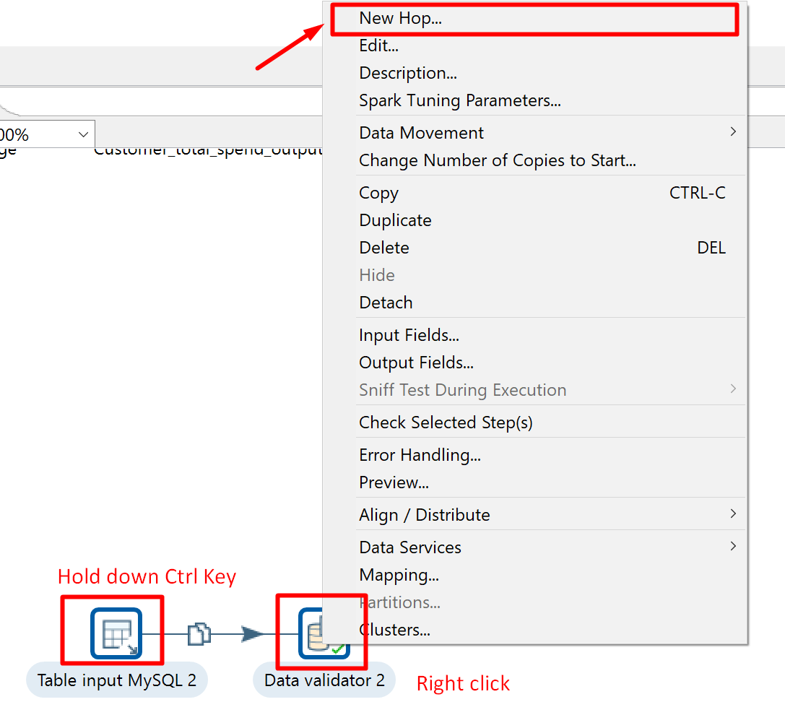

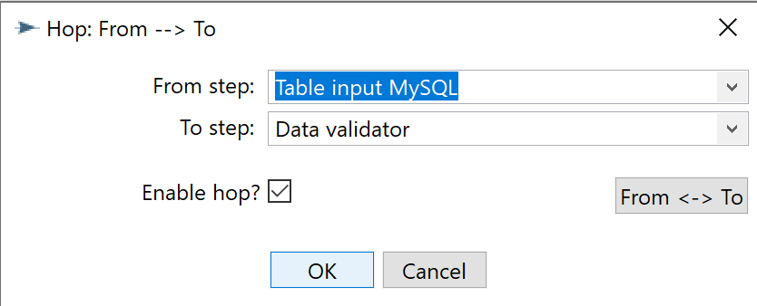

Now create the following 4 validations.

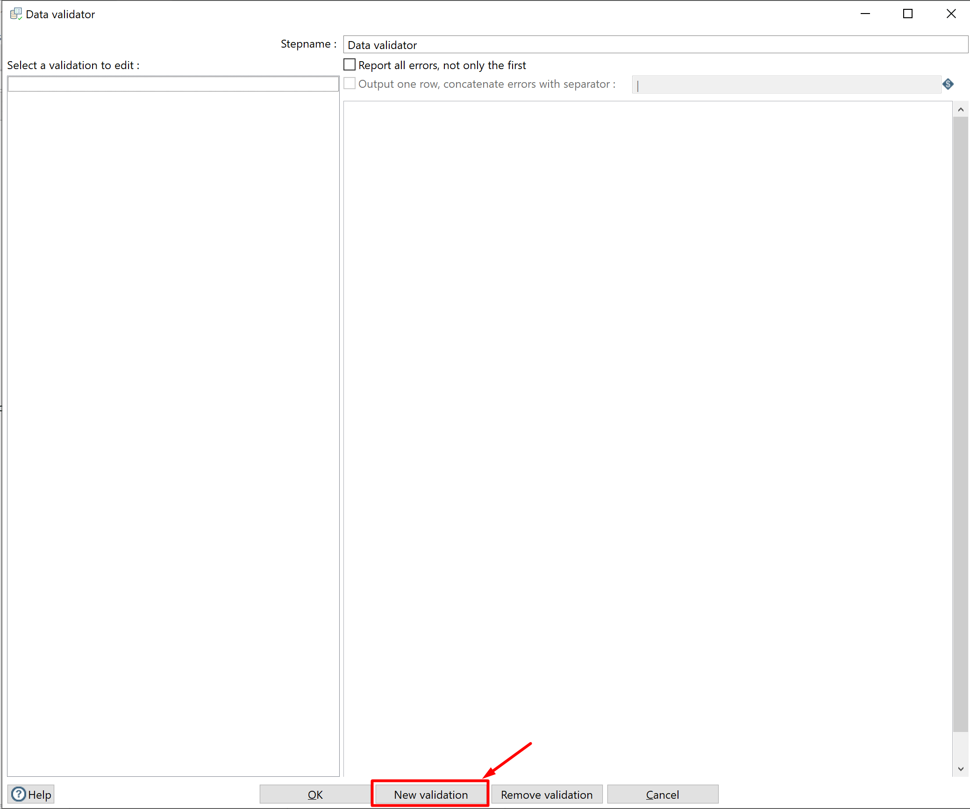

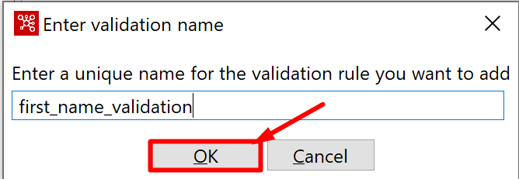

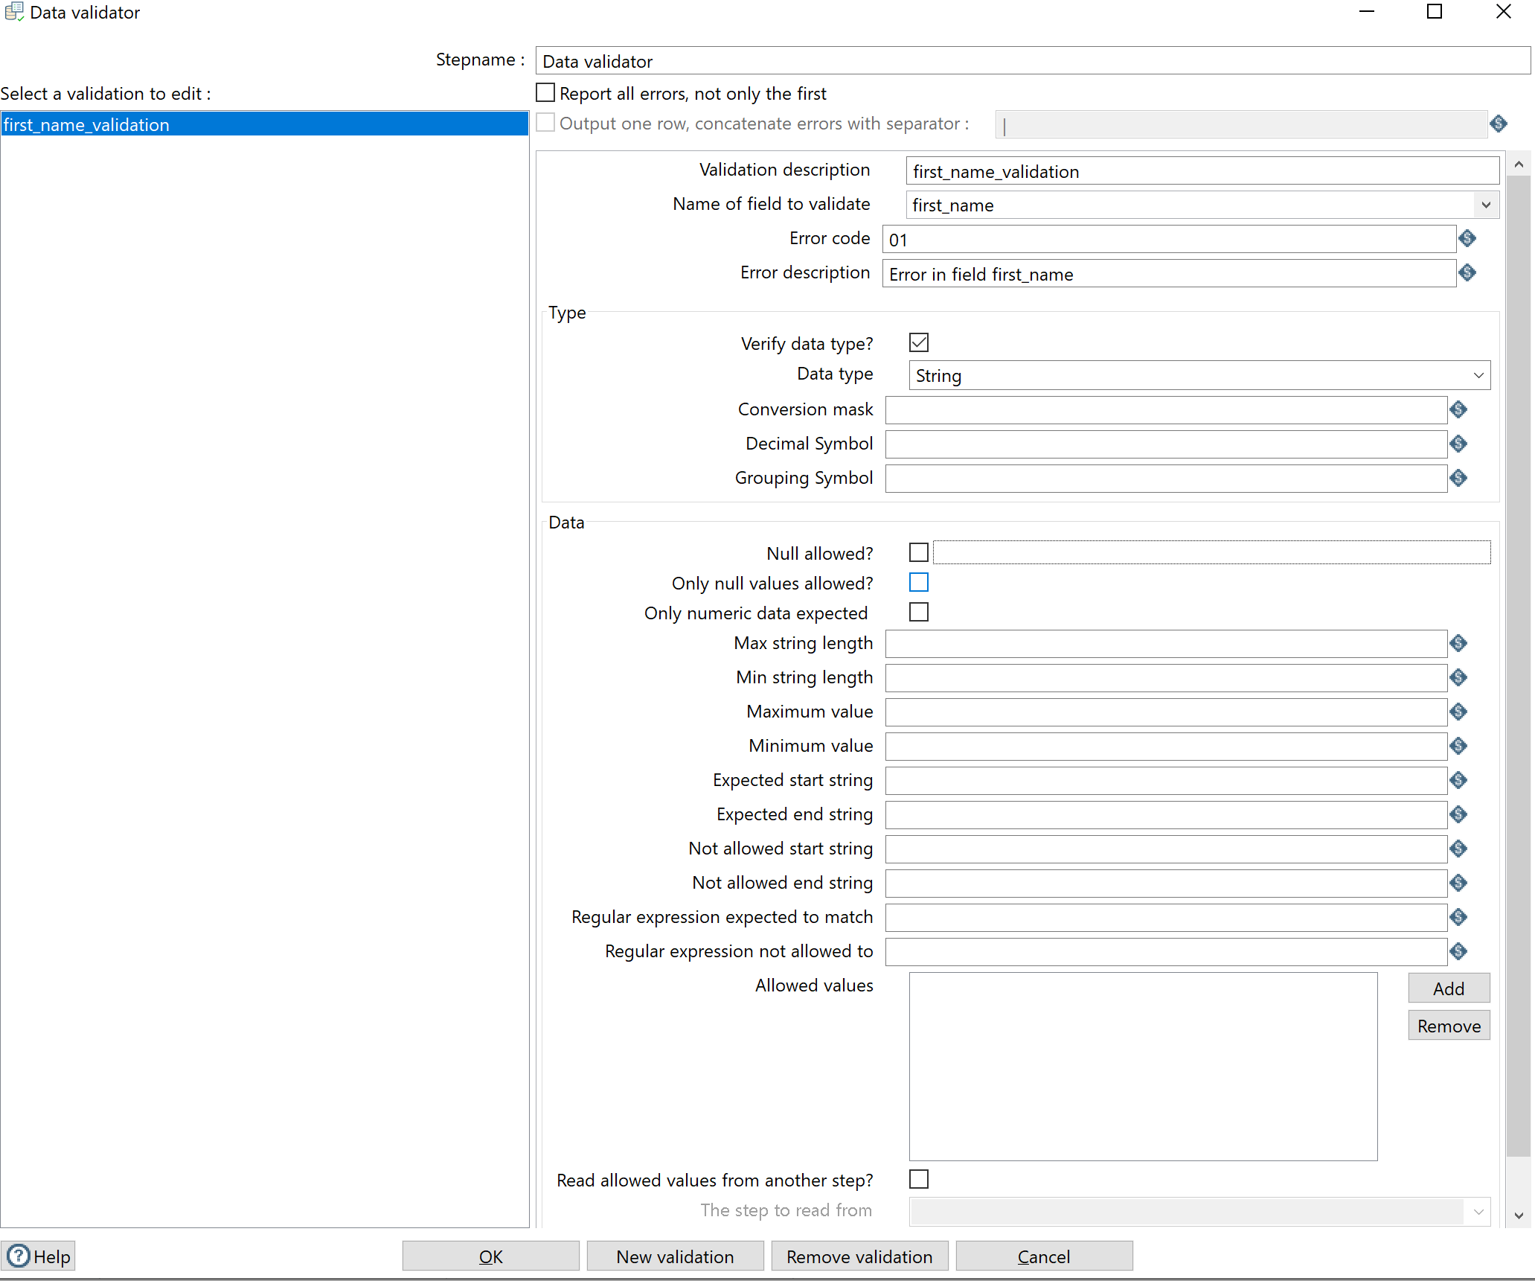

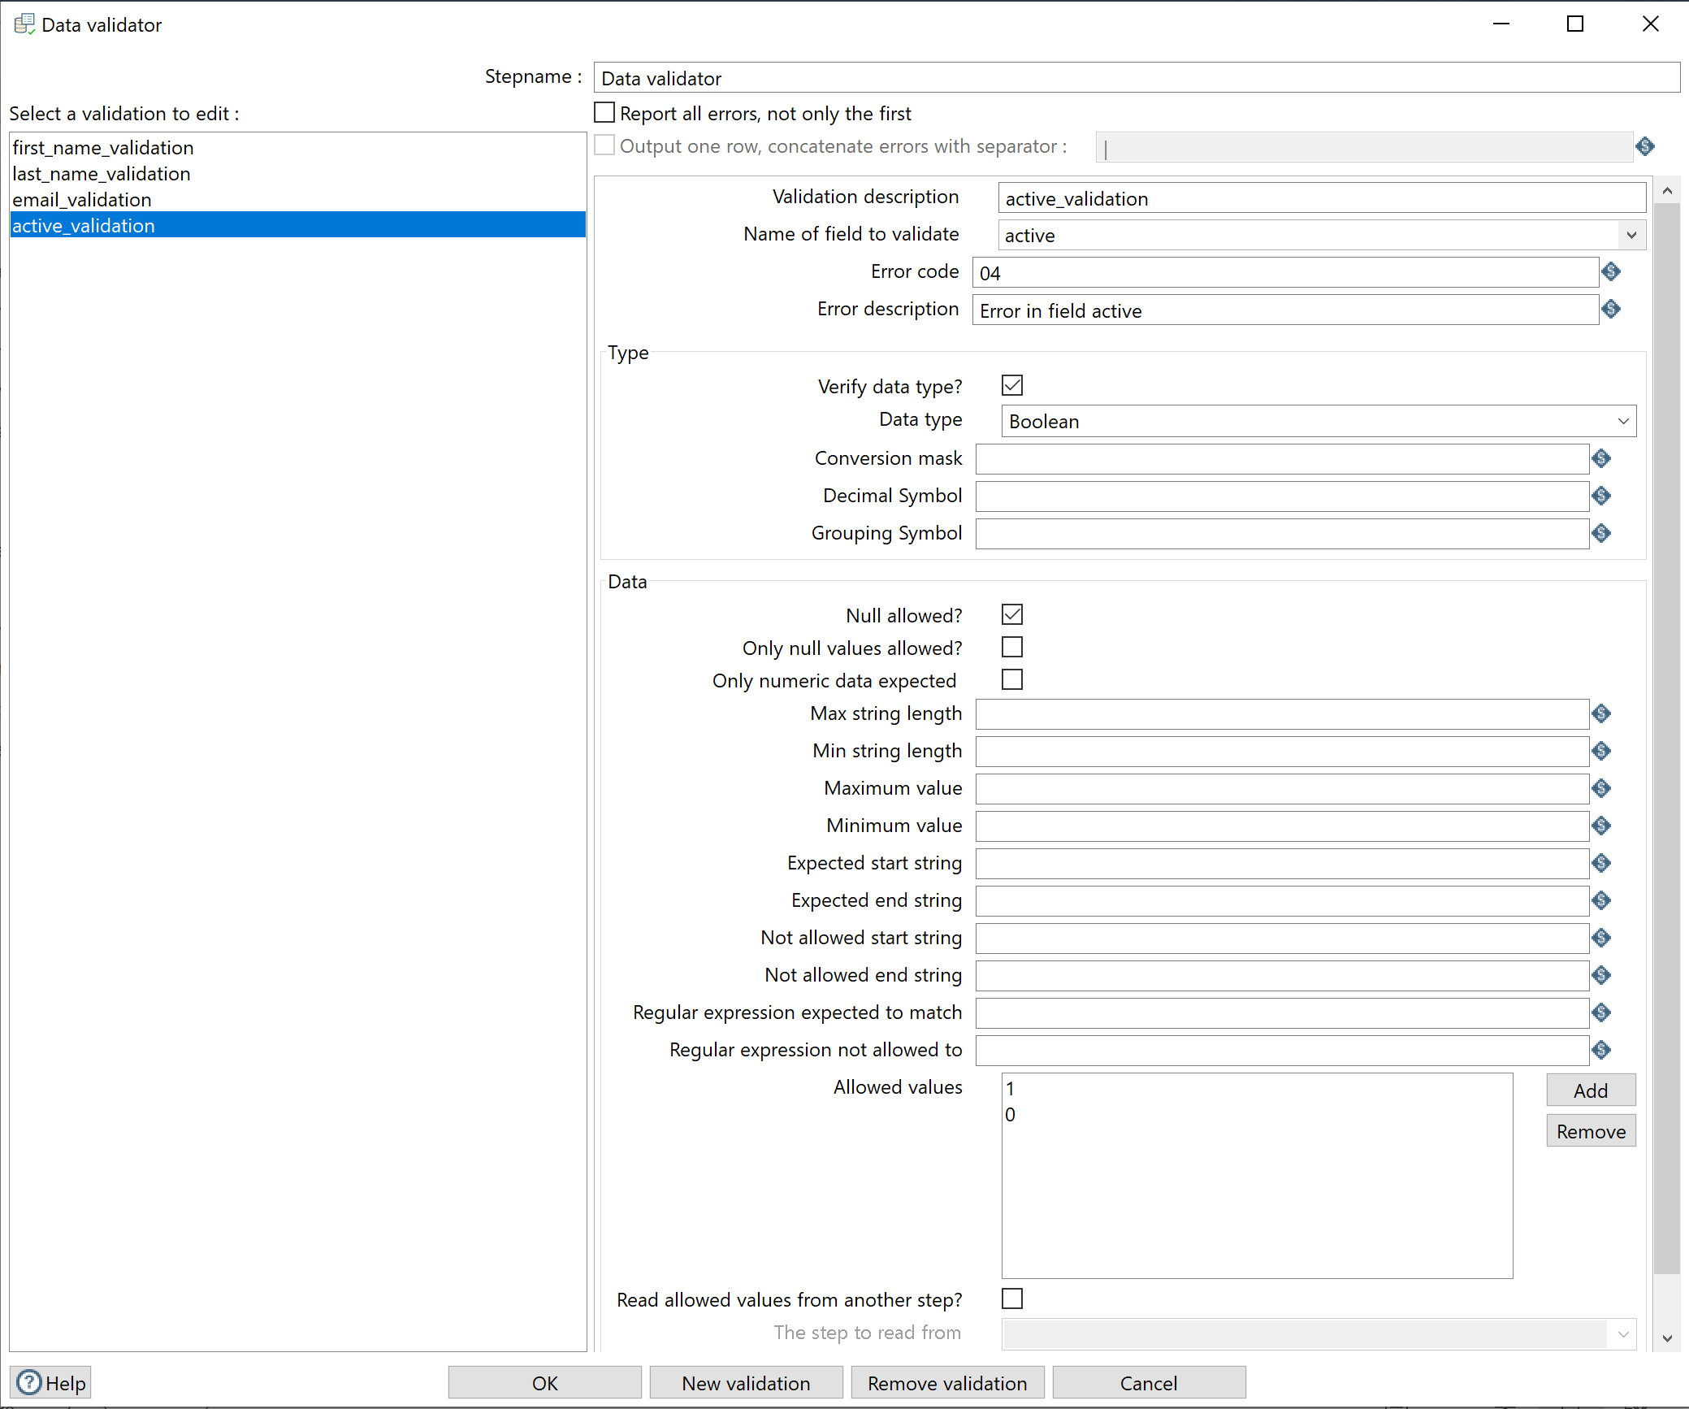

Next, we want to apply some operations to the strings. Add a String Operations step. Remember to link it to the data validator.

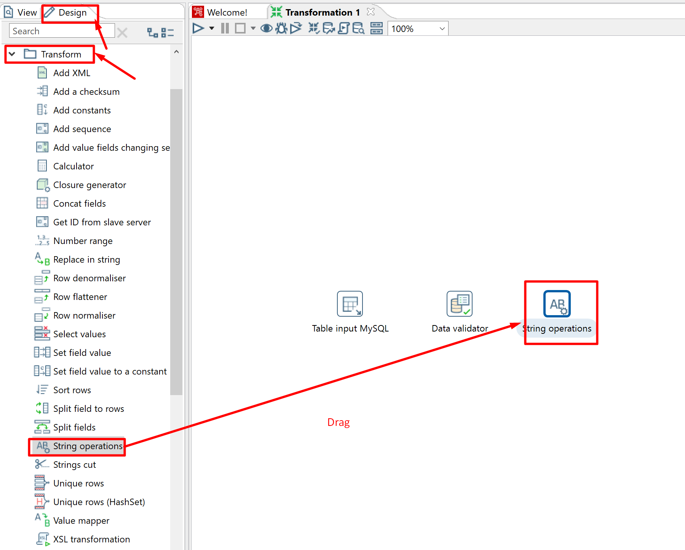

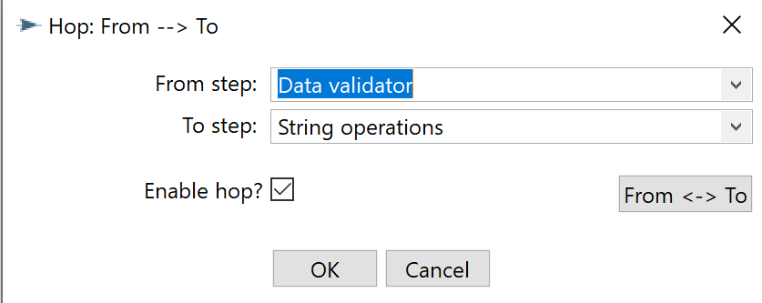

We want to remove spaces from the beginning/end of the following 3 text fields, first_name, last_name, and email. We also convert all the letters in the email field to lowercase. Finally, we remove all the spaces in the middle of the email. Rename this step as “Remove Spaces.”

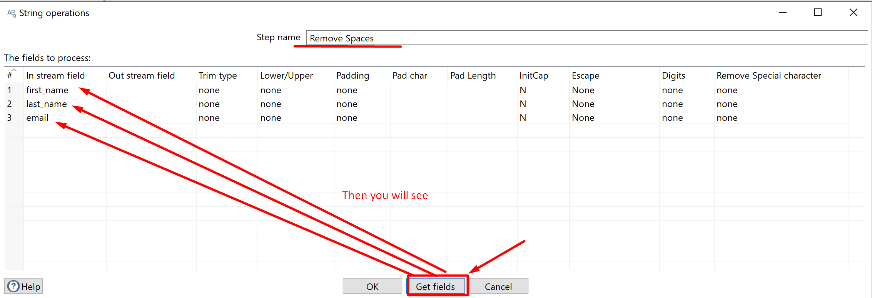

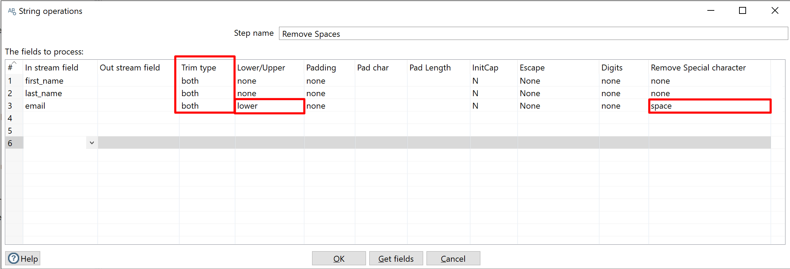

Finally, we will output the result to the PostgreSQL table we created previously.

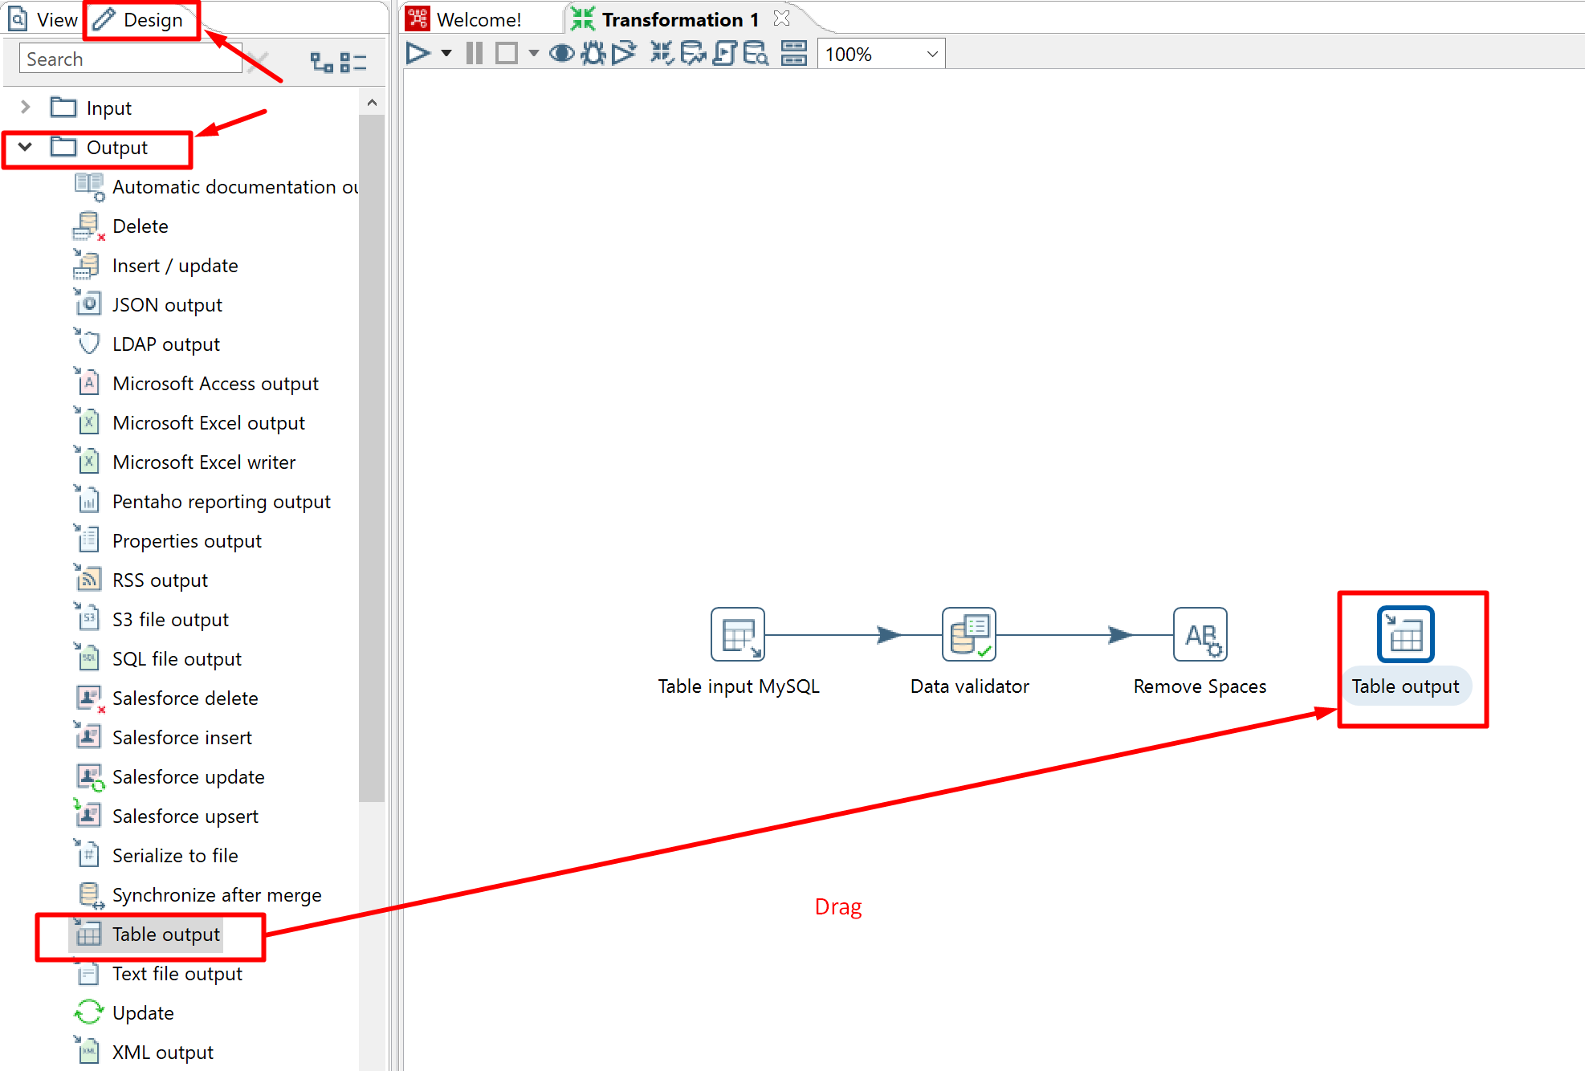

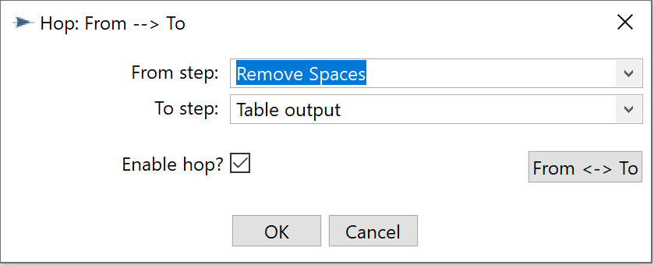

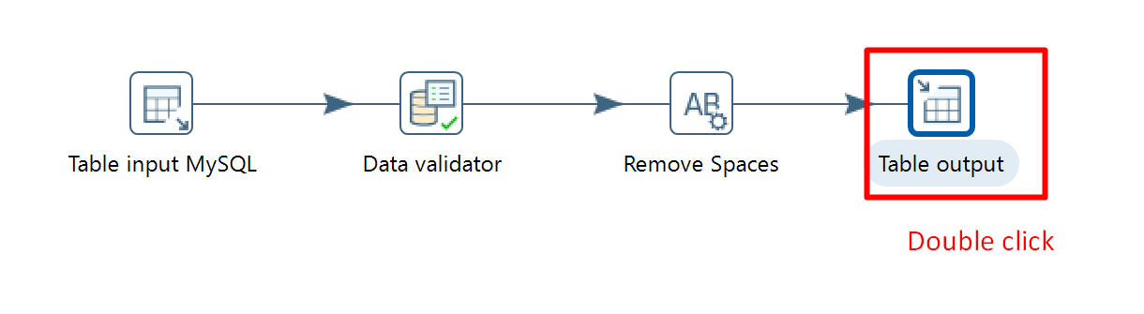

You might have found something wrong here as originally we have 5 fields but the target table only has 4 fields. But let’s ignore this potential problem and carry on.

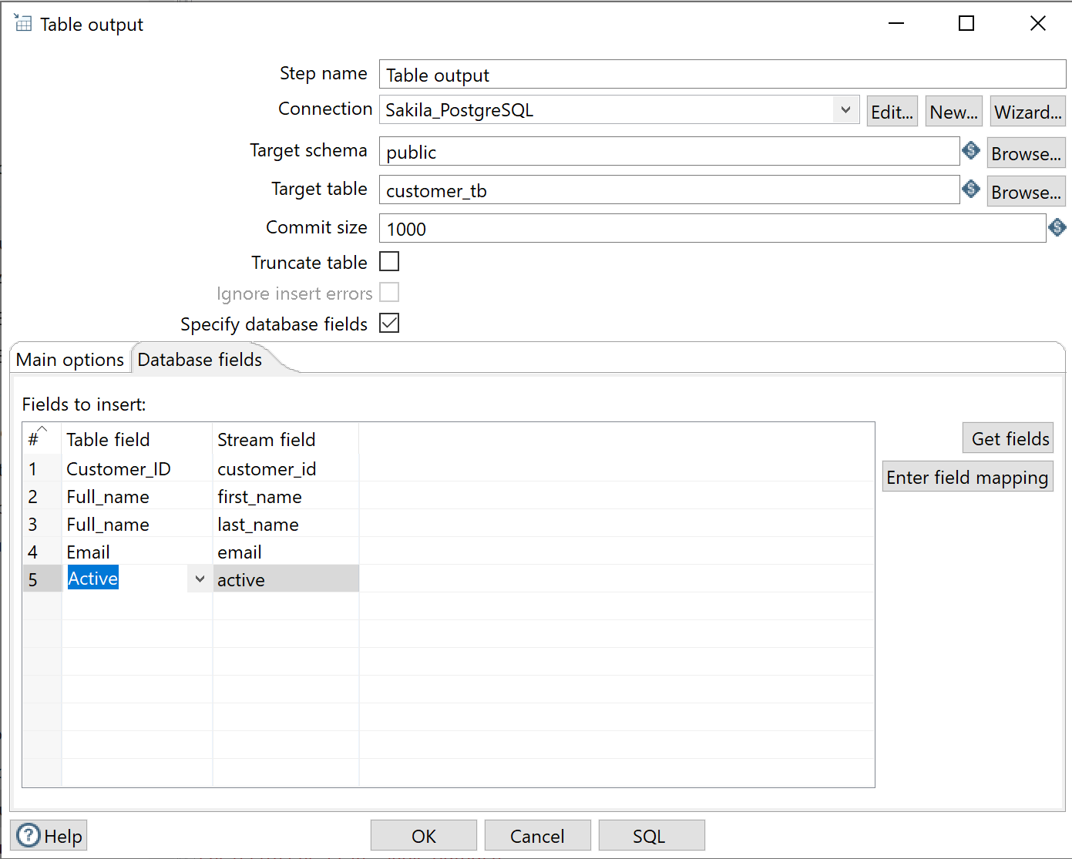

Run the whole transformation and you will see some error message, telling us exactly the problem we just figured out.

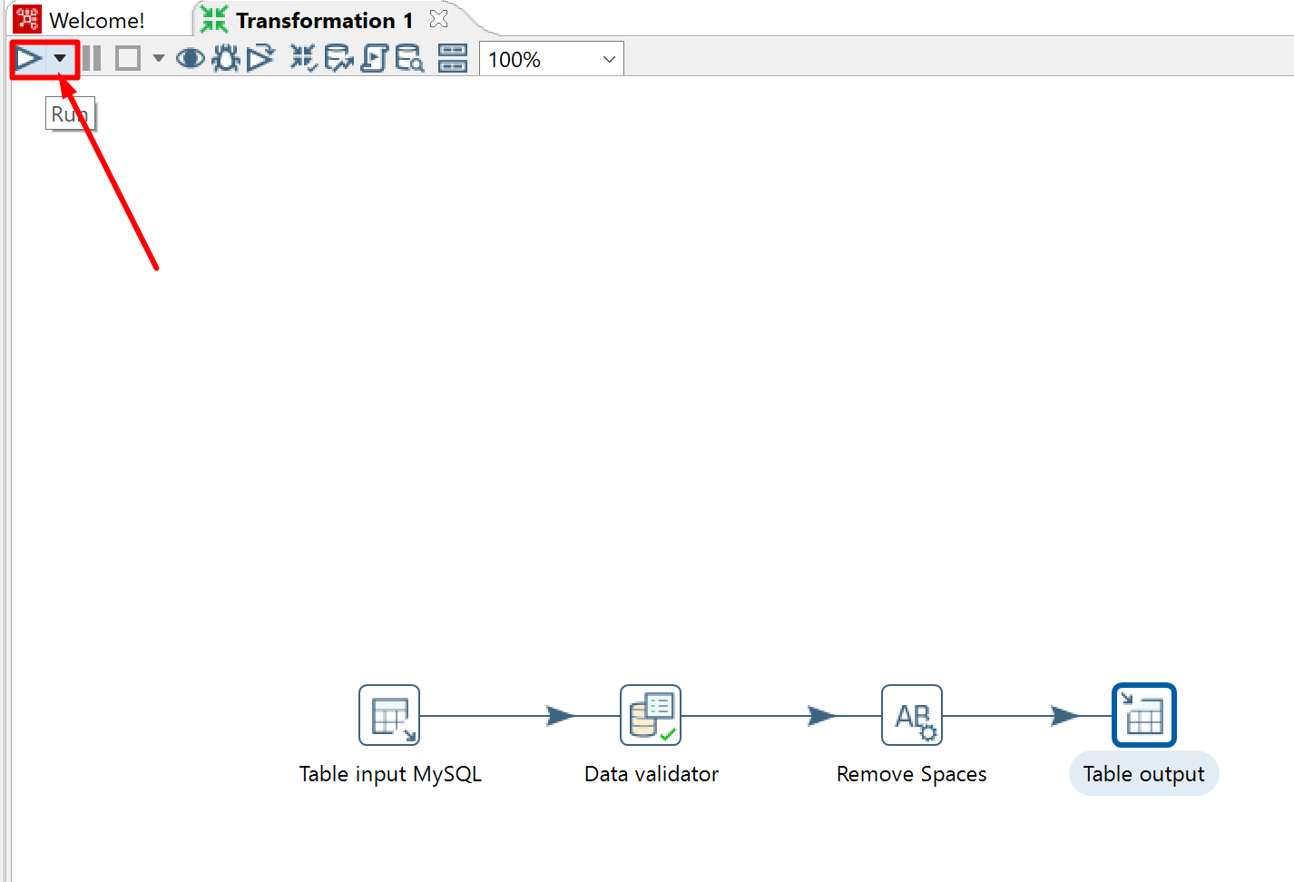

We need to concatenate the two fields first_name and last_name and use it as the full name to insert into the new table.

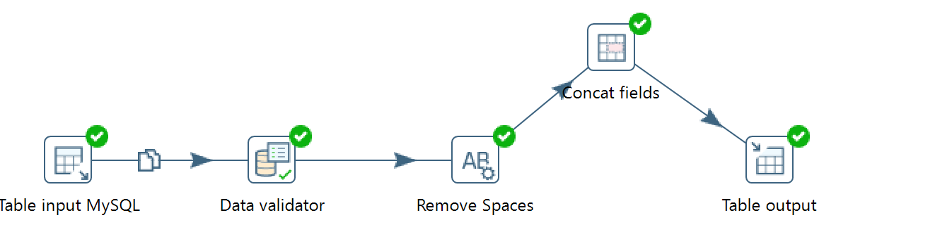

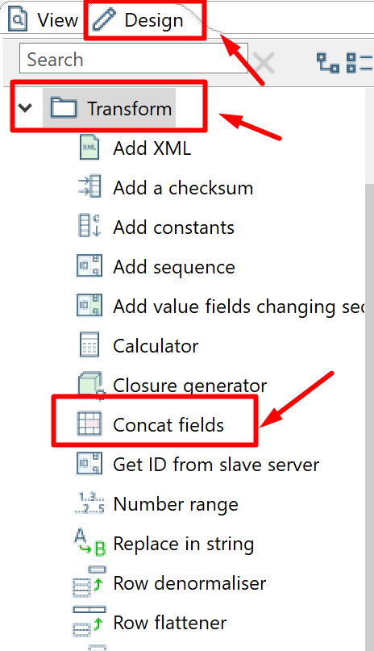

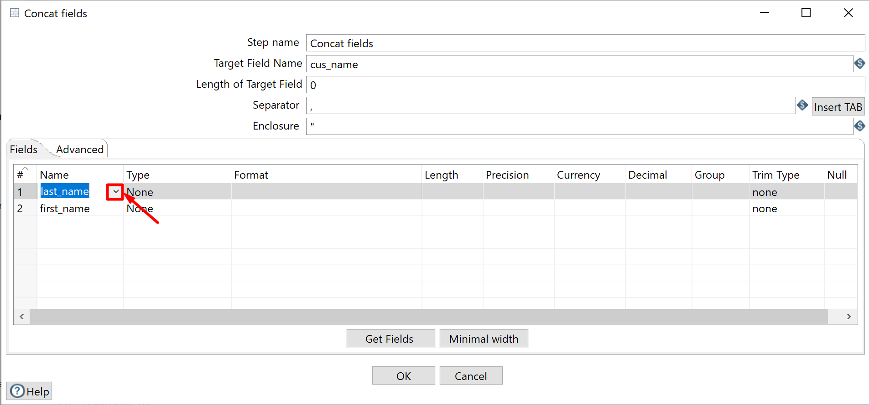

After this step, you will get a new field cus_name. And keep in mind to remove the original two fields last_name, and first_name.

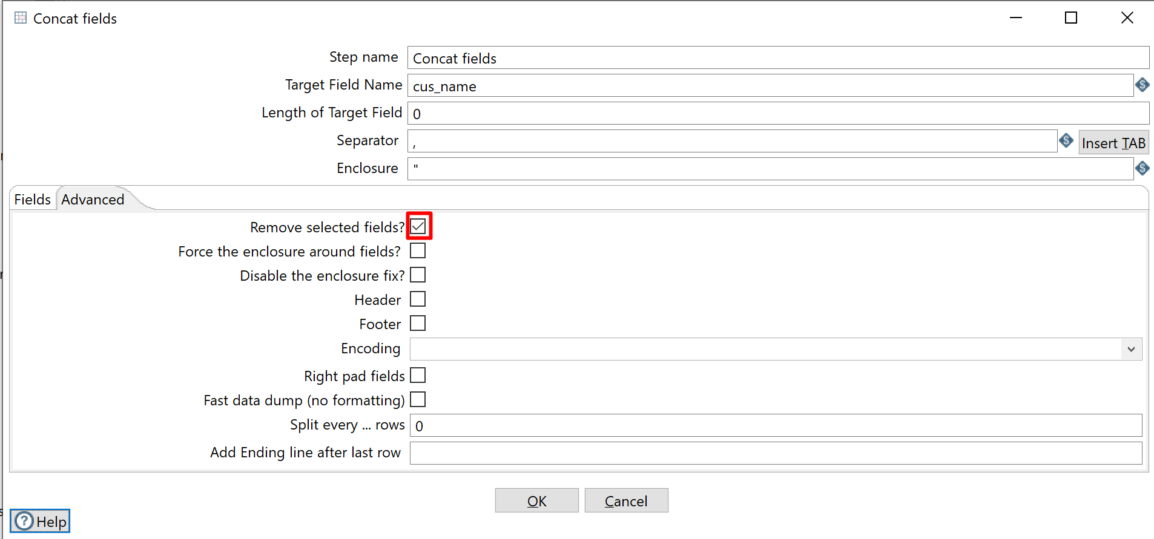

Now there shouldn’t be any problems to output to the target table.

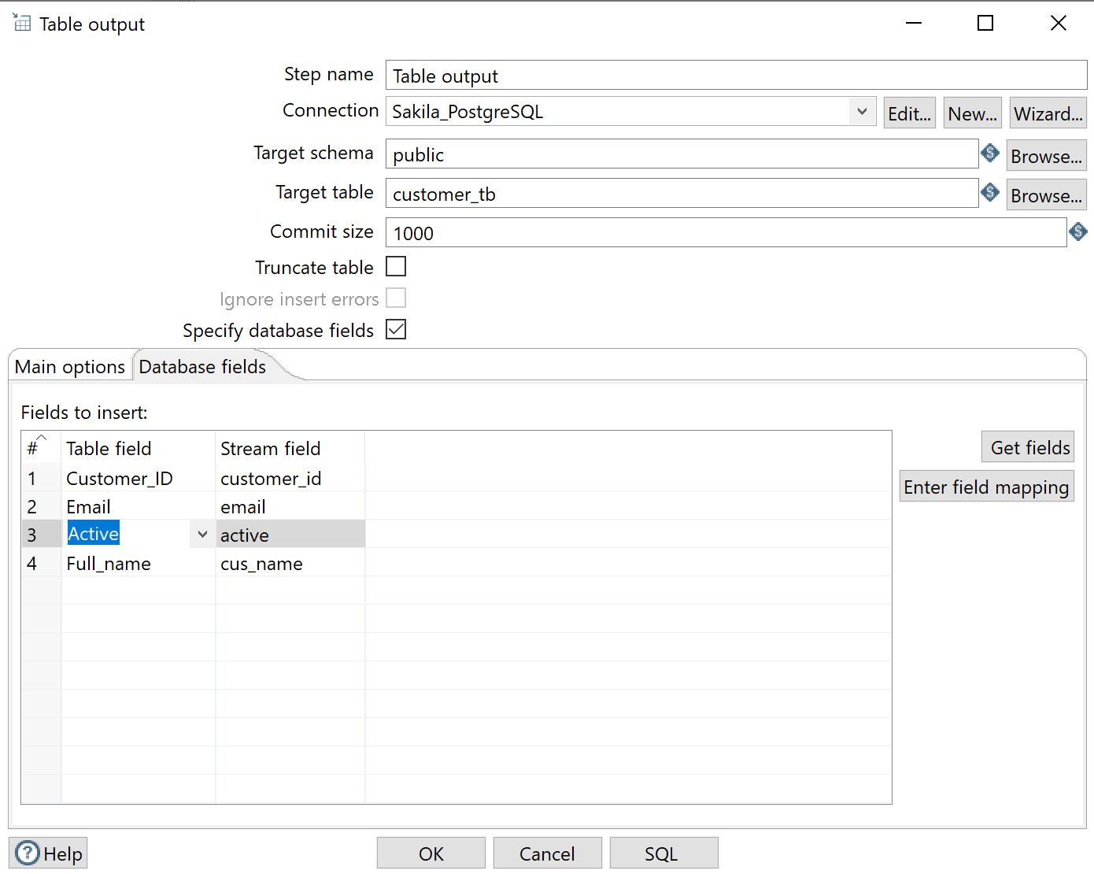

Wait a minute, still error? What happened?



It says that “customer_id” of relation “customer_tb” does not exist.

It is weird though, because we have the column “Customer_ID” in this table.

You might have found the problem. The reason is that PostgreSQL column names are CASE-SENSITIVE (not like MySQL) (So you know how important to read the error message). Use double-quote to quote these column names and now there shouldn’t be any problems.

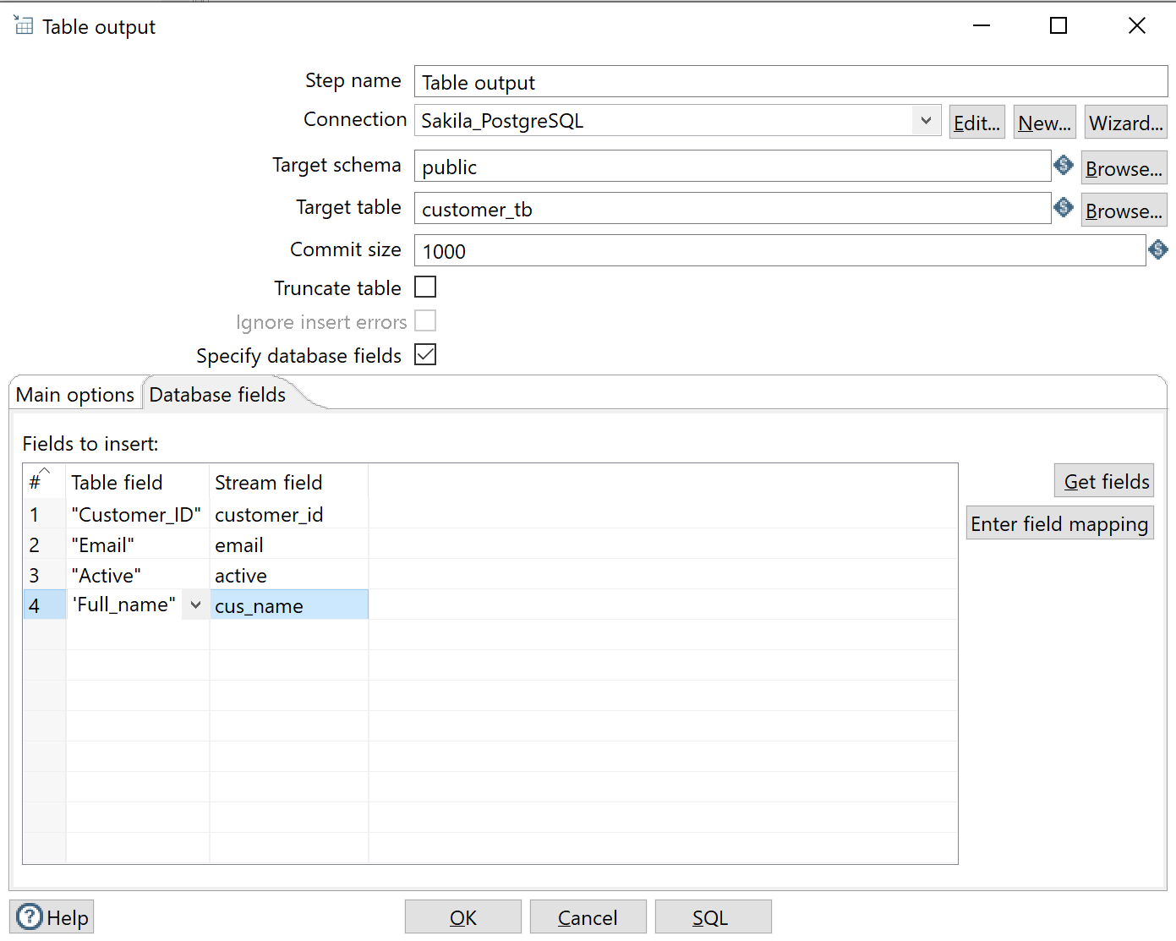

You can now see the data records in PostgreSQL.

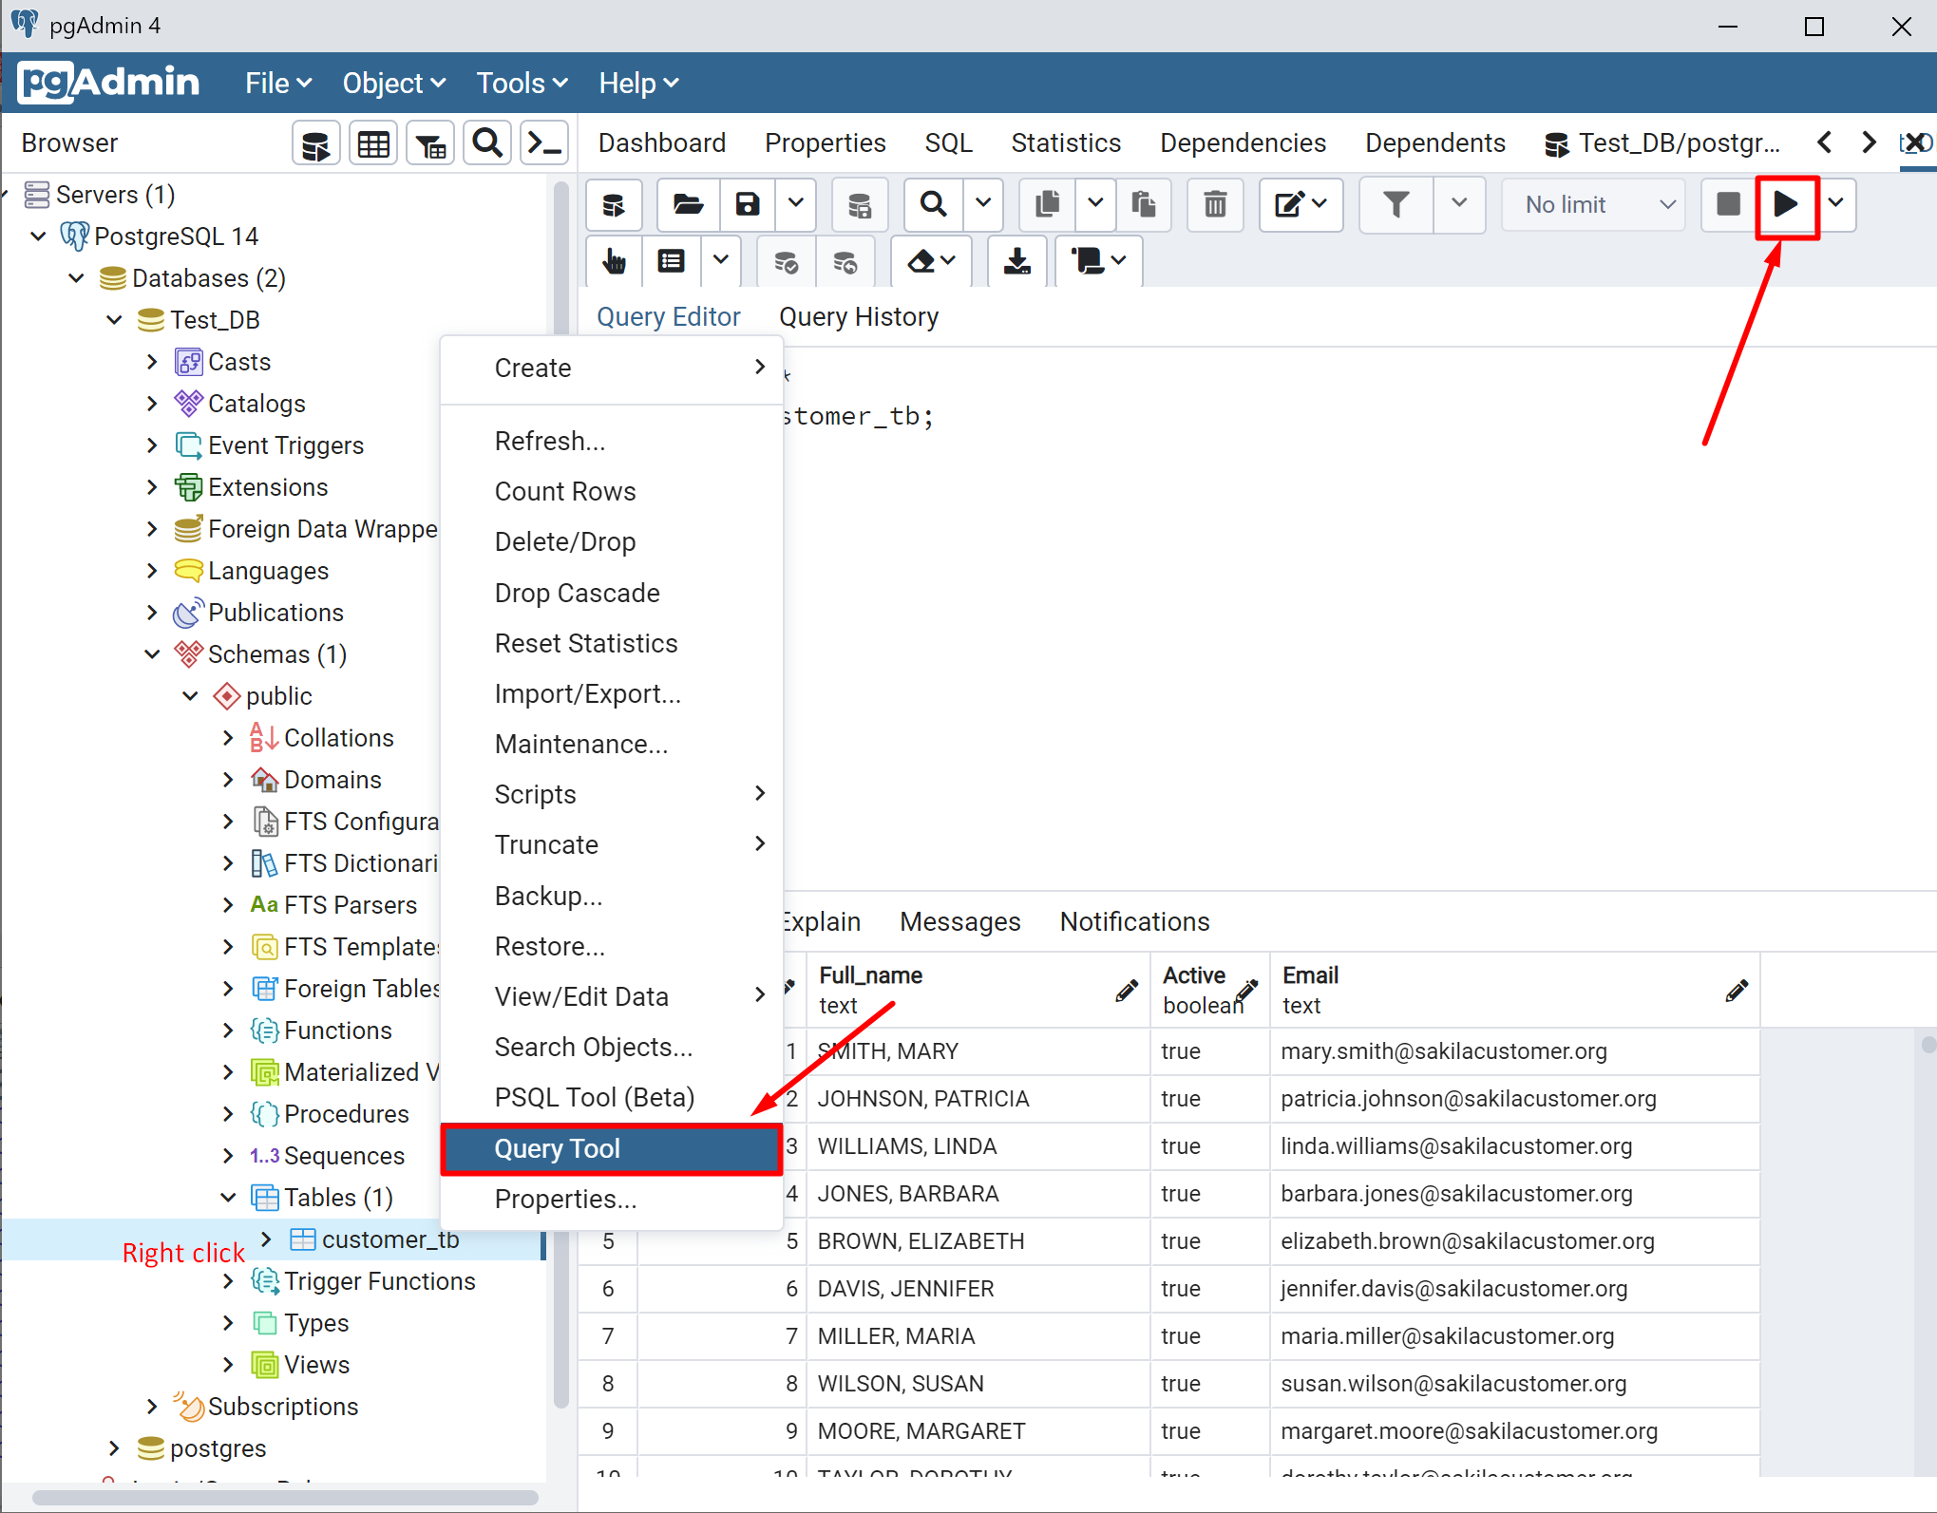

# Step 10: Create Table in Pentaho

If you don’t want to create the table in the target DBMS in advance, you can let Pentaho to create the table for you in the last step.

Let’s delete the PostgreSQL customer_tb table first.

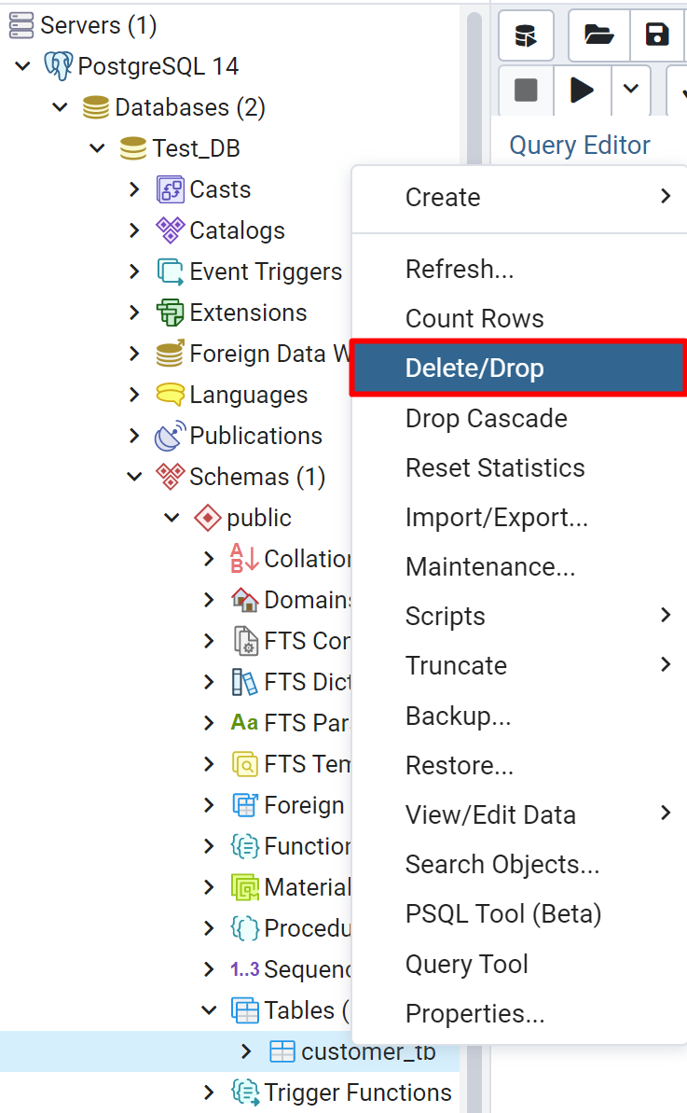

You can see now this table does not exist.

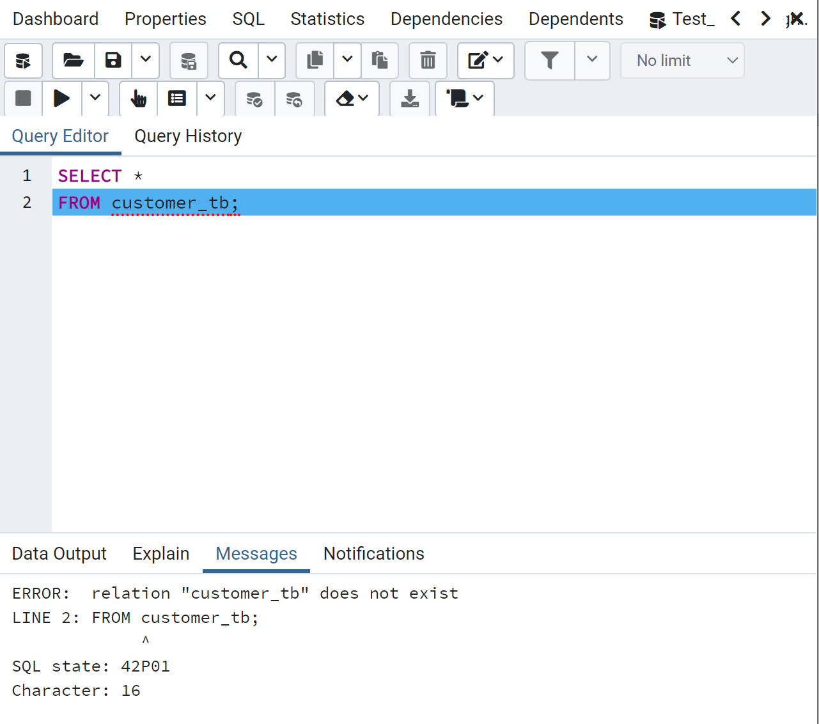

Then in the Output step, you can run the SQL DDL directly to create the table. Then you can see the message telling you that the table has been successfully created.

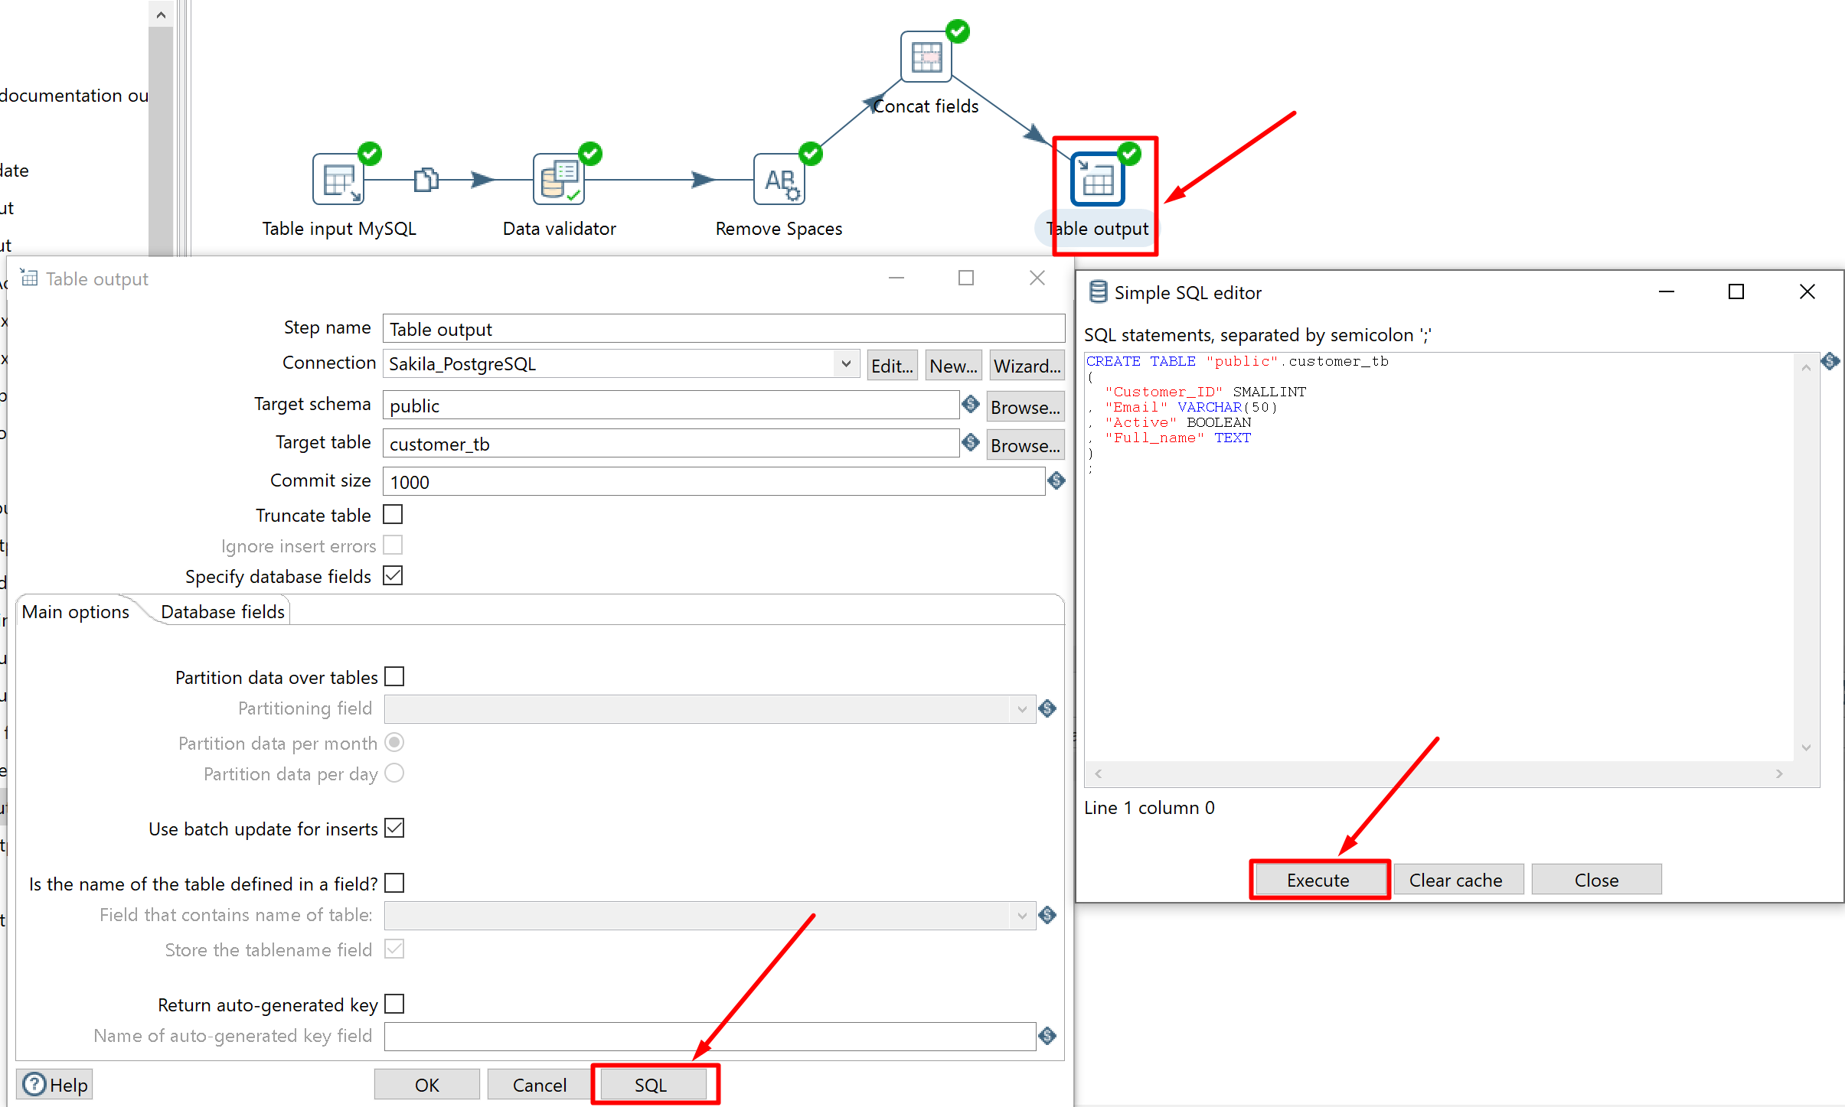

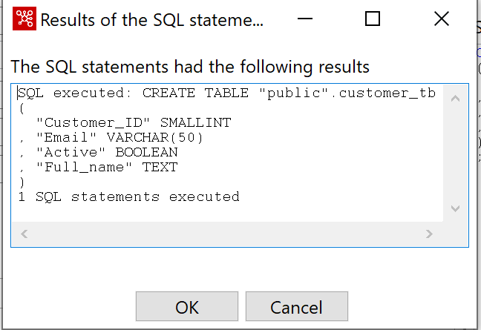

# Step 11: Another Example Customer Address

Now let’s try another example. Suppose we want to create a customer address table in the target database. We want to list customer_id, first_name, last_name, email, phone, city, district, country, and postal_code.

Create a new Input step and preview the result.

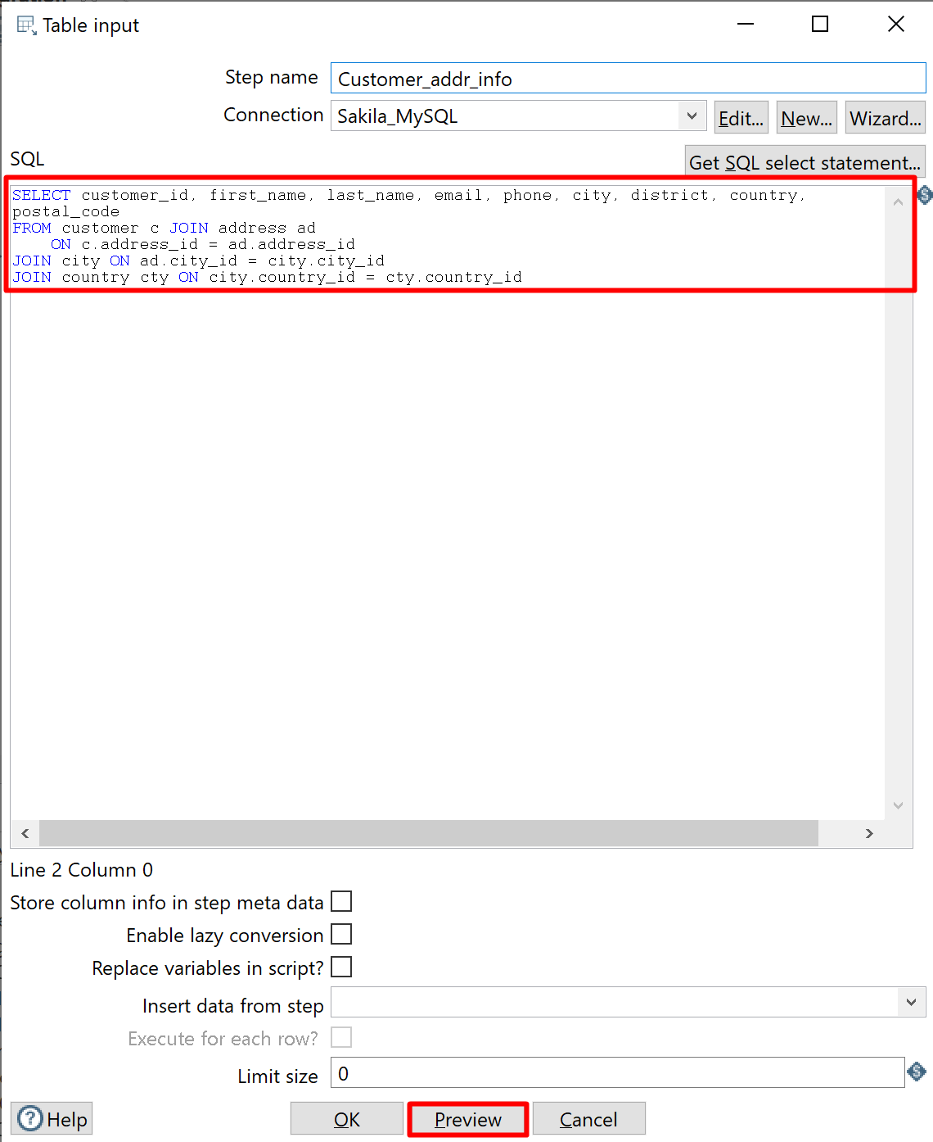

However, we have some data quality problems. For example, the missing value of the district field, and some invalid zip code.

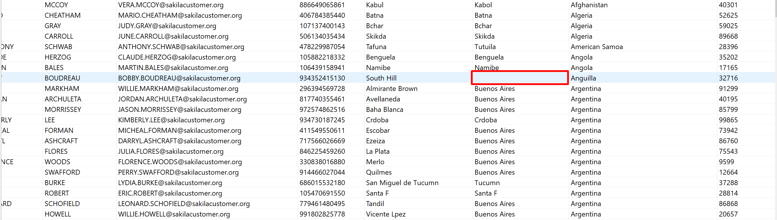

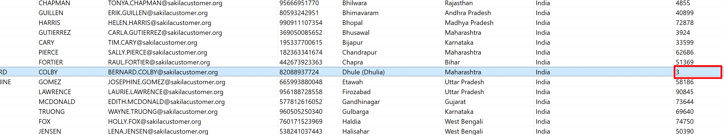

To solve the first problem, missing value. It is possible that some countries only have the country-city-street geographical hierarchy. To handle this possibility, we will simply copy the value in the city field to the district field.

Add the Filter Row step to the process.

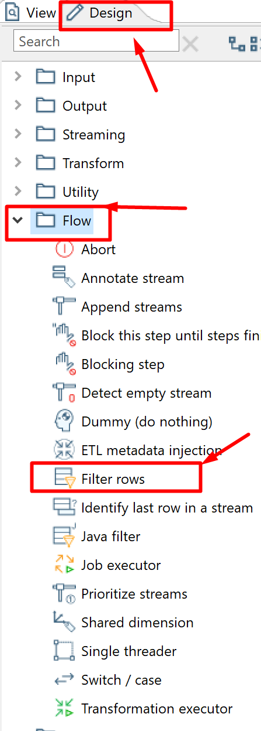

Set up the condition.

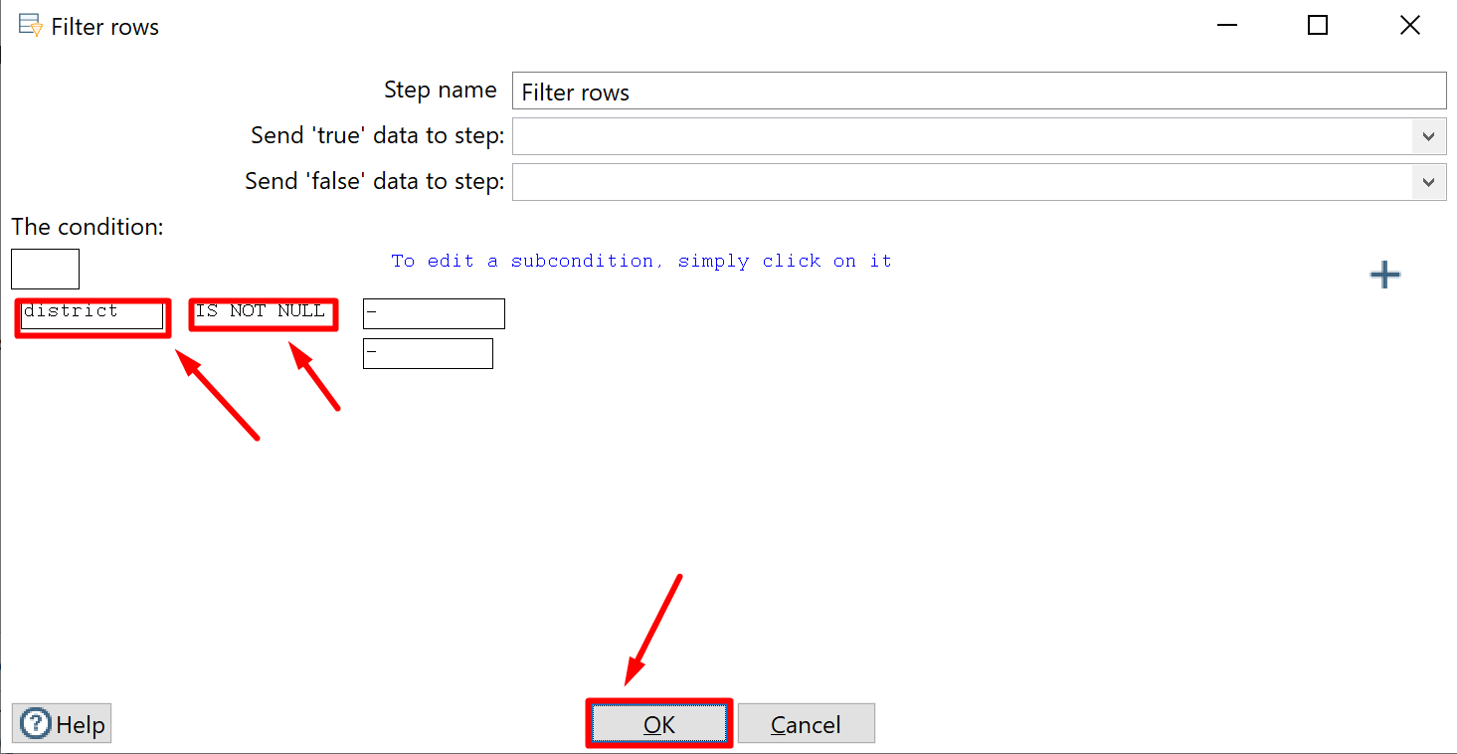

Now, when the district is null, we will set a field value. So add a Set Field Value step.

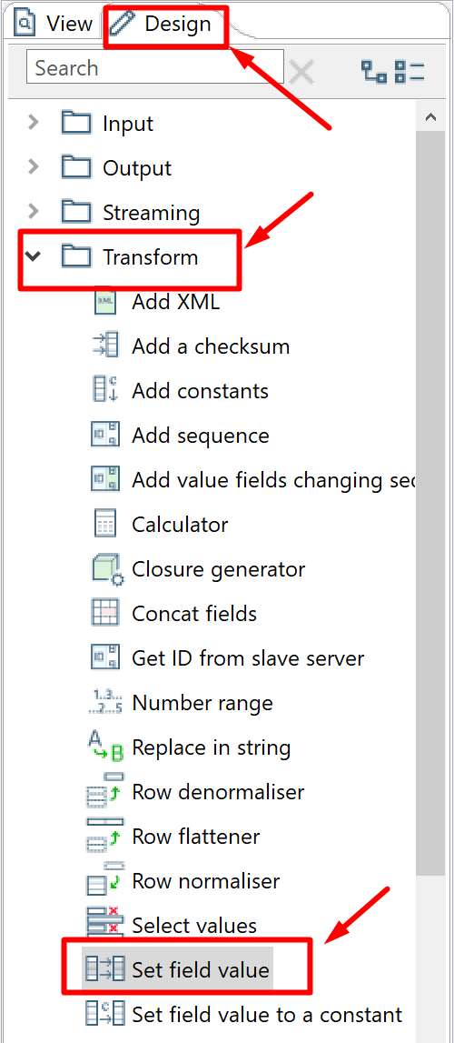

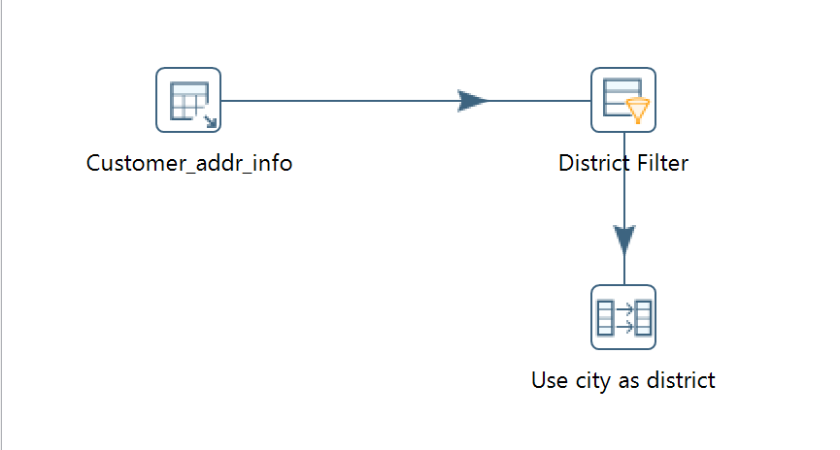

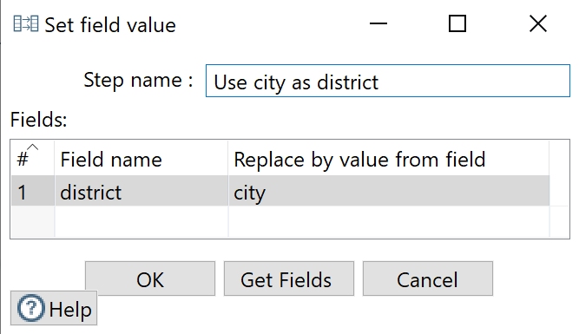

Going back to the filter, we will now send “false” data to the step “Use city as district.”

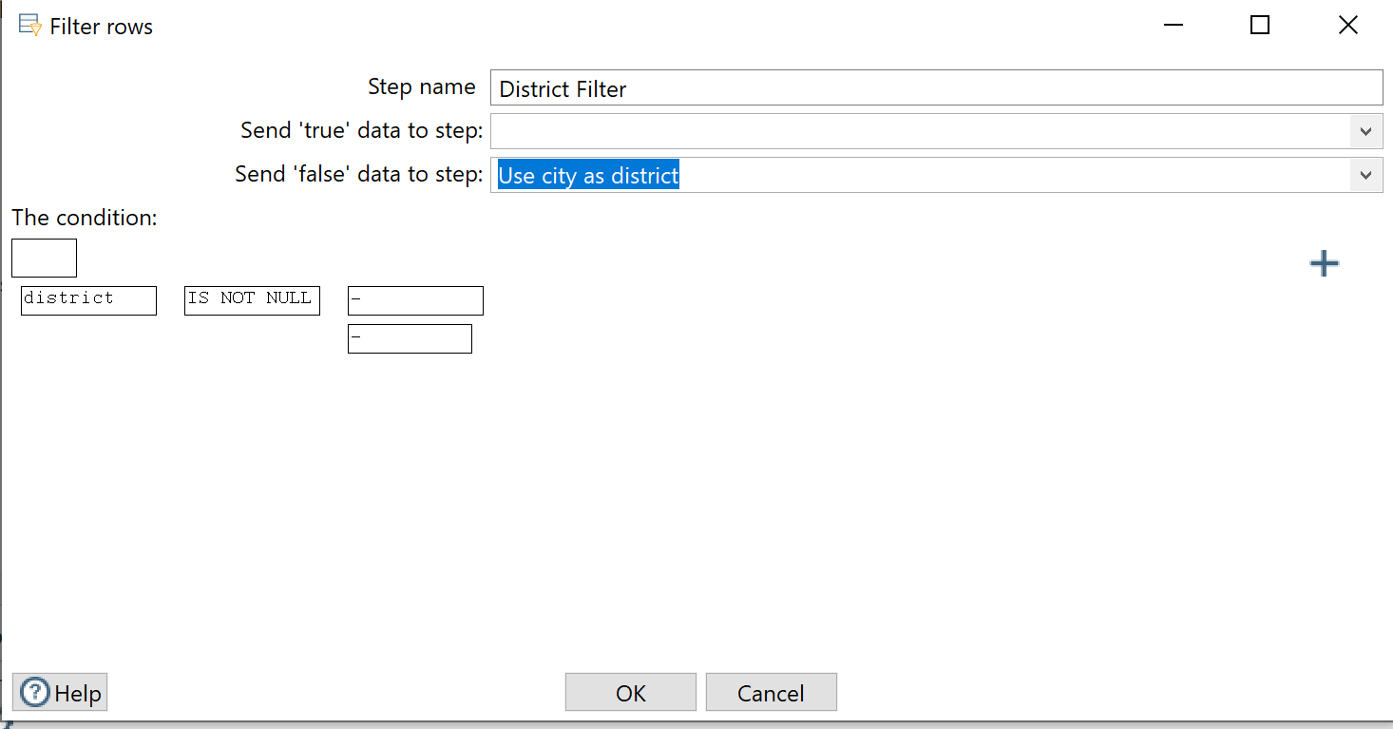

We don’t need to do anything to the “true” data because they don’t have the missing value problem. So all these data will be sent to the next step to deal with the second problem, incorrect zip code.

We assume that a correct zip code has at least 4 digits. So we can calculate the length of the postal_code field and based on the length to set up a new filter.

You can find the calculator here.

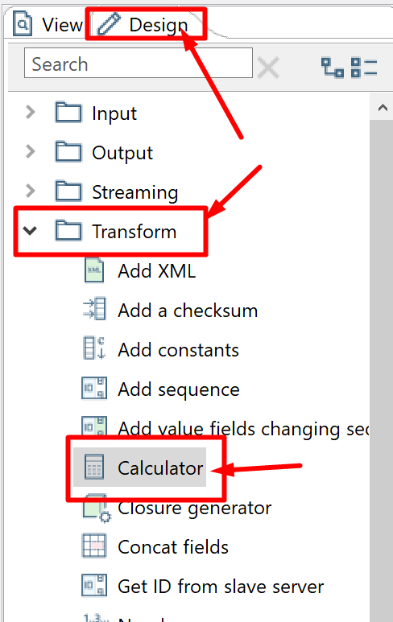

Now we calculate the length of the field and create a new field postal_length.

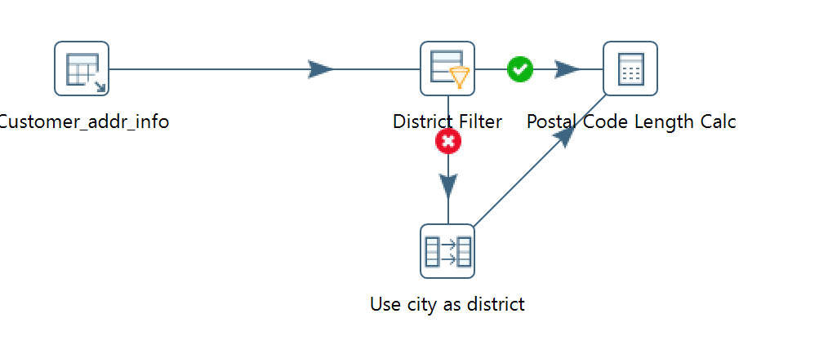

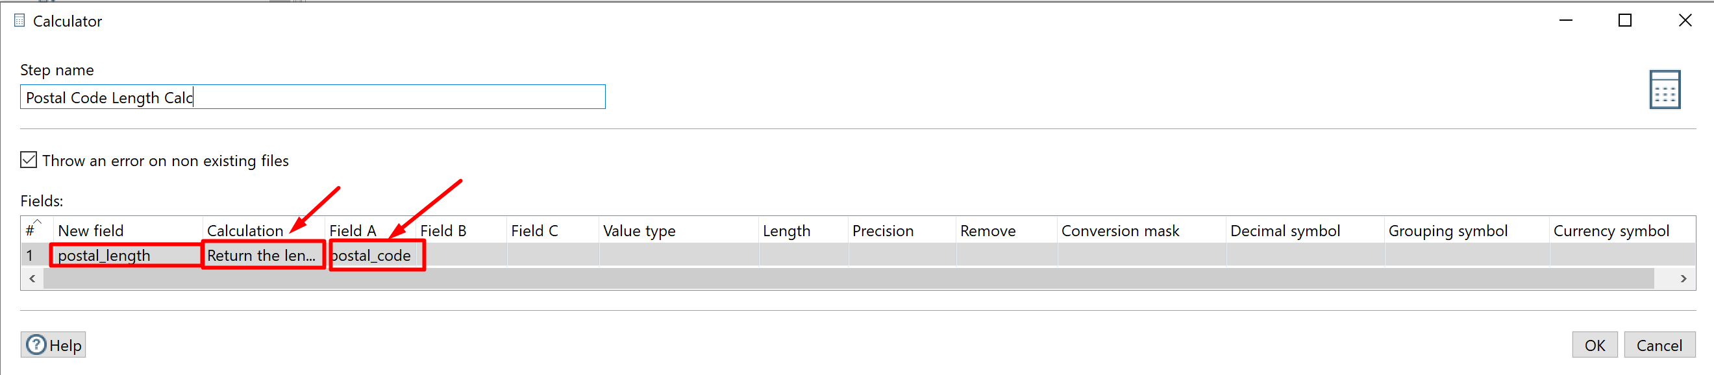

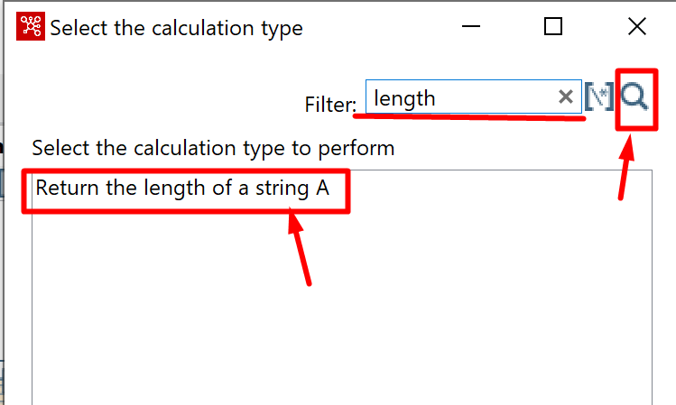

Remember that this is also the destination to send the “true” data from the District Filter.

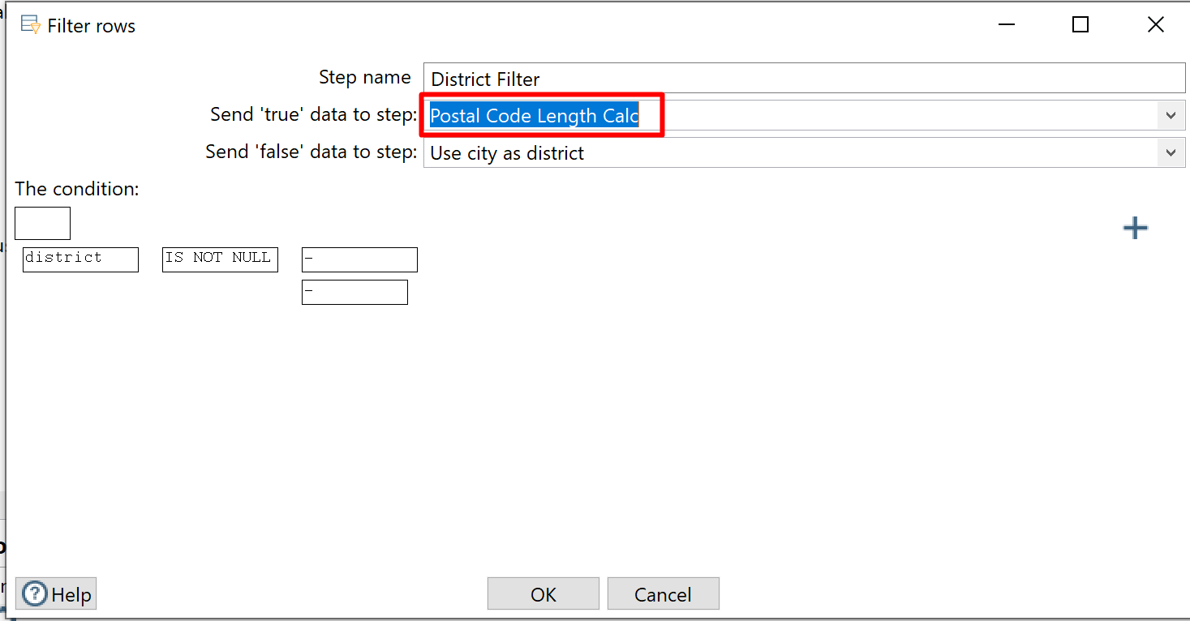

Finally, we use the length as condition in the new filter and discard data rows not meeting the requirement.

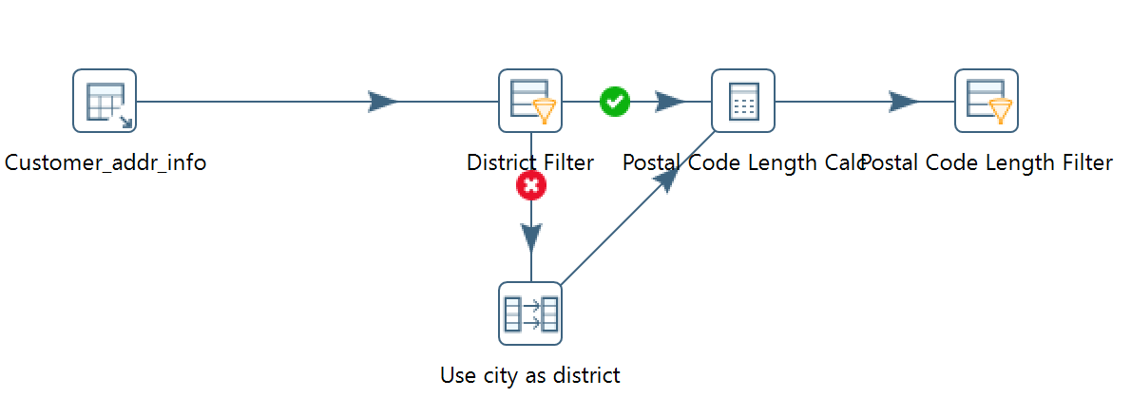

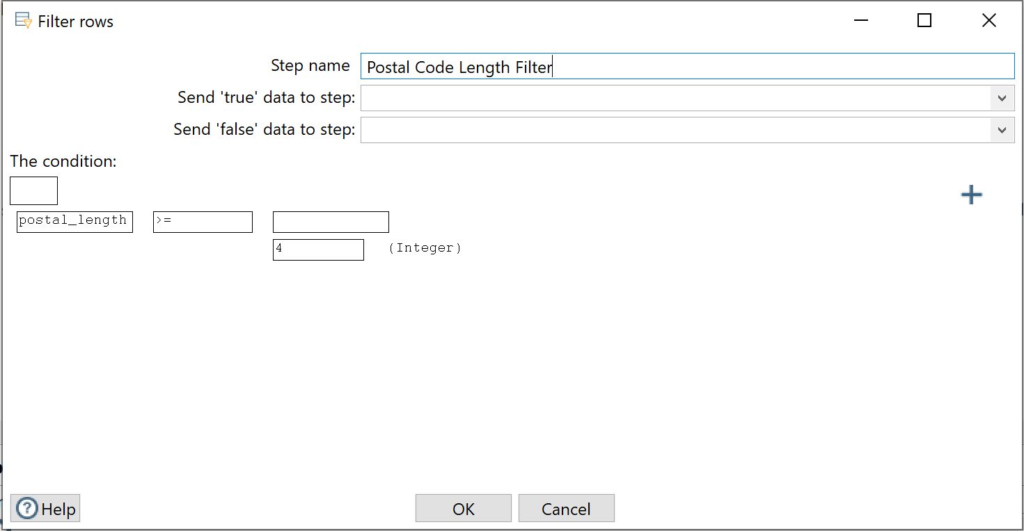

We then create a new Output step to export the data to a new PostgreSQL table.

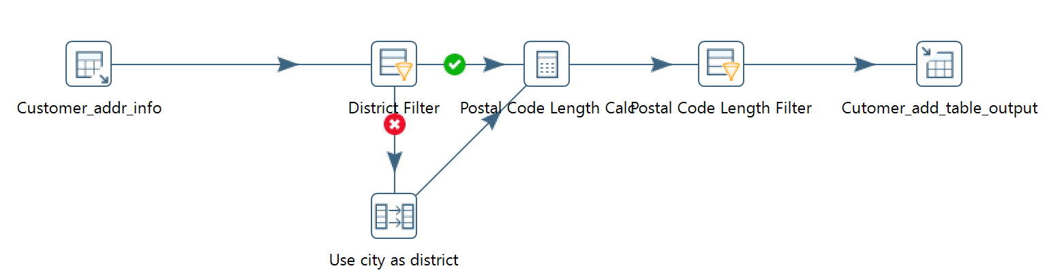

When you create the table, remember to delete the postal_length field as we don’t need it in the real data records.

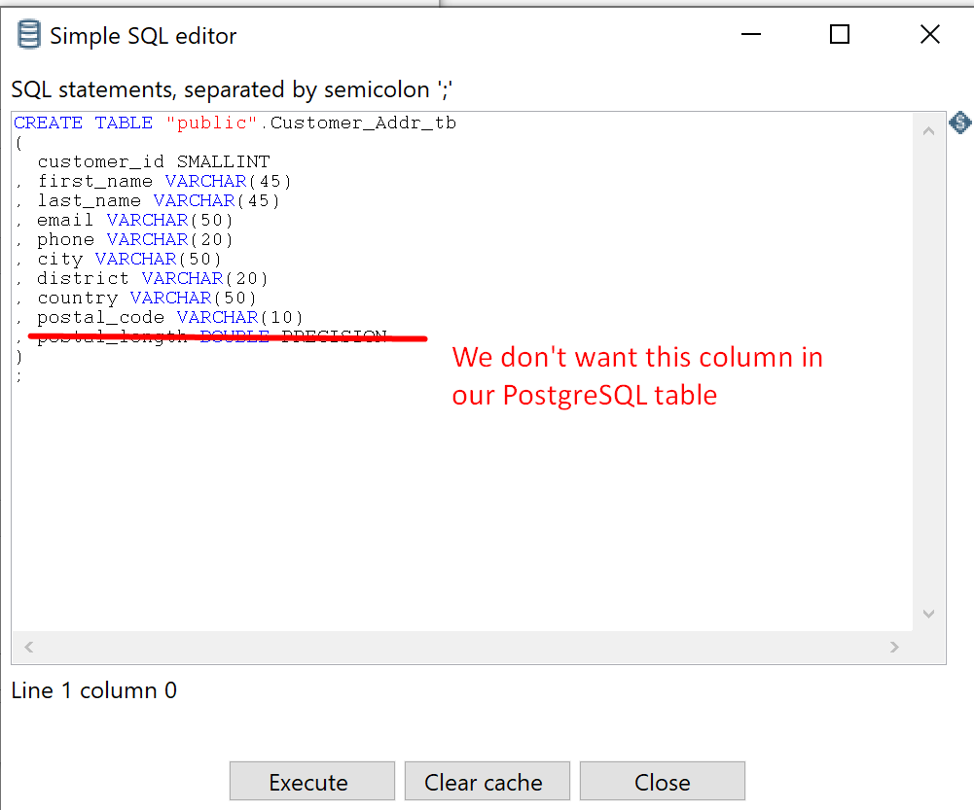

The final Output step is as follows.

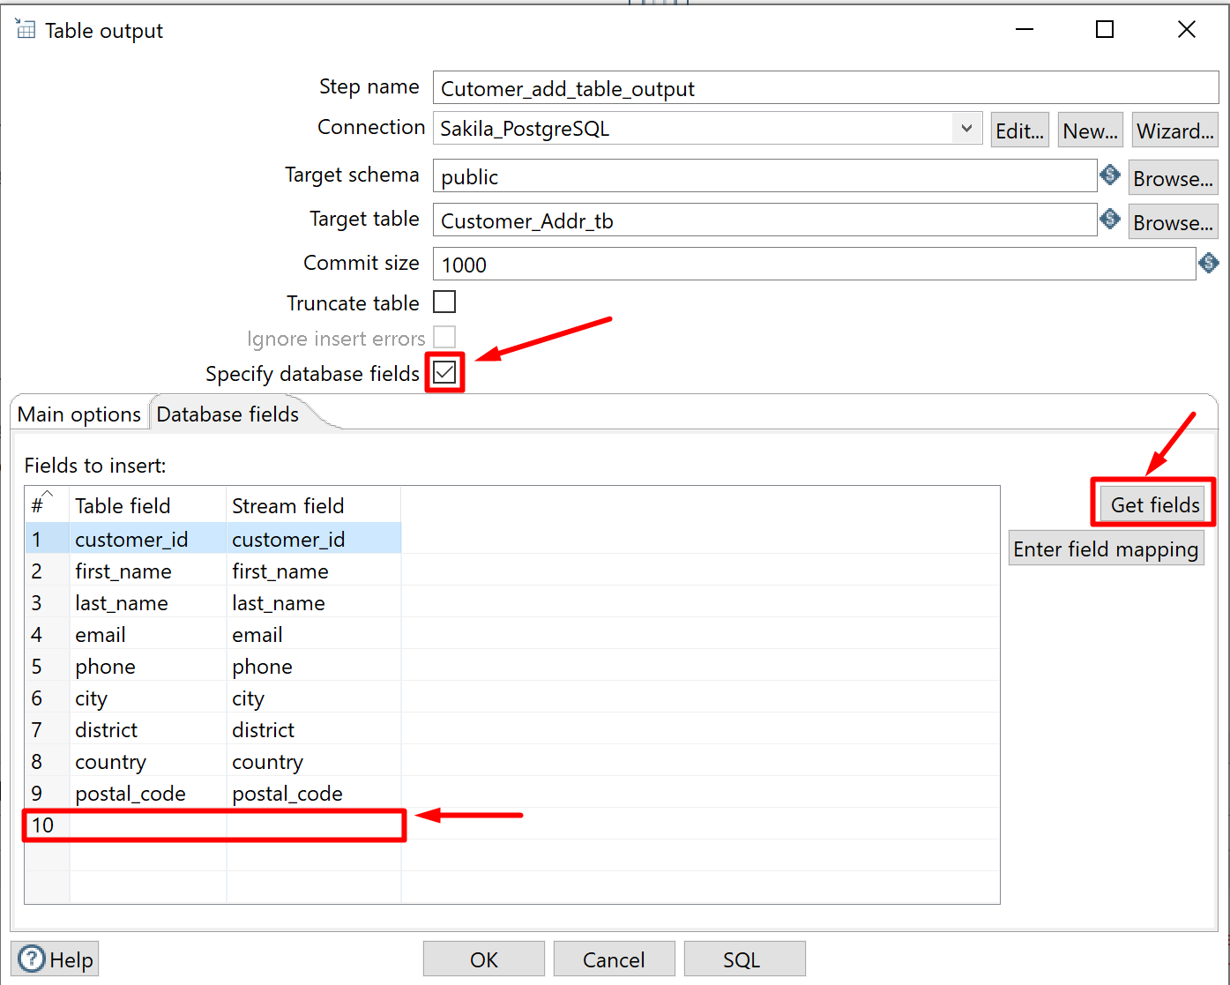

You can examine the result in the PostgreSQL database.

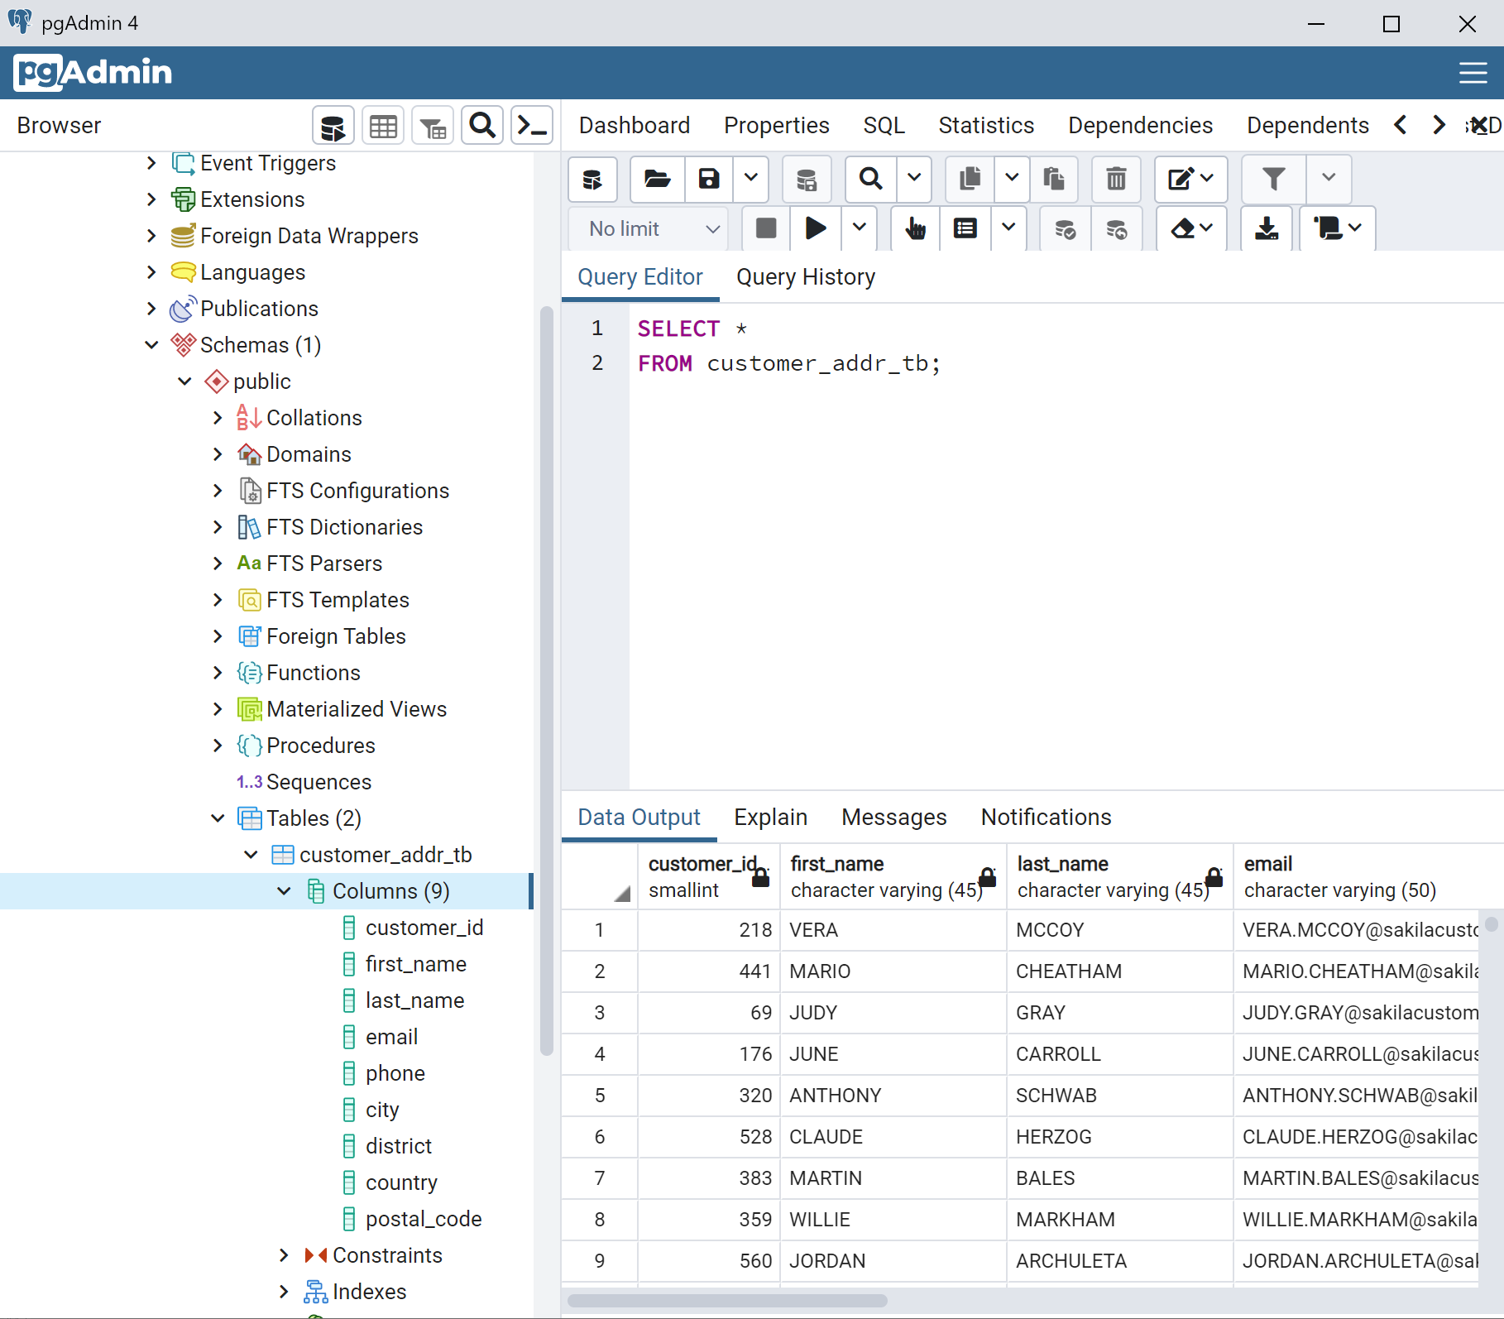

# Step 12: Another Example Apply Number Range

We can add a Number Range step to summarize quantitative information.

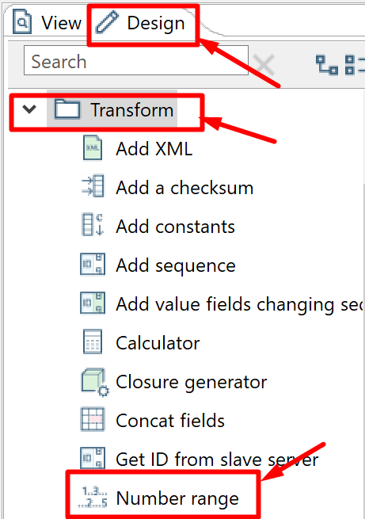

Suppose we want to calculate the total money spend of each of the customers.

We can obtain this information in the payment table.

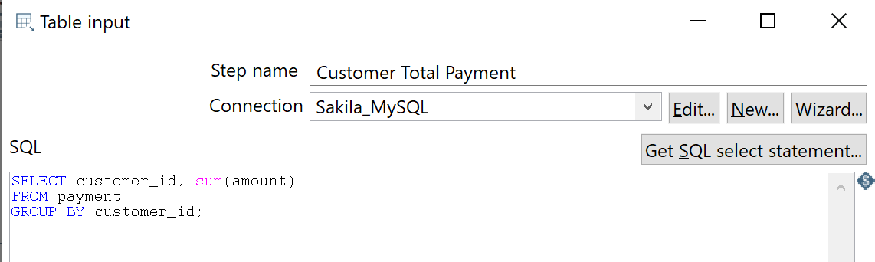

Now by applying a number range, we can summarize the relative importance of the customer in terms of the money they spent on our business

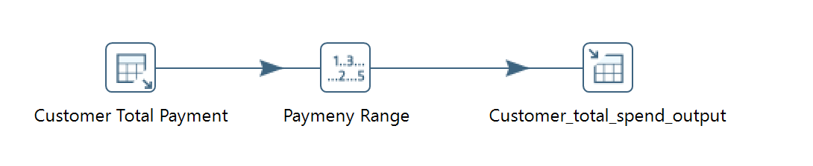

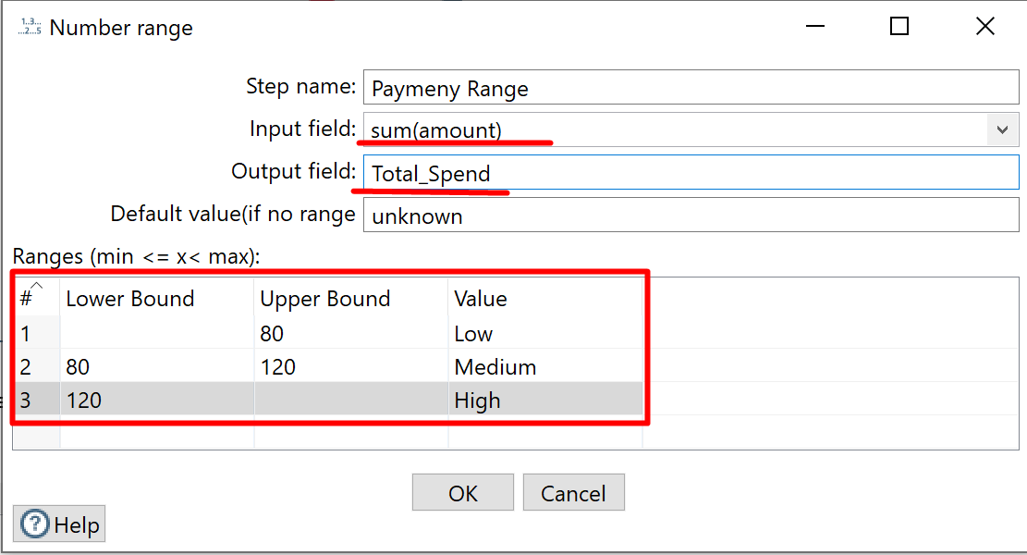

The final result table in PostgreSQL is as follows.

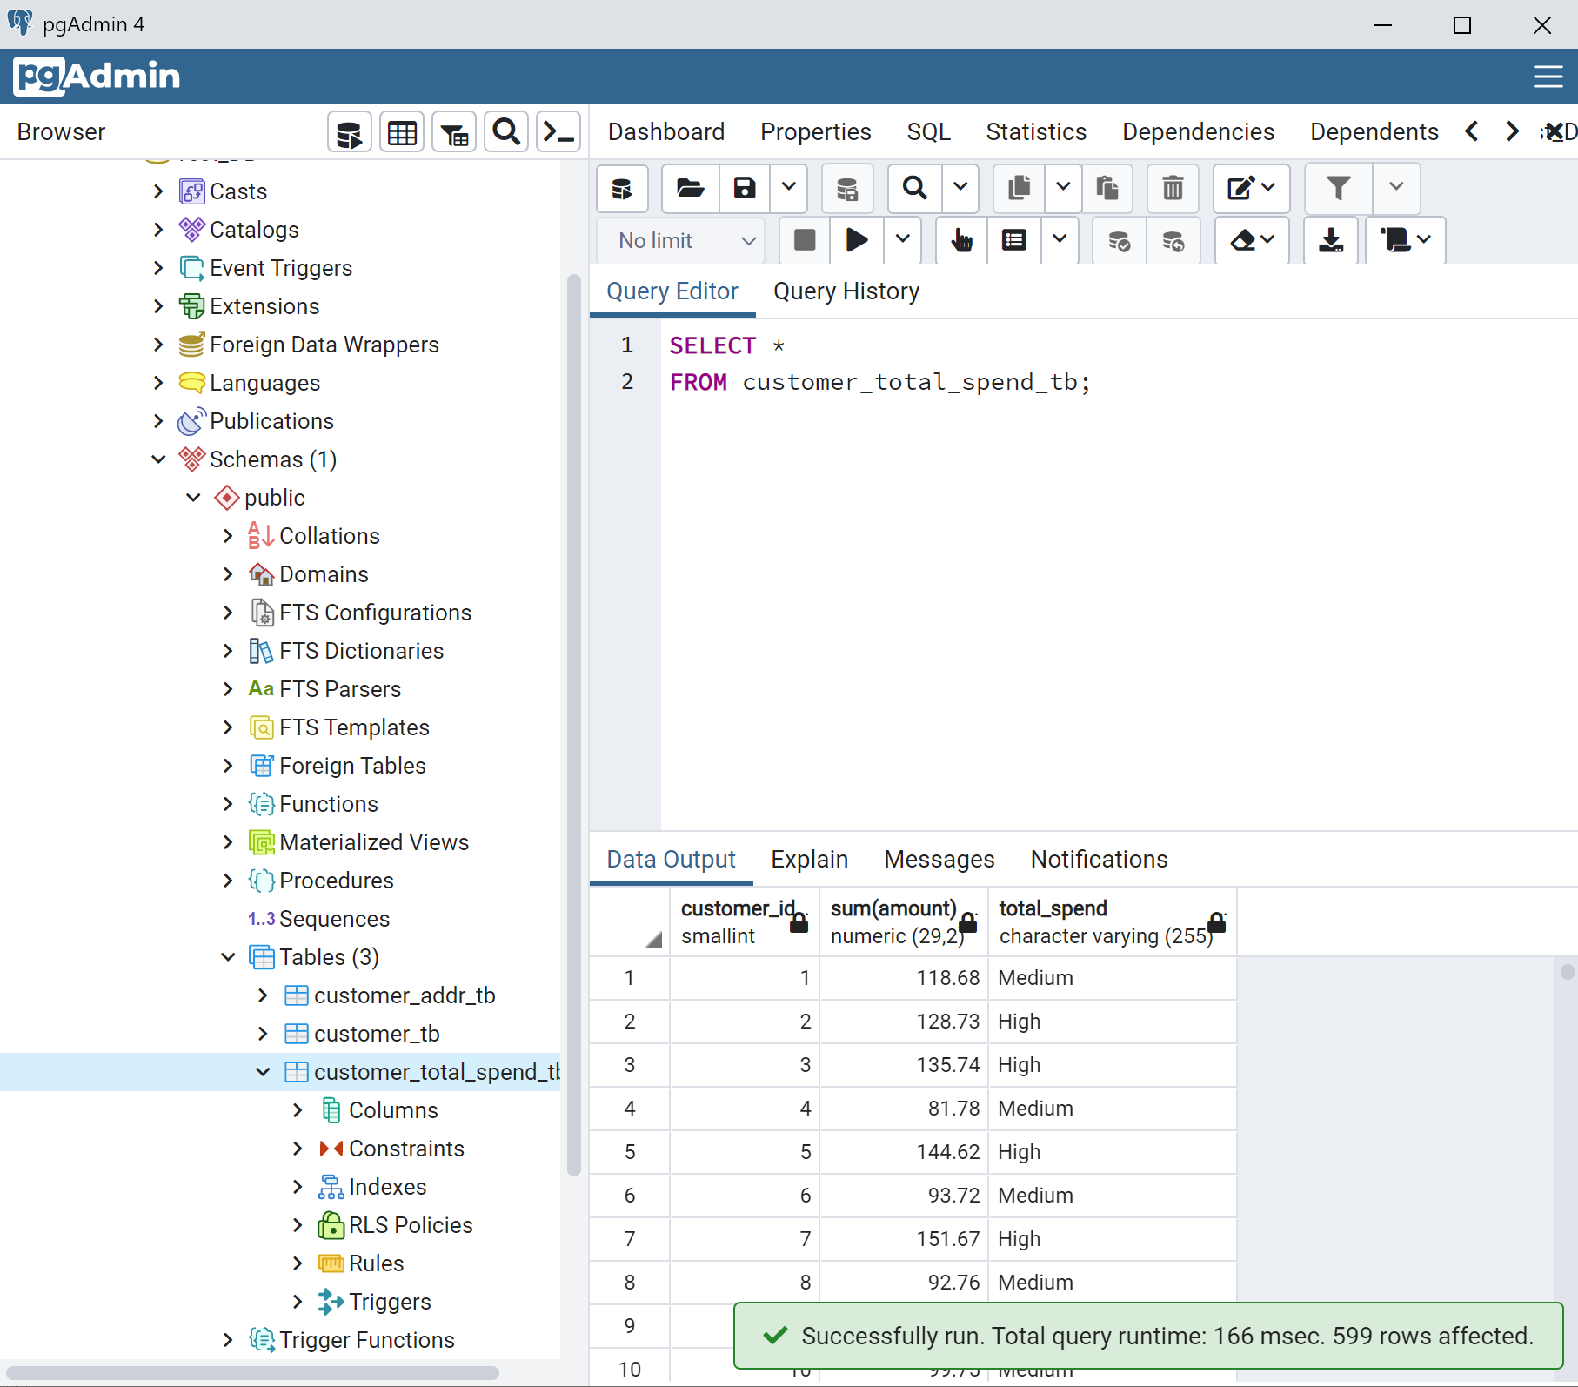

# Step 13: Group Project Requirement

Your goal in this project is to continue the data migration process. Design and create 5 Pentaho transformation by using the Sakila database. Your transformation steps are not limited to the steps I introduced above. You are encouraged to explore much more possibilities.

For each of the transformations

Use a Microsoft Word file to

1. Describe the business value why the output table is important.

2. Clearly state your assumptions and rules used in the transformation process.

Use a screenshot software to

3. Provide a screenshot of the transformation steps. For example,

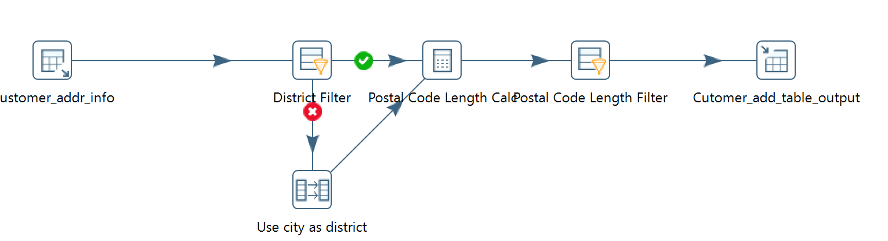

4. Show your result table in PostgreSQL.

5. You will create a Pentaho transformation file with a file extension .ktr. Remember to include this file as well in your deliverables.

You should submit one ZIP or RAR file containing all the files required above.